Scholars and Projects 2020

Alexander Zorob, MD
Investigation of circulating permeability factors in idiopathic FSGS in cell culture and zebrafish models
Department of Medicine 4, Universitätsklinikum Erlangen
Mentors: Prof. Janina Müller-Deile, Prof. Mario Schiffer

  - 
Alexander Zorob
Introduction
Primary focal-segmental glomerulosclerosis (FSGS) is a rare form of kidney disease that belongs to the group of glomerulopathies. The incidence of primary FSGS is increasing and it can lead to end stage renal disease.
Primary FSGS is believed to be caused by circulating permeability factors leading to podocyte effacement. However, the specific factor leading to FSGS remains unknown.
We therefore wanted to characterize the role of cathepsin L and its potential to induce podocytopathy in a zebrafish model. In order to demonstrate that this special model is indeed suitable for investigation of circulating permeability factors in a personalized manner, we additionally injected human serum from a patient with primary FSGS and control into the circulation of zebrafish larvae.

Methods
Cathepsin L cRNA was microinjected into 1-4 cell stage transgenic zebrafish (Tg(I-fabp:eGFP-DBP)) larvae which constitutively express a circulating green fluorescent Vitamin D binding protein, roughly resembling the size of albumin. Moreover, human serum from a patient with primary FSGS and a healthy control was injected into the circulation of 2-day old Tg (I-fabp:eGFP-DBP) zebrafish larvae. We considered a loss of this protein from zebrafish circulation to be an indirect hint for proteinuria and quantified fish with edematous phenotypes. Loss of Vitamin D binding protein was quantified by measuring mean fluorescence intensity (MFI) in zebrafish eye vessels at 96 and 120 hours post fertilization (hpf). One-way ANOVA was used to test statistical significance.

Results
We numerically observed more zebrafish with an edematous phenotype in the cathepsin L cRNA injected group than in control injected and uninjected group. Although MFI in the retinal vessel at 96 hpf did not differ significantly between groups, we could show significant differences in MFI between the cathepsin L cRNA injected group (mean MFI 15.85) and both the control injected (mean MFI 32.27; p < 0.01) and the non-injected group (mean MFI 27.25; p < 0.05) at 120 hpf .Moreover, injection of serum from a patient with primary FSGS into zebrafish larvae at 48 hpf caused reduced GFP signal in the retinal vessels 120 hpf

Conclusion and outlook
Injection of serum from a patient with primary FSGS into zebrafish circulation caused proteinuria indicating the suitability of our model for investigating circulating permeability factors in primary FSGS in a personalized manner. Furthermore, our data show significantly lower albumin sized plasma proteins in cathepsin L cRNA injected zebrafish at 120 hpf. These findings promote our assumption, that the endopeptidase cathepsin L might play a role in the development of proteinuria. However, further retries of our experiments are required to substantiate our thesis. Moreover, electron microscopy of the zebrafish glomeruli has to be performed in order to identify podocyte effacement after cathepsin L cRNA and patient sera injections.

Linus Butt, MD
Col4a3 and Col4a3/PodocinR231Q
Department of Internal Medicine II, Uniklinik Köln
Mentors: Prof. Markus Rinschen, Prof. Paul Brinkkötter


Linus Butt

Introduction, working program and status quo
Mammalian kidneys filter enormous amounts of fluid from plasma with almost complete retention of albumin in the blood. Breakdown of the three-layer renal filtration barrier results in loss of albumin into urine across the wall of small renal capillaries and is a leading cause of chronic kidney disease. We have previously generated a mouse model equivalent to a human genetic disease affecting the filtration barrier protein podocin and collected extensive morphometric data prior to and after onset of albuminuria (Fig. 1 a) ¹. We found a robust correlation of slit diaphragm length and foot process circularity with levels of albuminuria (Fig. 1 b-c). Using quantitative analyses together with mathematical modelling, we show that the permeability of the renal filter is modulated through compression of the capillary wall (Figure 1 d) ². In the present project, we would like to investigate whether the correlation of albumin permeability and slit diaphragm length is reproducible in a model of Alport syndrome, a genetic disease affecting collagen IV, one of the main components of the glomerular basement membrane. In addition, we cross Col4a3^{+/-} with Podocin^{R231Q/wildtype} mice. A trans-association of mutations affecting the collagen IV chains with the common polymorphism R229Q (murine R231Q) in the NPHS2 gene, encoding podocin, was observed to lead to an aggravated course of disease in patients. We will examine this association in mice and seek to unravel the underlying pathophysiology.
Alport syndrome is a hereditary disease in which homozygous or hemizygous mutations in the Col4a3, Col4a4 and Col4a5 genes cause the expression of defective collagen fibers within the glomerular basement membrane ³. Affected patients frequently present with hematuria, albuminuria and progression to terminal renal insufficiency. Morphological alterations of podocytes and progressive albuminuria are detectable in the course of disease, which is why we would like to validate our compression-permeability model in a NPHS2-independet disease model.
We have previously imported sperm from the Col4a3 knockout mouse from Jeff Miner ⁴, St. Louis, USA, and performed in vitro fertilization in our CECAD in vivo research facility. In analogy to our NPHS2-based mouse model, we will phenotype Col4a3^{+/-} as well as Col4a3^{-/-} mice. We will also use super-resolution STED microscopy to validate the effect of the Col4a3 knockout on the foot process and slit diaphragm morphology. We are particularly interested in whether there is a robust correlation of alterations in slit diaphragm length and levels of albuminuria in this disease entity as well, which would further strengthen our compression-permeability model of glomerular filtration. We will also investigate whether morphological alterations can be observed in Col4a3+/- mice, which are known to be otherwise phenotypically inconspicuous. To streamline the quantification of podocyte morphology and exclude a potential investigator-dependent bias, we have automatized the morphological analysis using a deep-learning network ⁵.

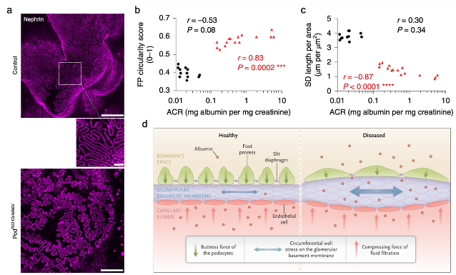
  - Figure 1: (a) Depiction of the slit diaphragm protein nephrin by immunolabeling and STED microscopy in a control (upper panel) and a Podocin^{R231Q/A286V} (lower panel) mouse. While in the control the capillary loop is completely covered by the slit diaphragm/ foot processes, the network in the Podocin^{R231Q/A286V} mouse is clearly less dense. Adapted from Butt et al. 1. (c)-(d) The foot process circularity (b) and slit diaphragm length (c) correlate with levels of albuminuria in a Podocin^{R231Q/A286V} mice (red triangles, controls = black circles). r = Spearman’s rank coefficient. Adapted from Butt et al. ¹.
  - (d) Compression-Permeability model of the glomerular filtration barrier. Physiologically, the counteracting forces of the filtration pressure and the podocytes’ buttress force result in a compression of the glomerular basement membrane thereby decreasing its permeability to macromolecules (left side). With foot process effacement comes the loss of foot processes and a decrease in slit diaphragm length which diminishes the podocytes’ ability to provide an adequate counter force. This leads to a relaxation of the fiber meshwork of the GBM and an increase in its permeability for macromolecules like albumin (right side). Adapted from Benzing and Salant ².

In a second step, we will characterize the association of collagen IV and podocin in vivo. While homozygous carriers of mutations in the Col4a3 and Col4a4 genes typically present with alport syndrome, heterozygous carriers are often affected by the thin basement membrane syndrome ⁶. The thin basement membrane syndrome is also associated with hematuria, albuminuria and renal failure. Epidemiological observations indicate a more severe course of disease in patients carrying the frequent podocin R229Q polymorphism ^{7,8}. We will cross Col4a3^{+/-} mice with our Podocin^{R231Q} mouse (human: R229Q) to imitate the human genetics of those patients and validate the effect of R231Q on the phenotype. Unpublished data from our group shows not only mild albuminuria and altered podocyte morphology in Podocin^{R231Q/R231Q} mice (Fig. 2 a-c) but also a more severe glomerular injury in response to injections of nephrotoxic serum in heterozygous Podocin^{R231Q/wildtype} mice already (Fig. 2 d-e), indicating a more pronounced susceptibility to glomerular injury ⁹. We therefore hypothesize that heterozygous deletion of Col4a3 represents a second hit, which leads to the development of overt glomerular disease.
As of now, we have backcrossed the imported Col4a3 knockout mice multiple generations because the background C57BL/6 mouse strain was slightly different to the one used in our animal facility. Since we have extensively backcrossed > 5 generations in the past months, we can now phenotype both Col4a3 and Col4a3/Podocin.R231Q mice and compare the results to our previous morphological and functional analyses.

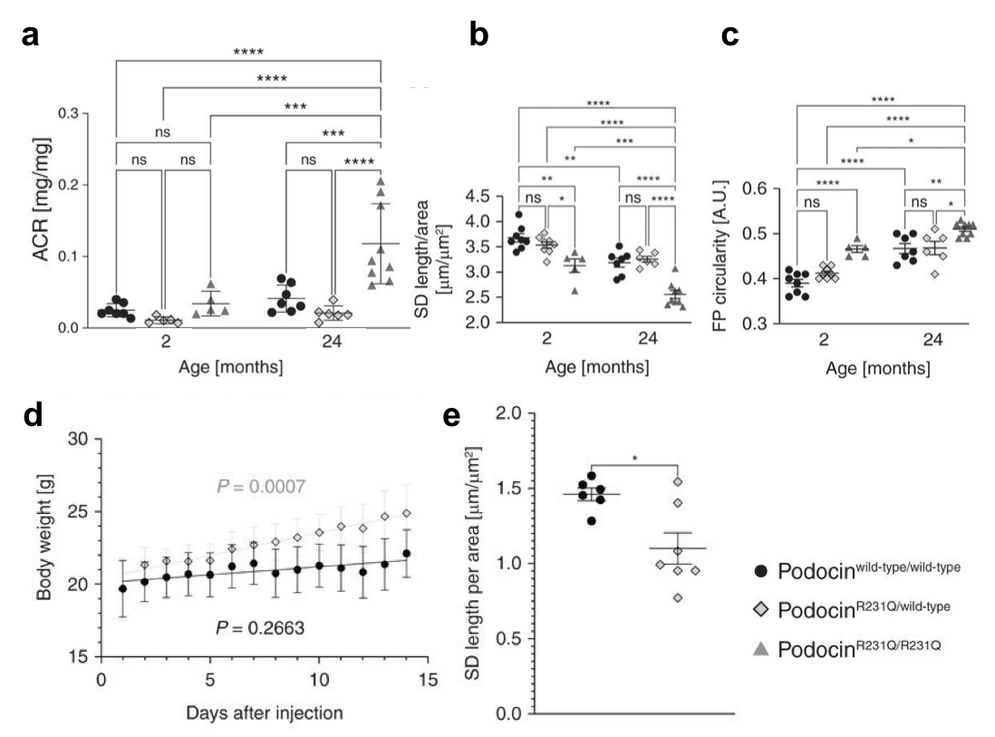
  - Figure 2: Podocin^{R231Q/R231Q} mice develop a mild albuminuria with age (a) and they depict a significantly decreased slit diaphragm length (b) as well as an increased foot process circularity (c). 2-way ANOVA tests were performed to test for statistical significance. * P < 0.05, ** P < 0.01, *** P < 0.001, **** P < 0.0001. (d) Weight curve of Pod^{wildtype/wildtype} (black circles) and Pod^{R231Q/wildtype} (light grey squares) after injecting nephrotoxic serum (n = 7 mice per group). Light grey and black line and P-values indicate the results of the simple linear regression. (e) Quantification of the SD length per area in Pod^{wildtype/wildtype} (black circles) and Pod^{R231Q/wildtype} (light grey squares) 14 days after injecting nephrotoxic serum. Each circle/square represents one mouse. Mann-Whitney-U-Test was used to determine statistical significance. * p < 0.05. Adapted from Butt et al.⁹.

The first experiments suggest mild morphological alterations in aged Col4a3^{+/-}/Podocin.R231Q^{+/-} mice ^{+/-} mice as compared to age-matched control animals (Fig. 3 a, b). We have previously shown that these morphological alterations are associated with podocyte injury and that they precede the development of albuminuria and podocyte loss ^{1,10}. Due to the limited number of aged Col4a3^{+/-}/Podocin.R231Q^{+/-} mice we have analyzed so far, more samples will have to be analyzed in order to come to a reliable conclusion. The first homozygous Col4a3^{-/-} and age-matched control animals are currently analyzed.

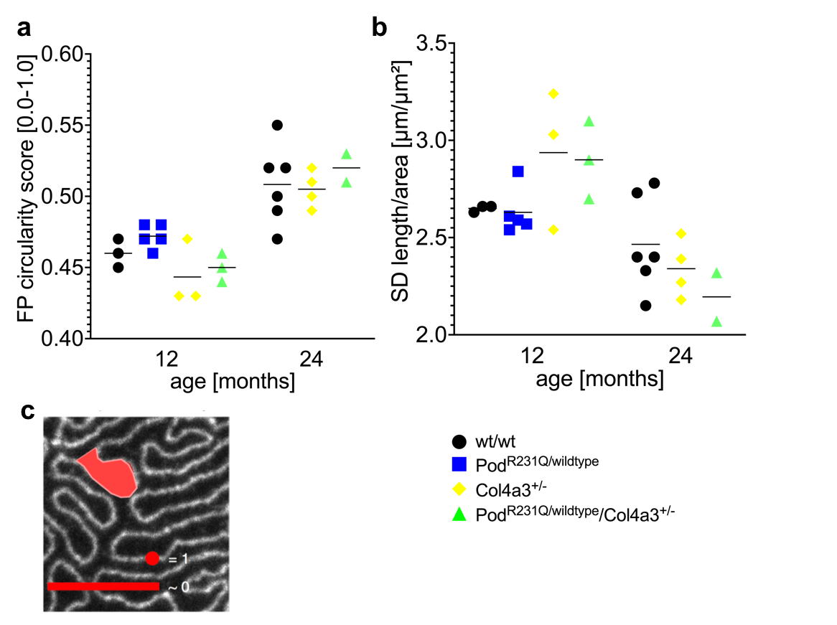
  - Figure 3: Quantification of foot process circularity (a) and slit diaphragm length (c) in wildtype, Col4a3^{+/-}, Podocin.R231Q^{+/-} and Col4a3^{+/-}/Podocin.R231Q^{+/-} mice at the indicated time points (unpublished data). (c) Schematic illustration of foot process circularity. A perfect circle has a value of 1, an elongated polygon approaches a value of 0. Adapted from Butt et al. ¹.

References
1. Butt, L. et al. A molecular mechanism explaining albuminuria in kidney disease. Nat. Metab. 2, 461–474 (2020).
2. Benzing, T. & Salant, D. Insights into Glomerular Filtration and Albuminuria. N. Engl. J. Med. 384, 1437–1446 (2021).
3. Kruegel, J., Rubel, D. & Gross, O. Alport syndrome--insights from basic and clinical research. Nat. Rev. Nephrol. 9, 170–178 (2013).
4. Miner, J. H. & Sanes, J. R. Molecular and functional defects in kidneys of mice lacking collagen alpha 3(IV): implications for Alport syndrome. J. Cell Biol. 135, 1403–1413 (1996).
5. Unnersjö-Jess, D. et al. Deep learning-based segmentation and quantification of podocyte foot process morphology suggests differential patterns of foot process effacement across kidney pathologies. Kidney Int. S0085-2538(23)00180–1 (2023) doi: 10.1016/j.kint.2023.03.013.
6. Voskarides, K. et al. COL4A3/COL4A4 mutations producing focal segmental glomerulosclerosis and renal failure in thin basement membrane nephropathy. J. Am. Soc. Nephrol. JASN 18, 3004–3016 (2007).
7. Stefanou, C. et al. Co-Inheritance of Functional Podocin Variants with Heterozygous Collagen IV Mutations Predisposes to Renal Failure. Nephron 130, 200–212 (2015).
8. Tonna, S. et al. The R229Q mutation in NPHS2 may predispose to proteinuria in thin-basement-membrane nephropathy. Pediatr. Nephrol. Berl. Ger. 23, 2201–2207 (2008).
9. Butt, L. et al. Super-Resolution Imaging of the Filtration Barrier Suggests a Role for Podocin R229Q in Genetic Predisposition to Glomerular Disease. J. Am. Soc. Nephrol. JASN 33, 138–154 (2022).
10. Butt, L. et al. A mathematical estimation of the physical forces driving podocyte detachment. Kidney Int. 100, 1054–1062 (2021).

Raluca Ursu, MD
Opposing roles of the miR-200b/c-ZEB1/2 axis in primary podocytopathies and diabetic nephropathy
Department of Medicine 4, Universitätsklinikum Erlangen
Mentors: Prof. Janina Müller-Deile, Prof. Mario Schiffer


Raluca Ursu

Introduction
Primary podocytopathies are a subgroup of rare renal diseases in which proteinuria is attributed to damage or dysfunction of podocytes. Regulation of signaling pathways that involves micro-RNAs (miR) networks, might play a context-dependent role in different glomerulonephropathies. MiRs are small non-coding RNAs that regulate gene expression in physiological processes as well as in diseases. MiRs lower the expression of target genes by interacting with the 3'-untranslated region of their target mRNAs and induce translational repression or degradation in a RNA-induced silencing complex (RISC)¹. They are stable and detectable in human biofluids (urine and serum), making them feasible as potential biomarkers². We hypothesize an intercellular pathomechanism that derives from glomerular endothelial cells and contributes to podocyte damage in proteinuric diseases. On the other hand, emerging evidence indicates that the epithelial-mesenchymal transition (EMT) of podocytes after injury is a mechanism underlying podocyte dysfunction and proteinuria³. Mesenchymal transition of podocytes after injury may play a vital role in causing podocyte dysfunction that ultimately leads to a defective glomerular filtration in various glomerular diseases.
In search for miRs that might play a role in glomerular diseases, we performed a miR screening in different glomerular and tubular cell cultures as well as pooled urines from patients with different renal diseases. The combination of both screenings enabled us to identify cell type and disease specific miRs and to attribute the urinary miRs to the different renal cell types⁴. We identified miR-200c as a common miR upregulated in urines from patients with various podocyte diseases. Interestingly, the same miR-200c was upregulated specifically in glomerular endothelial cells after stimulation with TGF-β but not in podocytes, making us hypothesize that miR-200c could be released from glomerular endothelial cells during injury and act in a paracrine and autocrine manner in the glomerular environment.

Methods
Cultured human podocytes and cultured human glomerular endothelial cells were stimulated with TGF-beta. miR-200c as well as U6 expression was detected via TagMan qPCR. We overexpressed miR-200c in zebrafish by injection of a miR-200c mimic in egg stage and screened for phenotype changes, proteinuria and disruption of the glomerular filtration barrier. We further studied potential targets of miR-200c in podocyte and glomerular endothelial cell culture and identified downregulation in genes involved in epithelial-to-mesenchymal transition (EMT).

Results
TGF-ß induces miR-200c in glomerular endothelial cells
After treatment with TGF-ß, miR-200c was significantly upregulated in cultured human glomerular endothelial cells after 24 h. In contrast, TGF-ß downregulated miR-200c in podocytes (Fig.1).

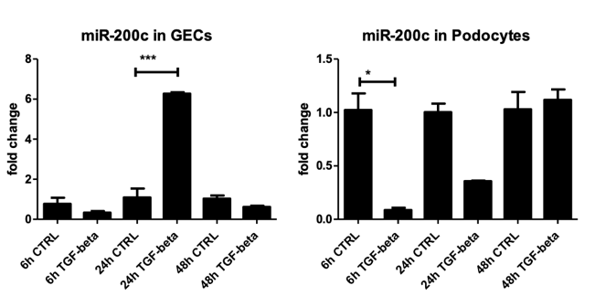
  - Figure 1: TaqMan qPCR for miR-200c detection in cultured human glomerular endothelial cells and human podocytes normalized to U6 RNA in unstimulated cells (CTRL) and after 6h, 24 h and 48 h stimulation with TGF-ß. Change in miR expression is given as fold change compared with the unstimulated condition. *p<0.05, ***p<0.001.
  - .

miR-200c overexpression causes proteinuria, edema, podocyte effacement and glomerular endotheliosis in zebrafish model
Human and zebrafish miR-200c are very conserved (Fig. 2A). We used the transgenic zebrafish (Tg(I-fabp:eGFP-DBP)) line, which constitutively express a circulating green fluorescent Vitamin D binding protein, roughly resembling the size of albumin. We injected miR-200c mimics in one-to-four-cell zebrafish larvae as well as a control miR composed of scrambled oligonucleotides with the help of a micro injector and stereomicroscope. In the miR-200c injected fish, a phenotype with edema of the pericardium and yolk sac was induced (Fig 2 B, C, D). In order to differentiate between a renal or cardiac origin of the edema we monitored retinal vessel plexus and observed a significantly reduced fluorescence in the miR-200c injected fish in comparison with the miR-control injected fish. The reduced fluorescence resulting from decreased Vitamin D binding protein in the retinal vessels of the transgenic fish is an indirect sign of the leakiness of the glomerular filtration barrier and loss of high-molecular weight proteins. We noticed that the zebrafish injected with the miR-200c mimic showed decreased nephrin and podocin expression as well as foot process effacement and loss of endothelial fenestrations (Fig 2G,H,I).

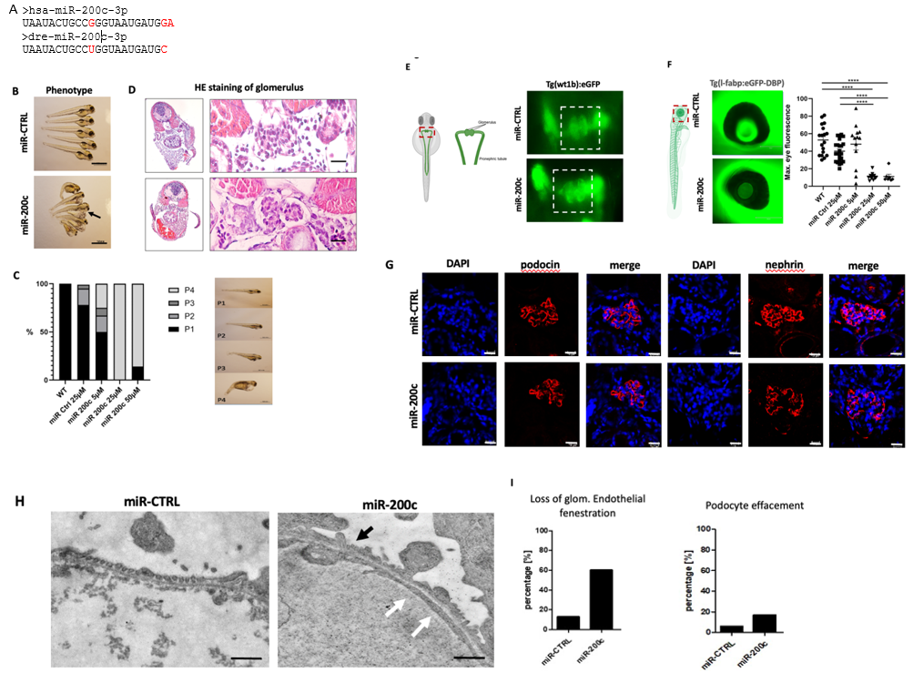
  - Figure 2 miR-200c morpholino overexpression induces edema, loss of high molecular weight proteins podocyte markers and loss of endothelial fenestrations.: (A) Differences in miR sequences between human and zebrafish miR-200c. (B) Phenotype pictures of zebrafish larvae at 96 hpf. Zebrafish were injected with a miR-CTRL mimic and miR-200c-3p mimic at cell stages one to four. Scale bar = 500 µm. Arrowhead shows pericardial edema. (C) Quantification of phenotype by severity of pericardial and yolk sac edema in percentage. Examples of phenotypic changes, grading the normal zebra fish phenotype with P1 and the most ‘edematous’ phenotype with P4. (D) Staining the zebrafish pronephri with hematoxillin-eosin at 96 hpf after miR-CTRL and miR-200c mimic injection in egg stage. Scale bar = 400 µm. (E) Timely fusion of the glomeruli at 48 hpf after miR-200c overexpression in Tg (wt1b:eGFP) zebrafish that expresses eGFP under the control of the wt1b promotor demonstrating normal development of glomeruli. Scale bar = 200 µm. (F) Representative image of an eye of an unaffected Tg(I-fabp:eGFP-DBP) fish appears green due to the fluorescent plasma protein in the retina vessels in zebrafish injected with a miR-CTRL mimic. In fish with proteinuria, the eye appears dark due to loss of green fluorescent plasma proteins (zebrafish injected with miR-200c mimic). Scale bar = 150 µm. Quantification of loss of circulating high molecular weight proteins by measuring max. eye fluorescence in the retinal vessel plexus of Tg(l-fabp:DBP:eGFP) zebrafish larvae at 96 hpf. ****p < 0.001. (G) Immunofluorescence staining for nephrin and podocin in zebrafish injected with miR-CTRL and miR-200c mimic. Nuclei were stained with Hoechst. In glomeruli from zebrafish injected with miR-200c mimic nephrin and podocin expression are slightly reduced. Scale bar = 50µm. (H) TEM pictures of the zebrafish glomerular filtration barrier at 96 hpf after miR-200c mimic and miR-CTRL injection in egg stage. White arrows indicate loss of fenestrated glomerular endothelium and black arrow podocyte effacement. Scale bar = 500 nm. (I) Quantification of loss of endothelial fenestrae and podocyte effacement. Numbers are given in percentage (n = 3 fish for each group).

miR-200c overexpression in podocytes causes a decreases in ZEB and VEGF-A and an increase in apoptosis
We found that ZEB2 and VEGF-A mRNA were downregulated after miR-200c overexpression in podocytes (Fig 3). Podocyte VEGF-A is on the one side a survival factor for podocytes, on the other side excess VEGF-A, especially locally, causes extensive foot process effacement and proteinuria⁵. ZEBs are involved in EMT. By performing immunofluorescence staining after miR-200c transfection in podocytes, we could observe a considerable diminished immunofluorescence for ZEB in the nuclei and a loss of VEGF-A in podocytes (Fig 4). Furthermore, Caspase 9 was upregulated due to miR-200c overexpression in podocytes indicating apoptose induction.
Furthermore, overexpression of miR-200c in podocytes resulted in disrupted stress fibers, which were disordered, short and branched, and altered morphology. In contrast, podocytes transfected with a miR-Control mimic exhibited orderly arranged stress fibers (Fig.4). This data shows that miR-200c overexpression alters podocytes cytoskeleton, suggesting another link with podocytopathies.

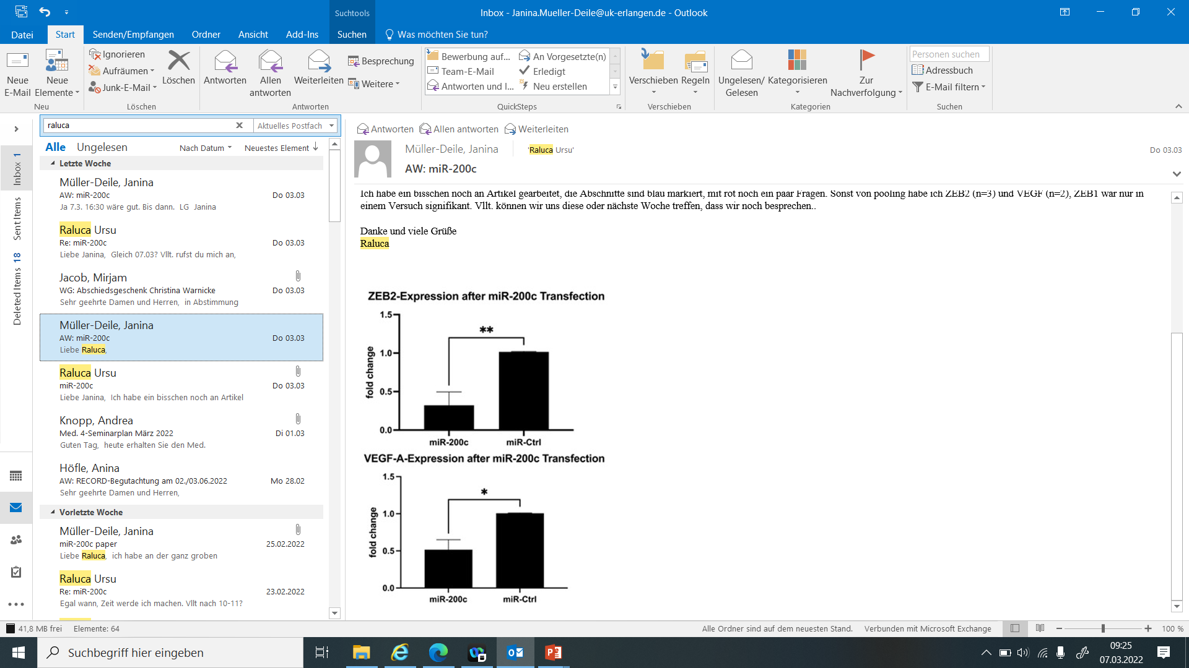
  - Figure 3 miR-200c overexpression downregulates ZEB and VEGF-A mRNA: qPCR for ZEB2 and VEGF-A in cultured human podocytes 48 h after a 4 h transfection with a miR-200c mimic compared to a miR control (miR-CTRL). Expression levels are given as fold change compared to miR-CTRL. *p < 0.1, **p<0.01 (n=3)

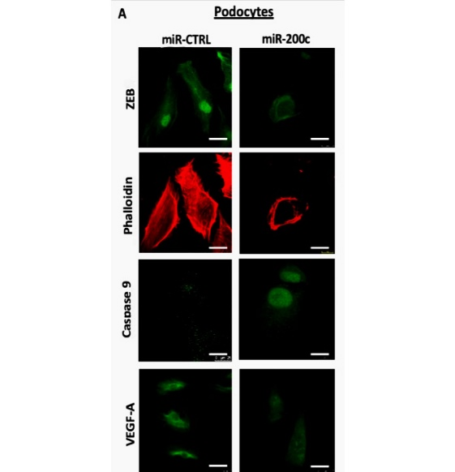
  - Figure 4 miR-200c overexpression downregulates ZEB and VEGF-A protein and induces cytoskeleton rearrangement and apoptosis in podocytes (A) and glomerular endothelial cells (B): Pictures show immunofluorescent staining with antibodies anti ZEB, anti Caspases and anti VEGF-A and immunofluorescent secondary antibodies as well as phalloidin staining to visualize intracellular actin cytoskeleton. Scale bar = 25 µm

Discussion
Increasing evidence of an intricate crosstalk between glomerular endothelial cells and podocytes through paracrine signalling is emerging as being important in physiological condition and disease. We could publish the transport mechanism of glomerular endothelial cell derived miRs to podocytes before (Müller-Deile et al JASN, 2021). Here, we extend our research on paracrine signaling of miRs by investigating communication of miR-200c between glomerular endothelial cells and podocytes.
MiR-200c was upregulated in proteinuric patients and in TGF-ß stressed glomerular endothelial cells. MiR-200c targets ZEBs, VEGF-A and apoptosis in cell culture.
We further could show that glomerular endothelial cell derived miR-200c upregulated in various glomerular diseases has both protective and harmful paracrine effects on podocytes. It decreases ZEB expression reducing EMT and maintaining an epithelial phenotype. On the other hand, miR-200c also increases apoptosis and decreases VEGF-A in podocytes leading to impaired autocrine VEGF signaling on podocytes and disrupted paracrine VEGF signaling on glomerular endothelial cell.
Our transgenic zebrafish model injected with miR-200c mimic showed a ‘proteinuric’ phenotype and alterations of the glomerular filtration barrier. Downregulation of nephrin and podocin, proteins of the slit diaphragm governing podocyte architecture and already present in zebrafish as early as 24 hours post fertilization, further adds to the data demonstrating the involvement of miR-200c in the pathogenesis of podocytopathies. Interestingly, we could observe an endotheliosis (loss of endothelial fenestrations) in the zebrafish injected with a miR-200c mimic.
Given the downregulation of VEGF-A through ‘overexpressed’ miR-200c in cell culture podocyte lineage and the allegedly paracrine detrimental effects on glomerular endothelial cells, we speculate that the endotheliosis seen in miR-200c injected zebrafish is explained through downregulation of podocyte VEGF-A.
Interfering with the miR-200c-ZEB / VEGF-A pathway at various levels could result in rescuing particular phenotypes, making the miR-200c promising targets in the pathology of podocytopathies with huge translational potential. By maintaining the epithelial identity of the cells we hypothesize that miR-200c might have also implications on promoting differentiation of podocytes.

References
- Filipowicz W, Bhattacharyya SN, Sonenberg N. Mechanisms of post-transcriptional regulation by microRNAs: are the answers in sight? Nat Rev Genet. 2008 Feb;9(2):102-14. doi: 10.1038/nrg2290. PMID: 18197166
- Long J et al. MicroRNA-29c is a signature microRNA under high glucose conditions that targets Sprouty homolog 1, and its in vivo knockdown prevents progression of diabetic nephropathy. J Biol Chem. 2011; 286:11837–11848

- Li Y, Kang YS, Dai C, Kiss LP, Wen X, Liu Y. Epithelial-to-mesenchymal transition is a potential pathway leading to podocyte dysfunction and proteinuria. Am J Pathol. 2008 Feb;172(2):299-308.
- Müller-Deile J, Dannenberg J, Liu P, Lorenzen J, Nyström J, Thum T, Schiffer M. Identification of cell and disease specific microRNAs in glomerular pathologies. J Cell Mol Med. 2019 Jun;23(6):3927-3939.
- Tufro A, Veron D et al. VEGF and Podocytes in diabetic nephropathy. Semin Nephrol. 2012 July ; 32(4): 385–393.

Marwin Groener, MD
The Role of Lrp1 in Podocytes
Department of Medicine 4, Universitätsklinikum Erlangen
Mentors: Prof. Mario Schiffer, Dr. Johannes Schödel


Marwin Groener

Introduction
Chronic kidney disease affects millions of patients worldwide. Currently, pharmacological treatment options are limited to blood pressure control and tubular transport inhibition. As many patients have concomitant proteinuria caused by disruption of the glomerular filtration barrier, there has been a focus on developing treatments that directly target glomerular cell types. Unfortunately, none have made it to clinical application yet. My research focuses on podocytes, the cell type that creates the slit-diaphragm. Podocyte effacement and loss is the hallmark of nephrotic syndrome, caused not only by the common diabetic nephropathy but also by rare renal diseases such as minimal change disease, FSGS, and membranous nephropathy. Podocytes are terminally differentiated and thus exhibit high endocytic activity to maintain their homeostasis in the glomerular microenvironment. Little is known about the cargo that is internalized by podocytes. In a recent study (Groener et al. Kidney360 2020), we used proteomics to identify the most abundant cargo proteins in podocytes. Interestingly, a high number of these bind to a large highly evolutionarily conserved receptor called low-density lipoprotein receptor-related protein 1 (LRP1). Since this receptor can be pharmacologically antagonized and stimulated and has not been investigated in podocytes, my goal was to determine its role in podocyte biology and assess its potential as a new pharmacological target in kidney disease.

Methods
We used immunoblotting and -fluorescence (IF) to determine quantity and localization of LRP1 in cultured human podocytes. siRNA knockdown (KD) of LRP1 was used to investigate potential functional importance in vitro. Immunoprecipitation (IP) was performed to assess interaction with integrin beta-1 (ITGB1). We used zebrafish morpholino knockdown models of LRP1 homologs to study the function of LRP1 in vivo. LRP1 expression in healthy and diseased human renal tissue was determined by immunohistochemistry.

Results
LRP1 is highly expressed in cultured human podocytes. Expression levels increase with longer differentiation times at 37°C (Fig. 1A). Expression was indirectly confirmed by two different siRNAs against LRP1, both of which resulted in marked reduction of LRP1 in transfected podocytes (Fig. 1B). Immunofluorescence showed localization of LRP1 to the cell membrane as well as early (Rab5) and late (Rab7) endosomes (Fig. 1C), in line with its role in endocytic trafficking.

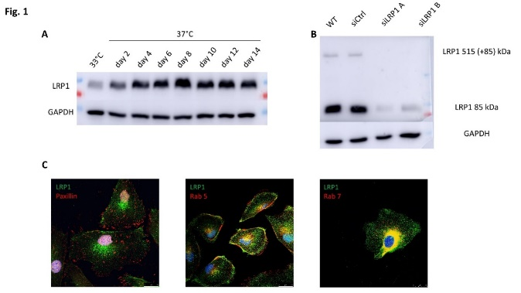
  - Figure 1A: LRP1 is highly expressed in cultured human podocytes. Expression levels increase with longer differentiation times at 37°C.
Figure 1B: Knockdown of LRP1 with two different siRNAs leads to decreased expression of both LRP1 domains.
  - Figure 1C: Immunofluorescence showed localization of LRP1 to the cell membrane as well as early (Rab5) and late (Rab7) endosomes.

Interestingly, siRNA knockdown of LRP1 resulted in a significant reduction of cell size and number, suggesting importance for podocyte adhesion (Fig. 2A). To investigate a possible interaction with the primary adhesion integrin in podocytes - ITGB1 - we performed endogenous IP of LRP1 and IF for both proteins. Indeed, ITGB1 co-precipitates and colocalizes with LRP1 (Fig. 2C). LRP1 colocalizes with inactive ITGB1 at the membrane and active ITGB1 in endosomal regions, confirming previously published findings from other cell types. Next, we used zebrafish morpholino knockdown models of both Lrp1 isoforms to determine the functional importance of Lrp1 in vivo. Lrp1 knockdown resulted in pronounced pericardial effusion and generalized edema, hinting at a renal phenotype (Fig 2B).
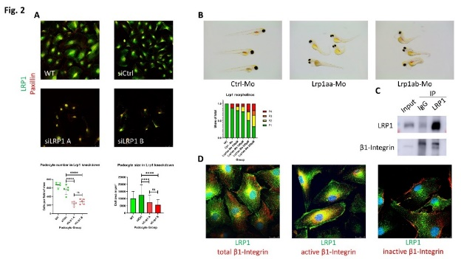
  - Figure 2A: siRNA knockdown of LRP1 results in a significant reduction of cell size and number.
  - Figure 2B: Lrp1 morpholino-knockdown results in pronounced pericardial effusion and generalized edema.
  - Figure 2C: Endogenous IP of LRP1 shows co-precipitation of ITGB1.
  - Figure 2D: LRP1 colocalizes with active ITGB1 in the perinuclear region and with inactive ITGB1 at the cell membrane.

Furthermore, we performed immunohistochemistry to assess LRP1 expression in healthy human kidneys and biopsy samples of different etiologies of nephrotic syndrome. Surprisingly, LRP1 has low baseline expression levels in healthy glomeruli. However, we saw an upregulation in all examined forms of glomerular disease (membranous nephropathy, minimal change disease, focal segmental glomerulosclerosis) (Fig. 3A). We used IF of LRP1 and nephrin to determine whether the observed signal originates from podocytes (Fig. 3B). Contrary to our in vitro findings, LRP1 did not localize to podocytes but rather to a different glomerular cell type, most likely mesangial cells. Podocytes in culture differ from their in vivo counterparts by their ability to proliferate which they lose during glomerular differentiation in the perinatal period. Thus, we performed additional IF staining on kidneys of newborn mice (P0) which exhibit all stages of glomerular development. LRP1 was expressed in podocytes (WT1) during the S-shaped body phase but was lost in more mature podocytes (Fig. 3C).

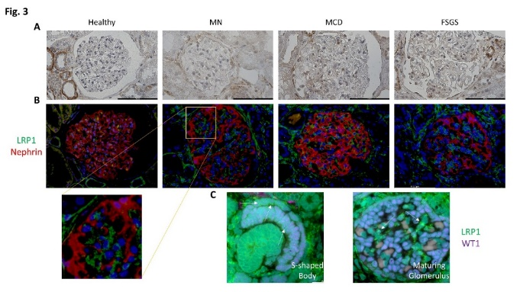
  - Figure 3A: Immunoperoxidase stainings show upregulation of LRP1 in all examined forms of glomerular disease (membranous nephropathy, minimal change disease, focal segmental glomerulosclerosis).
  - Figure 3B: IF of LRP1 and nephrin shows no colocalization.
  - Figure 3C: LRP1 is expressed in podocytes (WT1) during the S-shaped body phase but is lost in more mature podocytes.

Discussion
This study marks the first investigation of LRP1 in podocytes. It is highly expressed in cultured podocytes where it localizes to the membrane and endosomes, confirming the role of LRP1 in endocytic trafficking. Interestingly, siRNA-mediated knockdown of LRP1 leads to a severe phenotype in vitro resulting in podocyte shrinkage and detachment. This is likely due to involvement in adhesion regulation. ITBG1 is the primary adhesion integrin in podocytes. In vivo, it attaches the foot processes to the GBM. We found that LRP1 colocalizes and coimmunoprecipitates with ITGB1. This suggests that LRP1-mediated endocytosis of ITGB1, which has been observed in other cell types, is present in podocytes. Thus, a lack of LRP1 could lead to disruption of integrin recycling, resulting in detachment. To assess whether a lack of LRP1 leads to a nephrotic phenotype in vivo, we created morpholino-knockdown models of both isoforms of Lrp1 in zebrafish. Compared to control-morpholinos the Lrp1 global knockdown zebrafish larvae developed generalized edema and pericardial effusion in line with disruption of the glomerular filtration barrier, possibly due to podocyte effacement. This would resemble the phenotype observed in vitro.
Next, we assessed the expression of LRP1 in human and rodent renal tissue. While it is highly expressed in various tubular segments, it has surprisingly low baseline expression levels in glomeruli. This expression was increased in all tested biopsies of patients with podocytopathies. However, when co-stained with nephrin, it becomes clear that the glomerular LRP1 signal does not originate from podocytes but other glomerular cell types, likely mesangial cells. This is contrary to our findings in podocyte culture. Given cultured podocytes still have the ability to proliferate and usually do not express slit diaphragm proteins, they resemble developing podocytes more closely than mature ones. Therefore, we checked LRP1 expression in developing podocytes in perinatal mice. Confirming our hypothesis, we found a strong expression of LRP1 in podocyte precursors that was lost in their mature counterparts. This implies a role of LRP1 in podocyte development which is further corroborated by our zebrafish experiments. Due to the morpholino-injections in the 1-4 cell stage, all podocyte precursors lack Lrp1, likely leading to a disruption of podocyte maturation with subsequent podocyte effacement resulting in a nephrotic phenotype.
Taken together, we identified the large endocytic receptor LRP1 as a critical protein for cultured and developing podocytes. Further research is needed to evaluate its role in kidney function and its potential to act as a target for the pharmacological treatment of rare kidney diseases.

Christina Regensburger, MD
Establishment of a new FOrMe study center in Erlangen and a new transition program for pediatric nephrologic patients
Department of Paediatrics and Adolescent Medicine, Universitätsklinikum Erlangen
Mentors: Prof. Joachim Wölfle, Prof. Mario Schiffer

Christina Regensburger
Granted with the opportunity of working as a clinician scientist as part of the RECORD program, I focused on two translational research projects in rare kidney diseases and on my clinical training in pediatric nephrology in parallel. In the time dedicated to research, I engaged myself in the following two main projects.

Establishment of a new study center for the German Focal Segmental Glomerulosclerosis and Minimal Change Disease Registry (FOrMe)
The German Focal Segmental Glomerulosclerosis and Minimal Change Disease Registry “FOrMe” was founded by the Department of Internal Medicine and Pediatrics of the University Hospital of Cologne (UHC) and is sponsored by the DFG (Deutsche Forschungsgemeinschaft). It is a registry study with the goal of better understanding the causes of nephrotic syndrome, most often with the pathological finding of focal segmental glomerulosclerosis (FSGS) or minimal change disease (MCD). Both diseases are rare and still poorly understood. The aim of FOrMe is to acquire longitudinal patient data and biomaterials in order to better understand the pathogenesis of MCD and FSGS, to monitor disease progression and, in a translational approach, to find new therapeutic strategies. Until now, the only registry study center is located in Cologne but further centers are planned for extended data collection to gain a better understanding of the pathophysiology of FSGS and MCD leading to nephrotic syndrome.
During my research fellowship, I initiated the establishment of a new study center at the department of pediatric nephrology (head Dr. med. M. Galiano) of the Children´s University Hospital Erlangen. After receiving approval by the ethics committee of UHC, the study was approved by the local ethics committee in Erlangen. Currently, we identify eligible patients presenting at the outpatient pediatric nephrology department. The identified patients are checked for inclusion and exclusion criteria according to the study protocol and if eligible, the parents or legal guardian are educated about the study and informed consent is obtained for study inclusion of the patient. According to the study protocol, patients are pseudonymized and data are collected in an online registry including amongst others disease history, symptoms, laboratory findings, family history, and also genetic and histopathologic results, if available.
In addition, blood, urine, stool and tissue samples can be obtained during scheduled visits at the Department of Pediatric Nephrology and sent to the FOrMe center of Cologne where specimens can be preserved at a biobank at the pathology department in Cologne and genetic analyses can be performed at the department of genetics.
By implementing a new study center of FOrMe in Erlangen, we contribute to a growing database for FSGS and MCD aiming to facilitate further research on etiologies and therapies of these rare kidney diseases. Furthermore, the intended participation in the European Reference Network for Rare Kidney Diseases (ERKNet), a consortium of expert pediatric and adult nephrology centers in Europe, will help to improve translational research in rare pediatric kidney diseases.

Development of a new transition program for pediatric nephrologic patients
The treatment of chronically ill children is challenging in many aspects. It often affords a multimodal therapy including medical but also psychosocial aspects to facilitate proper development and thriving. Children and adolescents with renal diseases, in particular those having led to chronic renal failure, dialysis and renal transplantation, need this intense therapy over many years until they turn 18 years and certainly beyond. For many patients, this threshold very often implies a fundamental change and is in many aspects demanding. In order to facilitate this step into independency, to improve patient adherence and to decrease higher morbidity due to neglect of their own medical condition, especially after renal transplantation, we improved the transition of patients into adult medicine with a structured transition program for adolescent patients with renal diseases at the University Hospital Erlangen.
Existing structures between the different departments have been activated, medical staff responsible for the transition of patients in both the department of pediatric nephrology and internal medicine have been identified and interdisciplinary communication has been consolidated.
Inclusion criteria for the transition program were defined as following: patients with a kidney transplant, chronic kidney disease stage 3 or worse (GFR <60 ml/min/1,73m2), nephrotic syndrome, nephritis in systemic diseases, e.g. Lupus nephritis and nephrologic diseases with a foreseeable deterioration of kidney function, e.g. ADPKD. From the age of 16 years on, semiannual psychosocial transition talks are held with the patients by a psychologist trained in nephrology, addressing the subjects self-sufficiency, understanding of the disease, physical and mental well-being as well as educational and professional career and evaluating the patients’ transition readiness by means of a questionnaire. The new “Transitionswegweiser” guides the professionals through the course of the transition program while a “Transitionspass” summarizes medical history, genetics, study participation and contact data of physicians providing further outpatient treatment, among others. In case of transfer to the in-house department of nephrology, a common visit of the patient including a nephrologist is scheduled three months in advance in order to facilitate the process of transfer. The transfer itself occurs at the age of 18 years in the course of a joint visit at the nephrology department or by telephone in case of further treatment by an external specialist and is supported by a medical report. A patient questionnaire is prepared for evaluation of the program six months after transfer.
The establishment of this program was preceded by a thorough literature research and was followed by the development of a new standard of procedure (SOP), which is currently reviewed by the quality management department of the department of pediatrics at the University Hospital Erlangen.
By creating a standardized transition program for nephrological pediatric patients, we strengthen the cooperation between the department of pediatrics and the department of nephrology and improve the continuous medical care for young adults with rare kidney diseases. This could lead to new collaborative research projects in the future.

Dominik Kylies, MD
Development of a diagnostic tool to predict clinical outcome in adult patients with nephrotic syndrome using deep learning-based podometrics
III. Medical Clinic and Polyclinic Universitätsklinikum Hamburg-Eppendorf
Mentors: Prof. Victor Puelles, Prof. Tobias Huber


Dominik Kylies
Minimal change disease (MCD) and focal segmental glomerulosclerosis (FSGS) are part of a group of rare diseases defined as nephrotic syndrome (NS), which is characterized by high-degree proteinuria due to an impaired kidney filter. The diagnosis of NS is confirmed using renal biopsies and subsequent tissue analysis. Podocytes are specialized glomerular cells with a distinct ultrastructural morphology that play a central role in the kidney filtering mechanism.
Recently, molecular-morphological changes in podocyte parameters at both a cellular (podometrics)¹ and a nanoscale ultrastructural level, have been associated with renal outcomes. Despite these promising scientific advances, molecular morphological parameters are currently not being applied in the clinical routine due to multiple reasons, including (1) time constraints, hindering the manual quantification of podometrics, and (2) insufficient resolution of conventional LED-based widefield microscopes, hindering molecular ultrastructural tissue analysis.
In this project, we aim to bridge the gap between clinical pathology and deep molecular tissue analysis by combining deep learning-based image analysis and novel LED-based widefield microscopy-compatible super-resolution approaches, thereby paving the way for molecular precision medicine in nephrology.
Molecular podometrics using indirect immunofluorescence (IF) in human kidney biopsies from a patient cohort of MCD, FSGS, Immunoglobulin-A nephropathy (IgAN) and controls (nephrectomy due to renal cell carcinoma) are performed using a combined labelling with DACH1 and WT1 to unambiguosly identify podocyte nuclei and cytoplasm in combination with a nuclear marker (DAPI). After conventional LED-based widefield microscopy imaging of whole glomeruli, a portion of these images is manually annotated and used for training of a U-Net-based segmentation network to enable for automated podometrics (Fig 1a).
To enable nanoscale molecular profiling of kidney specimens using LED-based widefield microscopes, we developed a novel super-resolution pipeline called „expansion-enhanced super-resolution radial fluctuations “(ExSRRF)². First, molecular labeling using IF, followed by hydrogel embedding and tissue expansion is performed, after which a time-stack image acquisition and subsequent computational image enhancement using the SRRF-algorithm is performed (Fig 1d), resulting in the final super-resolution image.
For podometrics (Fig. 1a) 984 images of whole glomeruli from 87 patients with MCD, FSGS & IgAN, as well as from 13 controls were obtained. Of these images, a total of 115 glomeruli were annotated manually to mark the pixels belonging to glomeruli (Fig. 1b) and podocytes for network training. Dice scores indicate the overlap between manually annotated regions and the predictions of the network, for glomeruli (Fig. 1b & c) and podocytes (Fig. 1c).
ExSRRF in combination with conventional LED-based widefield microscopy (Fig. 1d) identifies foot process effacement human MCD (Fig. 1e). ExSRRF also resolves changes in SD in patients with MCD compared to patients with IgAN (Fig. 1f). Automated segmentation and ridge-detection allows the calculation of SD density, which was was significantly reduced in MCD compared to IgAN (Fig. 1g). Automated measurement of SD dilation, where colour-coding reflects local spacing at a pixel level with 0 being the shortest distance (blue) and 255 being the maximal distance (orange) reveals a significantly increased SD dilation in MCD compared to IgAN (Fig. 1h).
In summary, deep learning-based automated podometrics can aid efficient and precise quantification of podocyte parameters while being compatible with conventional LED-based widefield microscopes. ExSRRF identifies ultrastructural diagnostic features in human kidney biopsies, providing quantitative data that can be further analyzed using custom or open-source computational tools, without the need for specialized equipment. In the future, these pquantitative biological findings will be further validated by correlating these tissue-based parameters to clinical parameters with the ultimate goal to establish applicable diagnostic paths to enable individualized precision medicine in patients with nephrotic syndrome.

Literature:
1. Z. Zimmermann M, et al. Deep learning–based molecular morphometrics for kidney biopsies. JCI Insight. 2021;6(7).
2. Kylies D, et al. Expansion-enhanced super resolution radial fluctuations enable nanoscale molecular profiling of pathology specimens. Accepted 2023 Nature Nanotechnology.

  - 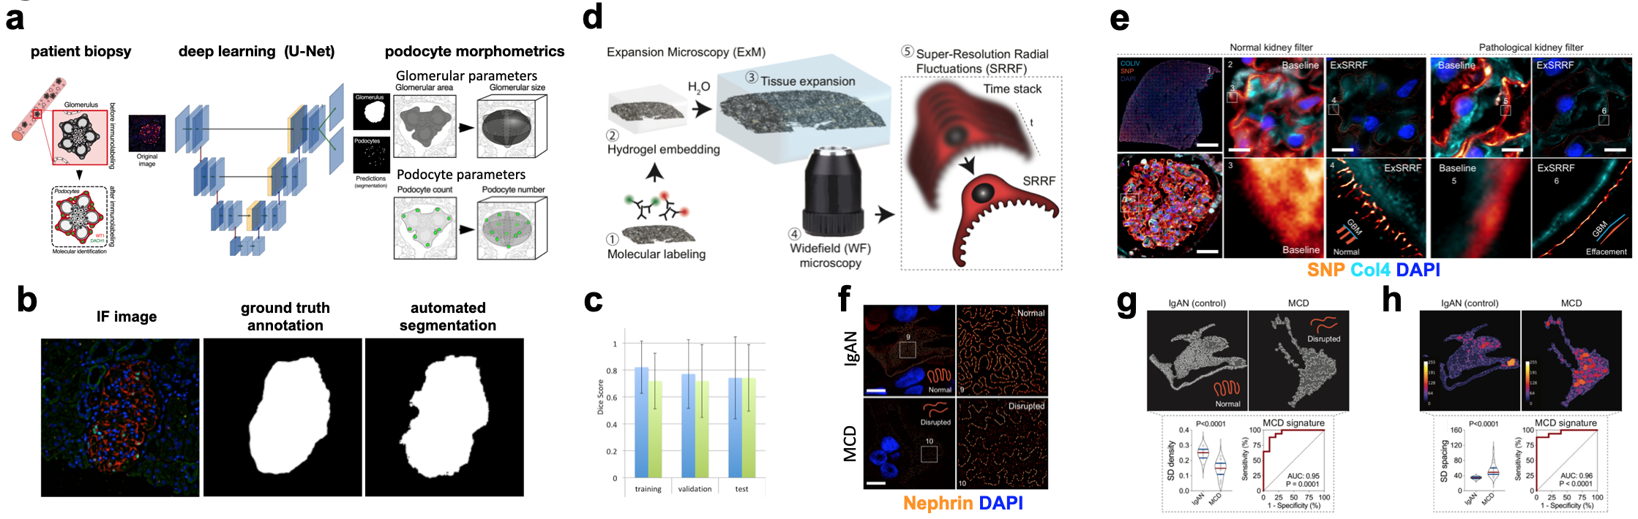
  - Figure 1. Schematic (a), examples of manually annotated and automatically segmented glomeruli (b) and podocytes for network training and respective dice scores (c). Schematic of ExSRRF (d). ExSRRF identifies foot process effacement (e) and changes in the SD in patients with MCD (f). Automated image analysis tools allow the calculation of SD density (g) and dilatation (h).

Scholars and Projects 2021

Tilman Jobst-Schwan, MD
The role of podocytic and tubular β-catenin in proteinuric kidney disease
Department of Medicine 4, Universitätsklinikum Erlangen
Mentors: Prof. Kerstin Amann, Prof. Mario Schiffer


Tilman Jobst-Schwan

Introduction
Podocytes are the epithelial cells of the glomerular kidney filter and their impairment leads to leakage of the filter with subsequent proteinuria, resulting in the disease nephrotic syndrome.
Wnt/β-catenin signaling is a highly conserved cellular signaling pathway, and is essential for regeneration and repair of tubular damage in acute kidney injury. In contrast, constant activation of Wnt/β-catenin signaling in chronic kidney disease (e.g. persistent proteinuria) leads to progression of the disease. However, the mechanism of tubular signaling is not well understood to date. Canonical Wnt/β-catenin signaling or endocytosis related regulation (LRP1, LRP2) are implicated. We have shown previously in podocytes that the location of β-catenin within the cell is important as well, with membranous β-catenin being protective but nuclear β-catenin causing cellular dedifferentiation and dysfunction of the glomerulus.
Thus, we aim to investigate two main questions:
1. How can we promote membranous location of β-catenin in podocytes by small molecules to reduce proteinuria?
2. What is the Wnt/β-catenin signaling mechanism in the tubular cells upon proteinuria?

Methods
We employed human immortalized podocytes for treatment with small molecules to promote membranous β-catenin localization and to reduce its nuclear localization. β-catenin localization was assessed by immunofluorescence in cell culture. Alteration of Wnt/β-catenin signaling was explored by qPCR analysis of downstream targets.
Proximal tubular cells (HK-2) were used to develop a novel proteinuria stress model for inducing Wnt/β-catenin signaling.
Kidneys of inducible proteinuric mouse models, podocin KO and the megalin/cubilin/podocin triple KO (mosaic expression of endocytosis complex megalin/cubilin) were immunostained for β-catenin and the Wnt-coreceptors LRP5 and LRP6. Additionally, alternative Wnt/β-catenin regulation mechanisms were primarily assessed by immunostainings of the endocytosis receptors LRP1 and LRP2 (megalin). β-catenin upregulation was confirmed by immunoblot of the corresponding kidney lysates.

Results
We established and optimized the HK-2 cell model to a reproducible proteinuria stress model showing upregulation of β-catenin upon proteinuria. Immunofluorescence of mouse kidneys showed strong expression of LRP1 and LRP6 in proximal tubular cells. Both Wnt/β-catenin regulators are downregulated in proximal tubular cells upon proteinuria, but both are upregulated in the interstitial cells. The interstitial upregulations are confirmed in kidney biopsies of human nephrotic patients.
In the podocyte cell culture model, initial experiments were used to establish dosage of casein-kinase 1 (CK-1) inhibitors to promote membranous β-catenin localization.
Conclusion and outlook
Initial podocytes treatment experiments confirm the potential increase of membranous β-catenin for several compounds. However, the regulation of Wnt/β-catenin downstream targets is compound dependent. Thus, further investigations are necessary.
Megalin KO cells did not show a different expression pattern of β-catenin in vivo, thus a megalin related alteration of Wnt/β-catenin signaling upon proteinuria seems unlikely. In contrast, LRP1 and LRP6 colocalize in the proximal tubule in healthy control mice, and are both upregulated in the interstitium of in proteinuric mouse kidneys, suggesting a modulation of Wnt/β-catenin signaling by both receptors. As LRP1 was already suggested to inhibit Wnt/β-catenin signaling by direct binding of LRP6, LRP1 may be a counteractor of LRP

Sebastian Uebel, MD
To model VHL-defective renal tubular lesions
Department of Medicine 4, Universitätsklinikum Erlangen
Mentors: Dr. Johannes Schödel, Prof. Michael Wiesener


Sebastian Uebel
Introduction
Von Hippel Lindau (VHL) disease is an inherited, autosomal dominant syndrome caused by germline mutations of the Von Hippel-Lindau tumor suppressor gene. These mutations predispose patients to the development of tumors in various tissues. We aim to model early renal lesions of this disease by isolating primary tubular cells from the urine of VHL patients and by inducing a second hit in the VHL gene using CRISPR-Cas9. Furthermore, we plan to deplete additional candidate ccRCC genes (PBRM1, BAP1 etc.) in these cells and use ATAC-seq, RNA-seq and ChIP-seq to discover epigenetic and transcriptional changes in these manipulated cells.
Methods
We isolated proximal tubular cells from the urine (huPTC) of patients with VHL disease. The tubular origin of these cells was determined using markers of the proximal (NCAD) and the distal (ECAD) tubule. We used huPTC from the proximal tubule to introduce a second hit in the VHL gene and other top ranked ccRCC mutated genes by CRISPR-Cas9 methodology. Editing efficiency was determined by qPCR analyses, Western Blot and Sanger sequencing.
We performed immune blotting and qPCR analyses to evaluate VHL knockout and downstream effects. Furthermore, in heterozygous and homozygous VHL knockout clones we conducted RNA-seq and ATAC-seq experiments to analyze whole epigenomic and transcriptomic changes.
Results
We isolated huPTC with a proximal signature from the urine of a VHL patient. Using CRISPR-Cas9 we achieved a complete knockout of VHL in two independent pools of these cells. Loss of VHL led to increased levels of HIF comparable to those in an established ccRCC cell line. We were also able to isolate single clones of these cells. Functionality of the HIF pathway in these cells was confirmed by a remarkable induction of expression of HIF target genes such as CA9 and EGLN3. In a second approach, we wanted to use huPTC to screen for consequences caused by mutations in prominent renal cancer genes Since some of these genes code for chromatin remodeling proteins, any disturbance in these pathways might impact on the repertoire and functionality of HIF signaling. Using CRISPR-Cas9, we were able to achieve effective knockout of several of these genes.
Conclusion and outlook
Our data indicates that complete VHL inactivation in proximal renal tubular cells results in stabilization of HIFs. Levels of HIF were comparable to that in the renal tumor cell line RCC4. Recent studies have highlighted that VHL loss is the truncal event in ccRCC evolution. We are now in an excellent position to model early transcriptomic and epigenetic changes in ccRCC precursor cells from patients at high risk of developing tumors. Analyses will also include 3D growth models and further manipulation of important cancer genes to identify mechanisms of tumor development that might be susceptible to therapy. The fact that the existence of these lesions precede detection of the tumor by decades opens a wide window of therapeutic opportunities.
The course of the disease is very heterogeneous and depends heavily on the underlying inherited VHL mutation. Currently, we aim to motivate patients to create a biobank of huPTC cells with different VHL mutations. This will help to better understand the underlying mechanisms of tumor evolution and provide first insight into personalized therapeutic interventions.

Alina Hilger, MD
CaRE for LUTO
Department of Paediatrics and Adolescent Medicine, Universitätsklinikum Erlangen
Mentors: Prof. Joachim Wölfle, Prof. Mario Schiffer


Alina Hilger
Congenital lower urinary tract obstruction (LUTO) generally manifests as urinary bladder outflow obstruction, which can represent an anatomical blockage or a functional obstruction. The most common anatomical cause of LUTO are posterior urethral valves, a lesion unique to males. Less common are anterior urethral valves, urethral atresia or congenital stenosis that can occur in either sex. LUTO of any kind has an estimated birth prevalence of three per 10.000 pregnancies (Malin et al. 2012). Severe forms cause oligohydramnios and are associated with dysplastic kidney malformations that may be secondary to LUTO (Dinneen et al. 1993). Indeed, LUTOs are among the leading causes for end-stage renal disease in children (Parkhouse 1990).
The RECORD-funded research systematically employed state of the art molecular genetic measures to identify genetic factors involved in monogenic and genetic complex LUTO phenotypes. For realization of the genetic work packages, the largest LUTO cohort worldwide (n=800) was studied consisting out of the from CaRE for LUTO cohort sampled by Dr. Hilger (400 patients) and 400 patients from Nijmegen cooperation partners (AGORA Study).
Using whole-exome sequencing (WES), in 20 LUTO trios of whom all patients besides LUTO also show anorectal malformation, identified 17 candidate genes. All of which were re-sequenced using molecular inversion probe assay (MIPs) in the CaRE for LUTO cohort. In several genes additional carrier of potentially damaging variants were identified. (Table 1)
.

Gene | WES / MIPs | LUTO phenotype | ARM phenotype
CERS5 | WES | megaureter + hypoplastic kidney left, Prune belly, VUR IV° right | posterior cloaca
CERS5 | WES | / | /
CSE1L | WES | urethralstenosis | analatresia with rekto-vesikal fistula
CSE1L | MIPs | / | rectourethral fistula
CSE1L | MIPs | / | rectourethral fistula, analatresia
CSE1L | MIPs | defect of urethra/bladder neck | rectalatresia
CSE1L | MIPs | PUV | /
CSE1L | MIPs | / | analatresia with perineal fistula
CSE1L | MIPs | PUV | /
FLNA | WES | urethral stricture | analatresia
FLNA | WES | / | rectourethral fistula
FLNA | MIPs | PUV, VUR | /
FLNA | MIPs | PUV, VUR | /
FZD7 | WES | urethralstenosis | analatresiea wit recto-vesikular fistula
FZD7 | MIPs | PUV | /
KIF23 | WES | PUV, prune belly | analatresia with recto-prostatic fistula
KIF23 | MIPs | / | Cloacal malformation with high analatresia
KIF23 | MIPs | LUTO | /
KIF23 | MIPs | PUV | /
NHSL2 | WES | urethralstenosis | analatresie with recto-vesical fistula
NHSL2 | MIPs | PUV | /
SCAPER | WES | PUV, prune belly | analatresia with recto-prostatic fistula
SCAPER | MIPs | / | analatresia with perineal fistula
SCAPER | MIPs | PUV | /
  - Table 1: Patients with LUTO or ARM Phenotype identified via whole exome sequencing (WES) or molecular inversion probe assay (MIPs) to carry potential disease causing variants in candidate genes

Prior to the funding period copy number variation (CNV) analysis of 155 LUTO individuals identified 3 novel CNVs > 50kb comprising 11 coding genes, of which three coding genes (FBLIM1, SLC16A12, SNCAIP) and the microRNA MIR107 have previously been shown to be expressed in the developing urinary tract of mouse embryos. Suggesting that CNVs play a role in the genetics underlying LUTO. This work was published in 2021 (Schierbaum et al. 2021).
Further, among the novel CNVs from the above mentioned study, we idnetified a small duplication of exon 7 of GPC5. Additional in a patient with anorectal malformation a small deletion comprising exon 8 of the same gene could be identified. Interestingly CNVs in this region already had been described in patients with urinary tract-, anorectal malformation and PUV. In total 14 patients are predescribed in the literature. (Boghossian et al. 2016, Kannu P et al. 2014). Hence, Morpholino knockdown of the zebrafish ortholog gpc5a was performed. This lead to a wide range of developmental phenotypes, predominantly tail abnormalities, pericardial effusion, small head and missing yolk extension (Figure 1 A-D). In transgenic line wt1b:eGFP we observed missing or severely malformed glomeruli (Figure 1 E-G), suggesting a critical role of gpc5a in general zebrafish embryonic development but also in development of the urinary tract. (Manuscript in preparation).

  - 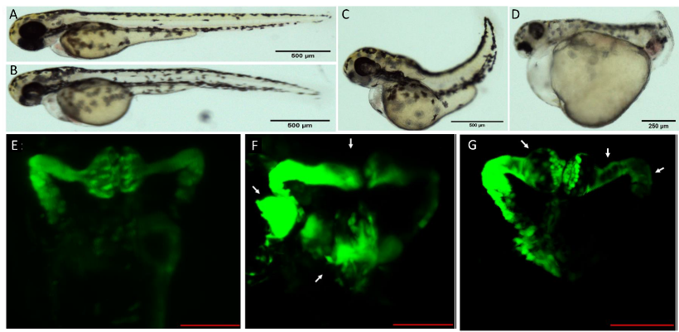
  - Figure 1 A-D Examples of various phenotypes of 3 dpf larvae: spine malformation (B,C), disrupted tail morphogenesis (D), pericardial effusions (D), unusual yolk extension formation (B-D), reduced head size (C-D), hampered development of facial structures (B-D), hemoperitoneum (D). A: Control Mo zfl. Scalebar (Sb)=500μm. B: Mo2 zfl Sb=500μm. C: Mo3 zfl Sb=500μm. D: Mo2 zfl Sb=250μm. E-G Representative renal phenotypes of 3 dpf zfl Tg(wt1b:eGFP). Sb = 100 μm. E: ControlMo zfl. normal glomerulus, neck segments, proximal tubules. F: Mo2 larva exhibiting a severe exterior phenotype (like zfl in D). Upper arrow indicates a (partially) missing or deformed glomerulus, left and lower arrow indicate malformed structures of pronephric duct. G: Mo2 larva exhibiting no exterior phenotype (like zfl in B). Arrows indicating dilation of the glomerulus, the neck segment and the proximal tubule.

To identify candidate genes or regulatory elements in genetically complex LUTO genome-wide association study (GWAS) in cooperation with the AGORA study from Nijmegen was used. No genomewide significant locus was identified. Nevertheless, 3 susceptibility loci with nominal significance were identified. (Figure 2) (van der Zanden et al. 2022)

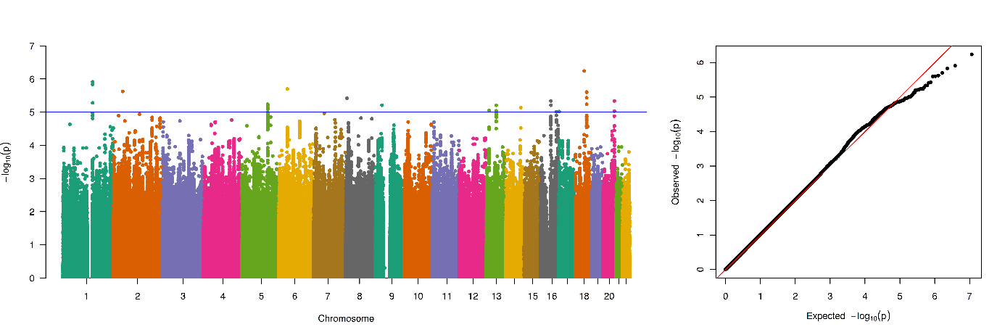
  - Figure 2: No genomewide significant locus was identified. Nevertheless, 3 susceptibility loci with nominal significance were identified

As recurrence risk and the existence of minor forms of obstructive uropathies within LUTO families play a major role in identification of disease causing genetic variation a clinical study systematically exanimating the parents of LUTO patients for the occurrence of minor forms of obstructive uropathies was performed. Examination included a clinical questionnaire as well as uroflowmetry and renal ultrasound. 31 families were included. At the time of inclusion, we identified five families in which the father had been previously diagnosed with infravesical obstruction. Of the remaining 26 families, nine agreed to participate in our study. Eight families with a child affected by PUV and one child affected by urethral stenosis. Here, we found two fathers and one mother with suspected mild forms of LUTO. Furthermore, in an additional family, family history revealed LUTO in the brother of the index patient. The identification of environmental and genetic risk factors and their cellular pathways will make an important contribution in the elucidation of the pathophysiology of LUTO and ultimately to an in depth understanding of the embryonic formation of the lower urinary tract. (manuscript in preparation)

References (references in bold highlight own publications):
- Birnbaum S, Ludwig KU, Reutter H, Herms S, Steffens M, Rubini M, Baluardo C, Ferrian M, Almeida de Assis N, Alblas MA, Barth S, Freudenberg J, Lauster C, Schmidt G, Scheer M, Braumann B, Bergé SJ, Reich RH, Schiefke F, Hemprich A, Pötzsch S, Steegers-Theunissen RP, Pötzsch B, Moebus S, Horsthemke B, Kramer FJ, Wienker TF, Mossey PA, Propping P, Cichon S, Hoffmann P, Knapp M, Nöthen MM, Mangold E. (2009). Key susceptibility locus for nonsyndromic cleft lip with or without cleft palate on chromosome 8q24. Nat Genet. 41,473-477.
- Boghossian NS, Sicko RJ, Kay DM, Rigler SL, Caggana M, Tsai MY, Yeung EH, Pankratz N, Cole BR, Druschel CM, Romitti PA, Browne ML, Fan R, Liu A, Brody LC, Mills JL. Rare copy number variants implicated in posterior urethral valves. Am J Med Genet A. 2016 Mar;170(3):622-33. doi: 10.1002/ajmg.a.37493.
- Cain JE, Islam E, Haxho F, Blake J, Rosenblum ND. (2011) GLI3 repressor controls functional development of the mouse ureter. J Clin Invest. 121:1199-1206
- Dinneen MD, Dhillon HK, Ward HC, Duffy PG, and Ransley, PG. (1993). Antenatal diagnosis of posterior urethral valves. Br J Urol. 72,364-369.
- Draaken M, Knapp M, Pennimpede T, Schmidt JM, Ebert AK, Rösch W, Stein R, Utsch B, Hirsch K, Boemers TM, Mangold E, Heilmann S, Ludwig KU, Jenetzky E, Zwink N, Moebus S, Herrmann BG, Mattheisen M, Nöthen MM, Ludwig M, Reutter H. (2015). Genome-wide association study and meta-analysis identify ISL1 as genome-wide significant susceptibility gene for bladder exstrophy. PLoS Genet. 11(3),e1005024.
- Green EK, Rees E, Walters JT, Smith KG, Forty L, Grozeva D, Moran JL, Sklar P, Ripke S, Chambert KD, Genovese G, McCarroll SA, Jones I, Jones L, Owen MJ, O'Donovan MC, Craddock N, Kirov G. (2016). Copy number variation in bipolar disorder. Mol Psychiatry. 21,89-93.
- Gupta M, and Brand M. 2013. Identification and expression analysis of zebrafish glypicans during embryonic development. PLoS One 8,e80824.
- Kannu P, Campos-Xavier AB, Hull D, Martinet D, Ballhausen D, Bonafé L. Post-axial polydactyly type A2, overgrowth and autistic traits associated with a chromosome 13q31.3 microduplication encompassing miR-17-92 and GPC5. Eur J Med Genet. 2013 Aug;56(8):452-7. doi: 10.1016/j.ejmg.2013.06.001. Epub 2013 Jun 20. Erratum in: Eur J Med Genet. 2014 Feb;57(2-3):123-4.
- Kolvenbach CM, Dworschak GC, Frese S, Japp AS, Schuster P, Wenzlitschke N, Yilmaz Ö, Lopes FM, Pryalukhin A, Schierbaum L, van der Zanden LFM, Kause F, Schneider R, Taranta-Janusz K, Szczepańska M, Pawlaczyk K, Newman WG, Beaman GM, Stuart HM, Cervellione RM, Feitz WFJ, van Rooij IALM, Schreuder MF, Steffens M, Weber S, Merz WM, Feldkötter M, Hoppe B, Thiele H, Altmüller J, Berg C, Kristiansen G, Ludwig M, Reutter H, Woolf AS, Hildebrandt F, Grote P, Zaniew M, Odermatt B, Hilger AC. (2019) Rare Variants in BNC2 are Implicated in Autosomal Dominant Congenital Lower Urinary Tract Obstruction. Am J Hum Genet, https://doi.org/10.1016/j.ajhg.2019.03.023
- Malin G, Tonks AM, Morris RK, Gardosi J, and Kilby, MD. (2012). Congenital lower urinary tract obstruction: a population-based epidemiological study. BJOG Int J Obstet Gynaecol. 119,1455-1464.
- Mangold E, Ludwig KU, Birnbaum S, Baluardo C, Ferrian M, Herms S, Reutter H, de Assis NA, Chawa TA, Mattheisen M, Steffens M, Barth S, Kluck N, Paul A, Becker J, Lauster C, Schmidt G, Braumann B, Scheer M, Reich RH, Hemprich A, Pötzsch S, Blaumeiser B, Moebus S, Krawczak M, Schreiber S, Meitinger T, Wichmann HE, Steegers-Theunissen RP, Kramer FJ, Cichon S, Propping P, Wienker TF, Knapp M, Rubini M, Mossey PA, Hoffmann P, Nöthen MM. (2010). Genome-wide association study identifies two susceptibility loci for nonsyndromic cleft lip with or without cleft palate. Nat Genet. 42,24-26.
- Parkhouse HF, and Woodhouse, CR. (1990). Long-term status of patients with posterior urethral valves. Urol Clin North Am. 17,373-378.
- Reutter H, Draaken M, Pennimpede T, Wittler L, Brockschmidt FF, Ebert AK, Bartels E, Rösch W, Boemers TM, Hirsch K, Schmiedeke E, Meesters C, Becker T, Stein R, Utsch B, Mangold E, Nordenskjöld A, Barker G, Kockum CC, Zwink N, Holmdahl G, Läckgren G, Jenetzky E, Feitz WF, Marcelis C, Wijers CH, Van Rooij IA, Gearhart JP, Herrmann BG, Ludwig M, Boyadjiev SA, Nöthen MM, Mattheisen M. (2014). Genome-wide association study and mouse expression data identify a highly conserved 32 kb intergenic region between WNT3 and WNT9b as possible susceptibility locus for isolated classic exstrophy of the bladder. Hum Mol Genet. 23,5536-5544.
- Schierbaum LM, Schneider S, Herms S, Sivalingam S, Fabian J, Reutter H, Weber S, Merz WM, Tkaczyk M, Miklaszewska M, Sikora P, Szmigielska A, Krzemien G, Zachwieja K, Szczepanska M, Taranta-Janusz K, Kroll P, Polok M, Zaniew M, Hilger AC. Genome-Wide Survey for Microdeletions or -Duplications in 155 Patients with Lower Urinary Tract Obstructions (LUTO). Genes (Basel). 2021 Sep 20;12(9):1449.
- Unger, S., Mainberger, A., Spitz, C., Bahr, A., Zeschnigk, C., Zabel, B., Superti-Furga, A., Morris-Rosendahl, D. J. Filamin A mutation is one cause of FG syndrome. (2007) Am. J. Med. Genet. 143A: 1876-1879
- van der Zanden LFM, Maj C, Borisov O, van Rooij IALM, Quaedackers JSLT, Steffens M, Schierbaum L, Schneider S, Waffenschmidt L, Kiemeney LALM, de Wall LLL, Heilmann S, Hofmann A, Gehlen J, Schumacher J, Szczepanska M, Taranta-Janusz K, Kroll P, Krzemien G, Szmigielska A, Schreuder MF, Weber S, Zaniew M, Roeleveld N, Reutter H, Feitz WFJ, Hilger AC. Genome-wide association study in patients with posterior urethral valves. Front Pediatr. 2022 Sep 27;10:988374

Florian Wopperer, MD
Molecular genetic causes of hereditary tubulointerstitial kidney diseases
Department of Medicine 4, Universitätsklinikum Erlangen
Mentors: Prof. Michael Wiesener, Prof. Francesca Pasutto


Florian Wopperer
A particularly difficult group of diseases to diagnose are the Autosomal Dominant Tubulointerstitial Kidney Diseases (ADTKD). To date, mutations in one of at least five genes have been identified (MUC1, UMOD, HNF1B, REN, SEC61A1), which lead to end-stage renal disease (ESRD) usually in mid adulthood. Families where no mutation can be found, yet the suspicion of ADTKD is upheld, are termed ADTKD-NOS (not otherwise specified) (Eckardt et al.; Kidney International 2015).

Results
We evaluated the ADTKD-registry of the group of Professor Wiesener (consisting of 45 families). 29 families were found to have a diagnostic mutation in one of the five previously mentioned genes. 16 families respectively, were left without molecular diagnosis and were the focus of the study. Furthermore, we established a novel diagnostic approach for genetic kidney diseases in general and for ADTKD, specifically. With a step-wise approach we first evaluated 560 renal candidate genes (here termed nephrome) in each family, resulting in the detection of the molecular genetic diagnosis in 9 of the 16 families. In the remaining 7 families we performed exome sequencing, where 27 promising novel renal candidate genes were identified. Extensive validation led to a prioritization of 5 genes (FOXO3, CDK5RAP3, WNT9b, WNT11, MMP3) (Wopperer et al.; Kidney International 2022).

Outlook
Within the scope of this new project, we plan to evaluate the pathogenicity of these novel candidate genes. We use primary cells as a model to study the effects of the identified genetic variants in affected individuals. Amongst these, we already obtained primary cells from the skin (fibroblasts) and from the urine (human urinary primary tubular cells; huPTC) of affected individuals. In addition, several other promising models (i.e. zebrafish / mouse model) will be considered after receiving data from the cell culture model. Furthermore, platforms like GeneMatcher (https://genematcher.org/) will be used for additional family recruitment.

Ingo Plagmann, MD
Bag3 as potential mechanoprotector in podocytes

Department of Internal Medicine II, Uniklinik Köln
Mentors: Dr. Matthias Hackl, Prof. Bernhard Schermer


Ingo Plagmann

Introduction:
Podocyte loss is a hallmark of glomerular diseases leading to glomerulosclerosis and progression of chronic kidney disease. Due to their exposed position on the outside of the glomerular filter, podocytes have to withstand extensive mechanical stress during the filtration process. We hypothesize that hyperfiltration and hyperperfusion in disease states cause podocyte detachment by overwhelming the mechanoprotective capacity, causing a vicious cycle of mounting strain on the remaining podocytes. However, the exact mechanisms of mechanoprotection in podocytes remain elusive.
Bag3 is an important mechanoprotector in many mechanical strained tissues. By inducing chaperone-assisted autophagy (CASA) it maintains the proteostasis of, e.g., Filamin (Klimek et al., 2017; Ulbricht and Höhfeld, 2013) and Synaptopodin (Ji et al., 2019) – proteins indispensable for podocyte biology. Additionally, Bag3 insufficiency renders susceptibility to diabetic nephropathy in a mouse model (Lim et al., 2014). These findings point toward Bag3 as a candidate for mechanical stress protection in podocytes.

Preliminary work
Recent evidence suggested that the co-chaperone Bag3 together with chaperone-assisted selective autophagy (CASA) may play an important role in mechanoprotection in podocytes (Fig. 1).

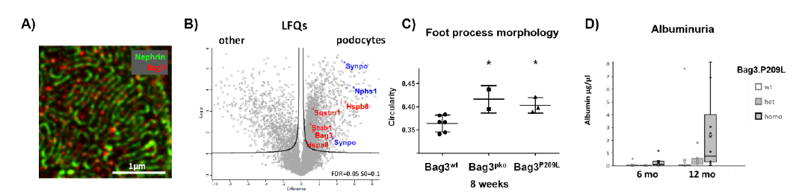
  - Figure 1: Bag3 localization and function in mouse podocytes. A) Bag3 staining is localized to the slit diaphragm protein nephrin in ultra-resolution STED imaging B) Bag3, as well as the CASA machinery, are expressed and enriched in isolated murine podocytes as compared to non-podocytes. C) Early changes at the slit diaphragm occur in both podocyte-specific Bag3 knock-out mice (Bag3pko) as well as podocyte-specific Bag3.P209L overexpression mouse line (Bag3P209L). D) Podocyte-specific expression of Bag3 P209L causes albuminuria in aged mice.

Immunofluorescence stainings localized Bag3 to podocytes and demonstrated abundant and clustered expression. STED-microscopy revealed a localization at or close to the slit diaphragm (Fig. 1A). Furthermore, Bag3 and the CASA complex components hsc70 (Hspa8), the small heat shock protein Hspb8, the ubiquitin-ligase Chip (Stub1), and the Ubiquitin-adapter Sqstm1 were enriched in primary mouse podocytes in label-free quantitative proteomic analyses (Fig. 1B). Preliminary data of the podocyte-specific knock-out of the Bag3 gene in mice (Bag3 pko) did not demonstrate an early phenotype but showed altered foot process morphology early in adulthood consistent with incipient damage (Fig. 1C). These results point toward an expected late onset phenotype in the Bag3 pko mouseline. Consistently, podocyte specific Bag3P209L transgenic mice showed the same foot process morphology alteration early in adulthood (Fig. 1C) and late-onset proteinuria at the age of 1 year indicating an aging- associated phenotype (Fig. 1D).

Results
To understand the role of Bag3 and CASA in podocytes, we analyzed the interactome of Bag3 in these cells. We found Bag3 interactions with essential actin cytoskeleton regulators (Rho A, Arpc2, and Dynamin2). Mechanical stress (0,5 Hz 17,5%) by the Flexcell cell stretch system induced a subtle short-term Bag3 turnover in parallel to autophagy stimulation and an pERK mechanosignal at 2 hours. However, at 24 hours of stretch, Bag3 levels were induced, and expression of extracellular matrix proteins such as collagen Type IV was reduced (Fig. 3B). In contrast, the actin cytoskeleton regulators APRC5L and ARPC5 were increased by mechanical stress.

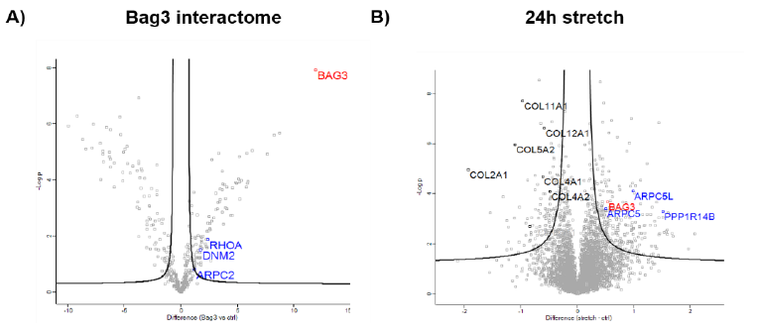
  - Figure 2 Podocyte Bag3 interactome and protein regulation under mechanical stress. A) The Bag3 interactome contains essential actin cytoskeleton regulators in podocytes; B) In turn mechanical stress induces Bag3 levels as well as actin regulators and PPP1R14B, a regulator of Proteinphosphatase 1 that is also regulating myosin contractility. Bag3ko Bag3wt Bag3ko Bag3wt Stretch Control Bag3wt stretch control Bag3 ko Control Stretch Control Stretch difference (log 2) difference (log 2) difference (log 2) difference (log 2)
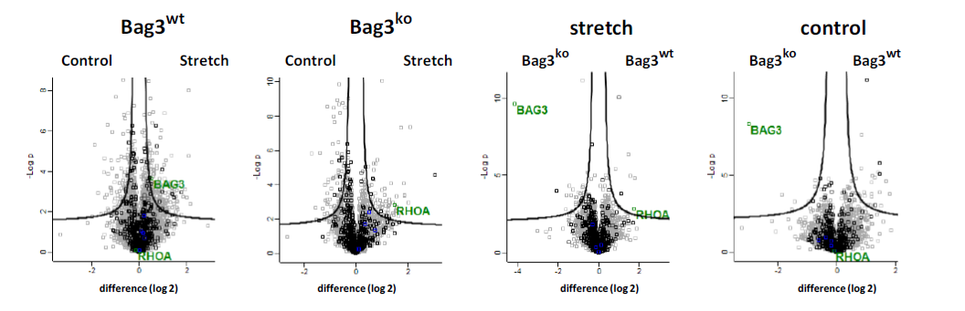Figure 3 The effect of Bag3-knockout in stretched human podocytes MS-analysis of stretched and unstretched human podocytes with different Bag3 status (wildtype / knock-out). Comparing the different conditions RhoA levels are increased only in stretched Bag3-knockout podocytes highlighting a potential role of Bag3 in mechanodependent RhoA degradation (black: uniprot keyword cytoskeleton).

Based on the previous results, we analyzed the effect of Bag3 deficiency in the mechanoresponse of podocytes. We used Cas9 technology employing two different sgRNAs to target exon2 of Bag3. We screened knock-out clones by Western Blot and validated candidate clones by sequencing and targeted proteomics to exclude a truncated protein and to prove a complete knock-out of the entire Bag3 protein. Next, we applied the same stretch parameters as used previously and analyzed changes in the overall proteome after 24 hours of stretch. Differential analysis revealed an increase of Rho A levels only in stretched Bag3 knock-out podocytes suggesting a potential role of Bag3 in stressed induced Rho A turnover. ABAlbumin μg/μl a6 mo12 mo18mo2,5mo 6 mo10 moAlbumin μg/μlaBag3.P209Lwthemihomo

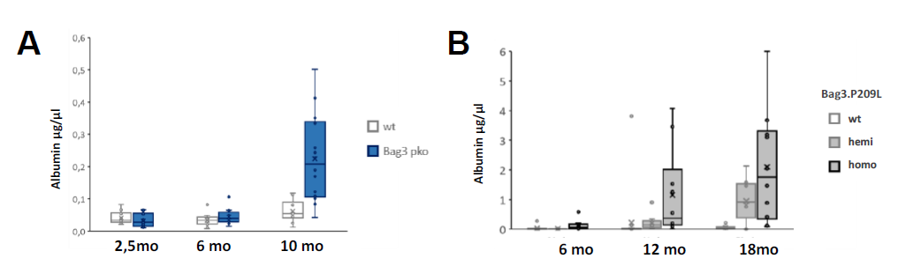Figure 4 Two different models of Bag3 insufficiency in podocytes result in late-onset proteinuria around 10-12 months of age: a conditional Bag3 knock-out in podocytes (Bag3pko) and podocyte-specific expression of the myopathy causing Bag3 mutation Bag3.P209L. A) Quantification of albumin in the urine shows the development of proteinuria with progressing age in Bag3pko animals. B) Podocyte Bag3.P209L transgenic animals display a gene dose-dependent effect on proteinuria development with progressing age.

In parallel, we conducted further in vivo analyses of the function of Bag3 in podocytes by evaluating the effect of podocyte-specific Bag3 deficiency in the two above-mentioned different mouse models. In line with the early changes at the slit diaphragm, the conditional podocyte Bag3 knock-out mouse line Bag3pko also showed progressing proteinuria with age (Fig 4 A). Independently, the ongoing analysis of the conditional Bag3.P209L overexpression in podocytes showed a gene-dose-dependent increase of proteinuria with progressing age of the mice (Fig 4 B).

Research Plan
We will continue and deepen the differential analysis to identify further proteins being differentially regulated by stretch in Bag3 ko condition. Next, we will analyze the stretched Bag3 ko podocytes by mRNA-seq to differentiate translational changes from changes in protein turnover to prove our hypothesis of a Bag3 dependent stress-induced Rho A turnover (samples already generated). Further studies to characterize protein turnover will be done by using the autophagy inhibitors chloroquine and Bafilomycin A.
To corroborate our data found in stretched podocytes we in parallel performed a second experiment of mechanical stress response in podocytes growing wildtype and Bag3 deficient podocytes on matrices of different stiffness. The samples have already been measured by proteomics, and analysis of the data set is currently ongoing.
Concerning the in vivo experiments, we will continue evaluating the development of proteinuria with increasing age. Regarding the lower levels of proteinuria in Bag3pko, a comparison with homozygous as well as hemizygous Bag3P209L at different ages will be of interest. In addition, we will analyze Rho A levels in vivo in both mouse models of Bag3 deficiency by using immunofluorescence / immunohistochemistry.
Functional analysis of Bag3 function in podocytes is currently being prepared by using our Bag3 deficient podocytes to compare re-orientation rate and velocity when applying uniaxial strain (in contrast to the biaxial strain that we used so far). This work will be done in collaboration with Prof. Merkel / Bernd Hoffmann from the Forschungszentrum Jülich, who established this method. As a second step, functional inhibition of Rho A will be evaluated in this model and Bag3 deficient podocytes. If these results show promising results, as a next step, force measurements of the Bag3 deficient podocytes in collaboration with Prof. MC Gather (Cologne) are planned.

References
- Ji, C., Tang, M., Zeidler, C., Hohfeld, J., and Johnson, G.V. (2019). BAG3 and SYNPO (synaptopodin) facilitate phospho-MAPT/Tau degradation via autophagy in neuronal processes. Autophagy 15, 1199-1213.
- Klimek, C., Kathage, B., Wordehoff, J., and Hohfeld, J. (2017). BAG3-mediated proteostasis at a glance. Journal of cell science.
- Lim, J.H., Youn, D.-Y., Yoo, H.J., Yoon, H.H., Kim, M.Y., Chung, S., Kim, Y.-S., Chang, Y.S., Park, C.W., and Lee, J.-H. (2014). Aggravation of diabetic nephropathy in BCL-2 interacting cell death suppressor (BIS)-haploinsufficient mice together with impaired induction of superoxide dismutase (SOD) activity. Diabetologia 57, 214-223.
- Ulbricht, A., and Höhfeld, J. (2013). Tension-induced autophagy. Autophagy 9, 920-922.

Sydney Gies, MD
Single cell-based transcriptional profiling of primary and primary recurring FSGS biopsies
III. Medical Clinic and Polyclinic Universitätsklinikum Hamburg-Eppendorf
Mentors: Prof. Tobias Huber, Dr. Maja Lindenmeyer

Sydney Gies
Focal segmental glomerulosclerosis (FSGS) represents a major glomerular cause of end stage renal disease. Its definition is derived from its histopathological description of lesions with diverse etiologies that are linked by an initial injury and subsequent depletion of glomerular epithelial cells, podocytes.
Primary FSGS (pFSGS) is characterized by circulating immune factor (s), responsiveness to immunosuppressive therapy (albeit highly variable) and a high risk of relatively early and often devastating recurrence after kidney transplantation (Ponticelli, 2010, Francis et al., 2016, Sethi et al., 2015, Alasfar et al., 2018, Uffing et al., 2020). In pFSGS, global foot process effacement accompanied with glomerular scaring usually leads to nephrotic-range proteinuria (Hommos et al., 2017). Despite considerable scientific efforts, the causative permeability factor(s) of pFSGS as well as its / their origin remain elusive.
Decoding podocyte signaling pathways in response to immune interactions will offer unprecedented opportunities to precisely stratify, target or prevent primary and recurring FSGS.
Single cell RNA-sequencing of the kidney allows us to analyse the expression of thousands of genes in thousands of individual cells (Malone et al., 2018) and enables a molecular characterization of this complex heterogenous tissue including infiltrating and resident immune cells (Park et al., Science 2018, Wu et al., JASN 2018, Kramann et al., Nature 2021).
In this study we aim to define the single cell-based transcriptomic landscape of kidney biopsies taken from patient cohorts of primary FSGS and rapidly recurring (within 48h) primary FSGS after transplantation to receive new insight into the early molecular disease pathways of pFSGS in epithelial and endothelial cells.
To achieve this goal the following strategy will be employed:
I) Development of a robust single cell/nuclei dissociation protocol of cryopreserved kidney biopsies for the emerging Hamburg and European Renal Omics (HERO) biobank.
The HERO biobank will provide the opportunity for the collection of kidney biopsies even from rare kidney diseases like FSGS through its multiple collaboration partners.
The obtained kidney biopsies will be stored in a cryopreservation solution at – 80 °C. A cryopreservation solution is indispensable for optimal shipment and storage conditions of the valuable kidney biopsies to prevent tissue and biomolecule degradation but often impedes tissue dissociation techniques by leading to varying extends of tissue fixation (Fig. 1).

Figure 1: Workflow for single nucleus/cell RNA sequencing kidney biopsies employing a cryopreservation step for long-term storage and a single cell platform (10X Genomics or ICELL8, Takara Bio).

In this study we have developed a robust single nuclei dissociation protocol for kidney biopsies stored in a cryopreservation solution. For the establishment of the protocol we used biopsies from pig kidneys, which resemble human kidney in their anatomic and histological architecture.
We examined three commercially-available (RNA stabilizing) cryopreservation media for the single nuclei protocol (RNAlater, CellCover, VivoPhix).
RNAlater is a cryopreservation solution already established for long term RNA protection and did not influence the single nuclei dissociation (Fig.2)

Figure 2: Light microscope: Single nucleus suspension of a pig kidney biopsy stored in RNAlater.

CellCover also allowed a single nuclei dissociation. VivoPhix preserved samples could not be dissociated with the same purity and accuracy as tissue preserved in the other tested solution.
We adapted a single cell dissociation protocol, that is already published for fresh mouse kidneys (Adam et al., 2017) for cryopreserved pig kidney (Fig.3).

Figure 3: Light microscope: Single cell suspension of a pig kidney biopsy stored in Cryostor.

We tested two commercially-available cryopreservation media for the single cell dissociation protocol (Cryostor, VivoPhix). Cryostor is already established for single cell protocols (Arazi et al., 2019) and is also suitable for our emerging single cell protocol. VivoPhix preserved tissue again did not yield satisfactory results.
II) Comparison of the single cell and the single nucleus sequencing protocol with two different droplet-based high throughput single cell platforms.
I will perform single cell and single nucleus RNA-sequencing of cryopreserved kidney biopsies with two commercially-available high throughput single cell systems (Chromium, 10X Genomics and ICELL8, Takara Bio) to examine library efficiency in terms of capture rate, cell-assignable reads and mRNA detection sensitivity. Especially the capture rate, or the fraction of cells recovered in the data relative to input as well as the bias produced by the tissue dissociating protocol is critical for the detection of rare (immune) cells.
We have compared the single nuclei protocol with 10X Genomics and the ICELL8 platform. Pig kidney biopsies stored in RNAlater were dissociated into a single nucleus suspension and analyzed either with the 10X Genomics or the ICELL8 platform. The possible number of captured nuclei is higher with 10X Genomics as with ICELL8 (in our experiments we received with an expected recovery rate of
6000 nuclei/cells for 10X Genomics 8070 nuclei and 1692 nuclei with ICELL8). After data processing and filtering, that includes i.e. filtering out nuclei/cells with mitochondrial content > 2% and nuclei/cells with < 200 genes and > 7000 genes for ICELL8/>5000 genes for 10X Genomics, 1192 nuclei for ICELL8 and 5772 nuclei for 10X Genomics met the quality criteria for further analysis.
The data processing showed that the sequencing depth was slightly higher with ICELL8 (3594 genes/nucleus) compared with 10X Genomics (3196 genes/nucleus). In comparison to ICELL8 (Fig. 4A), 10X Genomics generated more clusters that were assignable to a specific population of resident or immigrated cells of the kidney (Fig. 4B).

A

B
  - Figure 4: Single nucleus sequencing of a pig kidney biopsy stored in RNAlater.
  - A Single nucleus data set generated with ICELL8. The UMAP shows 9 cluster, 8 were assignable to a specific population of cells of the kidney.
  - B Single nucleus data set generated with 10X Genomics. The UMAP shows 18 cluster, 17 were assignable to a specific population of resident or immigrated cells of the kidney.

A further step will be the comparison of the single cell and the single nucleus protocol. Additionally, we will compare full length transcriptome analysis with 3’ expression libraries of ICELL8.
III) Analysis of transcriptional changes in renal epithelial, endothelial and immune cells from pFSGS patients.
I) and II) provides us with the technical background for optimal molecular characterization of kidney biopsies. I will perform single cell and/or single nuclei RNA-sequencing of kidney biopsies taken from patients with primary and rapidly recurring primary FSGS. Transcriptome profiles from kidney biopsies of both cohorts will be compared with each other and with already existing single cell transcriptome datasets from tumor nephrectomies.
Recently we dissociated the first biopsy from a patient with early recurrent FSGS into single nuclei, followed by the 10X Genomics protocol. The results of the sequencing are still pending.
The detection of transcriptional changes induced by the proposed circulating factors signaling pathways in epithelial and endothelial cells of patients with early recurring primary FSGS as well as the profile of renal immune cells will directly point towards potential
candidate factors and contribute to the discovery of a target directed therapy in patients with primary and recurrent FSGS.
Ethiknummer der HERO-Biobank: PV6037

References
- Adam M, Potter AS and Potter SS (2017) Psychrophilic proteases dramatically reduce single-cell RNA-seq artifacts: a molecular atlas of kidney development. Development 144, 3625-3632.
https://doi:10.1242/dev.151142
- Alasfar S, Matar D, Montgomery RA, et al (2018) Rituximab and Therapeutic Plasma Exchange in Recurrent
Focal Segmental Glomerulosclerosis Post Kidney Transplantation. Transplantation 102(3):e115-e120.
https://doi:10.1097/TP.0000000000002008
- Arazi A, Rao DA, Berthier CC et al (2019) The immune cell landscape in kidneys of patients with lupus nephritis. Nat Immunol. 20(7): 902–914.
https://doi:10.1038/s41590-019-0398-x
- De Vriese AS, Sethi S, Nath KA et al (2018) Differentiating primary, genetic, and secondary FSGS in adults: A clinicopathologic approach. J Am Soc Nephrol 29: 759–774.
https://doi.org/10.1681/ASN.2017090958
- Francis A, Trnka P, McTaggart SJ (2016) Long-Term Outcome of Kidney Transplantation in Recipients with Focal Segmental Glomerulosclerosis. Clin J Am Soc Nephro 11:2041–2046.
https://doi.org/10.2215/cjn.03060316
- Hommos MS, De Vriese AS, Alexander MP et al (2017) The incidence of primary vs secondary focal segmental glomerulosclerosis: A clinicopathologic study. Mayo Clin Proc 92: 1772–1781.
https://doi.org/10.1016/j.mayocp.2017.09.011
- Kopp JB, Anders H-J, Susztak K, et al (2020) Podocytopathies. Nat Rev Dis Primers 6:68.
https://doi.org/10.1038/s41572-020-0196-7
- Malone AF, Wu H, Humphreys BD (2018) Bringing Renal Biopsy Interpretation into the Molecular Age with Single Cell RNA-Sequencing. Semin Nephrol. 2018 January; 38(1): 31–39.
https://doi:10.1016/j.semnephrol.2017.09.005.
- Park J, Shrestha J, Qiu C et al (2018) Single-cell transcriptomics of the mouse kidney reveals potential cellular targets of kidney disease. Science 360(6390):758-763.
https://doi: 10.1126/science.aar2131
- Ponticelli C (2010). Recurrence of Focal Segmental Glomerular Sclerosis (FSGS) after renal Transplantation. Nephrol Dial Transplant 25:25–31.
- https:// doi: 10.1093/ndt/gfp538.
- Sethi S, Zand L, Nasr SH, Glassock RJ, Fervenza FC (2014) Focal and segmental glomerulosclerosis: Clinical and kidney biopsy correlations. Clin Kidney J 7(6):531-7.
https://doi: 10.1093/ckj/sfu100.
- Sethi S, Glassock RJ, Fervenza FC (2015) Focal segmental glomerulosclerosis: towards a better understanding for the practicing nephrologist. Nephrol Dial Transplant. 30(3): 375-384.
https://doi: 10.1093/ndt/gfu035
- Uffing A, Perez-Saez MJ, Mazzali M et al (2020) Recurrence of FSGS after Kidney Transplantation in Adults. Clin J Am Soc Nephrol. 15(2): 247–256.
https://doi.org/10.2215/CJN.08970719
- Wu H, Malone AF, Donnelly EL et al (2018) Single-Cell Transcriptomics of a Human Kidney Allograft Biopsy Specimen Defines a Diverse Inflammatory Response. J Am Soc Nephrol 29: 2069–2080.
https://doi.org/10.1681/ASN.2018020125

Jan Schaefer, MD
Colonization status of pediatric Patients with Oxalobacter formigenes suffering from Crohn’s disease and enteric hyperoxaluria
Department of Paediatrics and Adolescent Medicine, Universitätsklinikum Erlangen
Mentors: Prof. Joachim Wölfle, Prof. Mario Schiffer


Jan Schaefer

Enteric hyperoxaluria and establishment of DNA extraction from stool, PCR detection of Oxalobacter formigenes and microbiome analysis in pediatric patients with Crohn’s disease
Besides recurrent infections, malnutrition and failure to thrive, pediatric patients with Crohn’s disease suffer from multiple comorbidities. These patients can develop affections of the kidneys, one of these is enteric hyperoxaluria which represents a rare kidney disease. Because of an unphysiologically high intestinal uptake of oxalate, it can result in nephrolithiasis, nephrocalcinosis or even renal insufficiency. Of importance in the pathophysiological model seems to be the absence of Oxalobacter formigenes, an obligate anaerobic bacterium which utilizes oxalate for its metabolic needs. There are only few data concerning the incidence of enteric hyperoxaluria in pediatric patients with Crohn’s disease. Therefore, I aimed to investigate the incidence of enteric hyperoxaluria an its clinical consequences in pediatric patients with Crohn’s disease.
The goal of the granted time was to plan and initiate the study as well as establishing of laboratory techniques. As solely recruitment of patients was expected to take some time, I was granted for a volume of 50% in a one-year period, which allowed me to cover more than wider time span.
In the first month, planning of the study, writing and correction of ethics took place. In the same period, I was able to elaborate reference groups out of a newly created patient database of all pediatric nephrological patients in our clinic over the last ~8 years. After positive ethic vote was achieved, I was able to recruit the first patients. Parallel working on the study and networking in the RECORD group in the whole granted time was very enriching. Due to the granted scholarship, I was able to connect to other researches in the RECORD and university network. By doing so, I could get relevant information on how to isolate DNA for PCR detection of Oxalobacter formigenes out of stool and plan microbiome investigations.
Patient visits in the study were planned every month within a period of 6 months, therefore 7 visits were performed. Patients were advised to carry out 24-hour urine collections for oxalate excretion every second visit. Stool collection for PCR detection of Oxalobacter formigenes and blood examination for oxalate metabolism was made every visit. Microbiome investigations of the gut is planned for the beginning and the end of the study.
In the granted period I could establish the extraction of bacterial DNA from stool by a stool extraction kit. As no commercial PCR detection of Oxalobacter formigenes is present, we established a PCR based detection (touch down method) of the oxalyl-CoA-decarboxylase gene which is only present in O. formigenes and a 16SrRNA detection as a housekeeping gene.
At the end of the granted period, 10 patients were completely enrolled in the study and recruitment goes on until at least 15 patients have fulfilled the whole study time. All stool samples have been processed and DNA extraction was performed.
In the next step, DNA probes will be tested for presence or absence of O. formigenes and microbiome analysis will be done in collaboration with the core unit for microbiome analysis of the Friedrich-Alexander University Erlangen.

Enteric hyperoxaluria as a rare kidney disease in pediatric short bowel patients
Another study was performed in parallel in the granted time in collaboration with the department of pediatric gastroenterology. The survival of pediatric patients with short bowel syndrome has improved in recent years. These patients can develop enteric hyperoxaluria, too, but it has been hardly addressed so far. We assessed the prevalence of hyperoxaluria and its pathogenic consequences in a retrospective single centre study over the last 12 years.
We conducted an internal database research for all pediatric patients suffering from short bowel syndrome treated from 2010-2022 in the department of pediatric gastroenterology as well as the pediatric nephrology and dialysis unit. Out of 56 patients identified, urinary oxalate excretion was available in 24 patients. Among these two were anuric receiving dialysis treatment and displayed enteric hyperoxaluria due to small bowel resection. These 26 patients were analysed for etiology of short bowel syndrome, renal excretion of oxalate (24/26), eGFR and urinary stones or nephrocalcinosis correlated to remaining short bowel length and stool frequency.
Hyperoxaluria was detected in 14/26 patients (54%). Nephrocalcinosis was present in four patients, in three of them hyperoxaluria could be proven (21% of all hyperoxaluric patients), one hyperoxaluric patient had nephrolithiasis (7%). In one patient hyperoxaluria lead to end stage renal disease. 80% of patients with volvulus developed enteric hyperoxaluria which was not described before. None of the investigated factors had an effect on oxalate excretion. Data is in review process at the time of scholarship report writing.

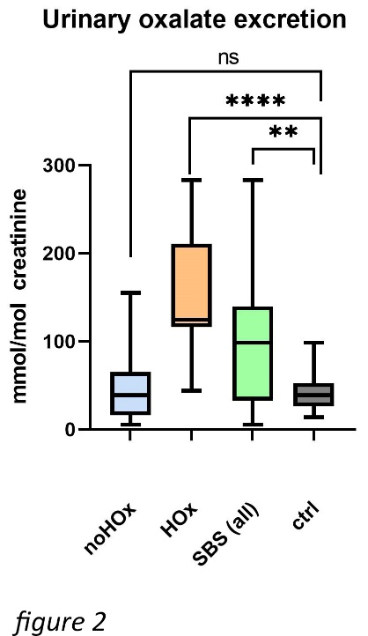
  - Figure 1: Urinary excretion of oxalate per creatinine between the different groups showing minimal to maximal values. Significantly higher oxalate excretion between whole short bowel patients and a control group can be demonstrated. No higher oxalate excretion was seen in the non hyperoxaluric short bowel group and the control group, but a tendency towards a higher oxalate excretion is seen. Abbreviations: ** = P ≤ 0.01, **** = P ≤ 0.0001, ns = not significant, HOx = patients with hyperoxaluria, noHOx = patients without hyperoxaluria, SBS (all) = all patients with short bowel syndrome.

Prevention of apoptotic cell death in tubular epithelial cells by a pan caspase inhibitor
As mentioned above, networking and collaboration with other researches was one of the most enriching aspects in the whole scholarship. As a part of the program, regular meetings with participants of the RECORD network were planned. Within one of these meetings, we discussed about the newly developed, first oral available pan caspase inhibitor Emricasan. Apoptosis plays a crucial role in different pathophysiological concepts, one of these is tubular damage in acute kidney injury by hypoperfusion and resulting hypoxemia. In collaboration with colleagues from the Department of Nephrology and Hypertension, University Hospital Erlangen, I planned an in vitro cell culture experiment in the last two months of my scholarship simulating acute kidney injury in immortalized tubular HK-2 cells. Cells were treated with gentamicin as induction for apoptosis and in parallel with different molar concentrations of Emricasan. Apoptosis was quantified by LDH measurement (ELISA method of supernatant of cell culture). Western blot of cleaved caspase 3 was performed for visualization of apoptosis in a second method. All experiments were performed by the applicant and a biologist in escort.
First preliminary results show a reduction of apoptosis depending on the molar concentration of Emricasan. Emricasan in a high concentration was well tolerated in HK-2 cells. Even in the group without gentamicin treatment, Emricasan could prevent cells from cell death.
In the next step, these first promising results will be tested in HK-2 cells with hypoxia as a stimulus for apoptosis. Another experiment could be performed with primary tubular cells.

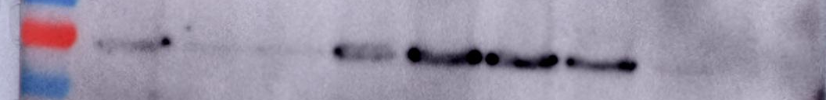
  - Figure 2A and B: Results showing a reduction of apoptotic markers in HK-2 cells after treatment with Gentamicin for induction of apoptosis and rescue with Emricasan, an oral available pan caspase inhibitor. Figure 2A depicts LDH activity in different groups, showing a reduction of LDH activity in the group with Gentamicin depending on the molar concentration of Emricasan with 10µmol showing the highest reduction. Figure 2B shows these results in Western blot for cleaved caspase 3 which are in line with LDH activity assay. Abbreviations: EM = Emricasan treatment, no Em = no Emricasan treatment, Genta = Gentamicin treatment, DMSO = Dimethylsulfoxide, control = group without Gentamicin treatment;

These results lead to another collaboration with Prof. S. Dittrich, Director of pediatric cardiology Erlangen. Recently Emricasan as a rescue treatment is tested in neonatal cardiomyocytes of the rat.
In summary, RECORD scholarship enabled me to learn and apply different scientific methods, build up a scientific network and start first collaborations. Therefore, RECORD scholarship was a fundamental aspect in starting my scientific career by providing sufficient time and monetary funding.

Scholars and Projects 2022

Vanessa Visconti, MD
The role of Microbiota in BK virus infection after kidney transplantation: MIBKON
Department of Medicine 4, Universitätsklinikum Erlangen
Mentors: Prof. Janina Müller-Deile, Prof. Mario Schiffer


Vanessa Visconti

Introduction and purpose of this study
Allograft rejection (AR) represents one of the most common complications after renal transplantation, which can negatively impact longterm graft survival ⁽¹⁾. The activity of the immune system is regulated by several endogenous and exogenous mechanisms, among which the gut microbiota is primarily involved through its known capability to modulate the activation of the human immune system ⁽²⁾. In the field of solid organ transplantation, few data are available concerning dysbiosis and allograft rejection.
In this study, we investigated gut microbial composition of a German cohort of renal transplanted patients with and without AR. Our aim was to identify a gut microbial fingerprint specific for each group, which could possibly suggest different bacterial functional profiles.

Methods
Basic inclusion criteria were adult age (> 18 years), a renal graft function expressed as glomerular filtration rate of at least 15 ml/min and 1 liter of urine output per day, as well as a transplantation history of at least 6 months. Specific inclusion criteria assigned to the control group were a stable renal graft function over time and a negative history of biopsy proven kidney graft rejection at any time since transplantation.
Basic exclusion criteria were corticosteroid dosing above 5 mg/day, use of microbiota-disturbing medications in the last 90 days, any infectious or inflammatory gastrointestinal disorders, AR therapy with high dose corticosteroid regimens or change in immunosuppressive medication in the last 30 days. Exclusion criteria specific for the rejection cohort included the delivery of the stool sample after initiation of a high-dose corticosteroid therapy, and rejection happening due to lack of immunosuppressant intake.
In total 76 patients were enrolled in the study, of which 42 in the rejection group and 34 as controls. Due to the presence of exclusion criteria at the time of collecting the stool sample, a total of 10 patients were excluded from this study after enrollment. The total of samples used to perform the rejection analysis was 36, of which 13 were derived from patients with acute T cellular mediated rejection (aTCMR), 8 with chronic active T cellular mediated rejection (cTCMR), 8 with antibody mediated rejection (AMR) and 7 with borderline rejection without acute kidney failure (BORi, irrelevant). Among the control cohort, 4 participants were excluded after enrollment, leaving the control cohort with 30 participants.

Results
Statistical comparison of demographic and clinical characteristics between controls and patients with AR showed no relevant differences, aside from age at enrolment, which was significantly lower in the rejection group, and male gender, which was lower represented in the control cohort. Furthermore, patients with AR had significantly higher level of donor specific antibody as well as worse creatinine level and stage of chronic kidney disease at the time of sampling. The relative abundances of different bacterial taxa between the two groups was compared at a phylum and family level (fig. 1A). At phylum level, the relative abundance of Proteobacteria and Bacteroidota was higher in the rejection group, while controls were characterised by higher abundance of Cyanobacteria and Firmicutes. At family level, the relative abundance of Enterobacteriaceae and Prevotellaceae was higher in the rejection group, while a higher relative abundance of Ruminococcaceae and Oscillospiraceae was found in controls.
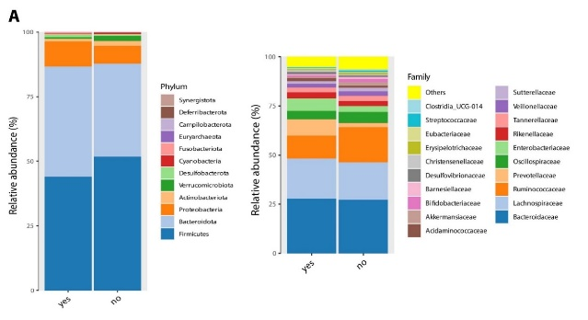
  - Figure 1A: comparison of gut microbiota of AR and control Gut microbial community structure of the study population at the phylum and family level.

Alpha diversity comparison between patients with AR and controls revealed a trend of lower bacterial richness within samples from patients with AR, even if statistical significance was not achieved (fig. 1B).

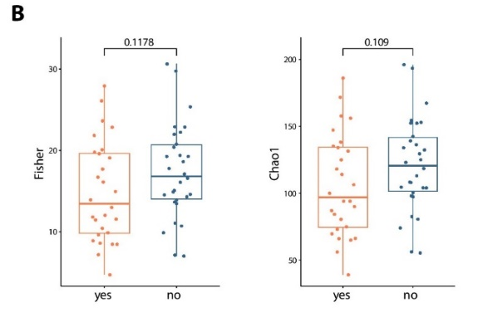
  - Figure 1B: comparison of gut microbiota of AR and control. Alpha diversity metrics (Fisher and Chao1) were compared between individuals with and without kidney graft rejection.

PERMANOVA analysis based on Aitchison distance, Bray-Curtis dissimilarity and Jaccard distance revealed differences in the microbial beta-diversity between samples from controls and patients with AR with an adjusted p-value of p = 0.013, p=0.004 and p= 0.002 (fig. 1C)

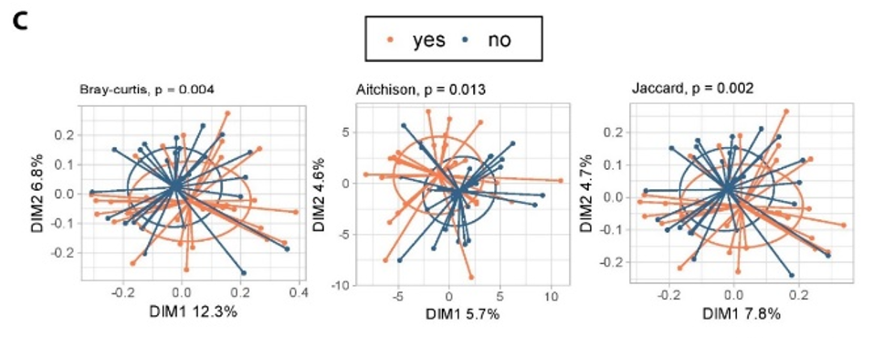
  - Figure 1C: comparison of gut microbiota of AR and control. ASV-level gut microbial community variation represented by principal coordinates analysis (Bray–Curtis dissimilarity, Aitchison distance and Jaccard distance).
When splitting the AR group according to the four types of rejection, alpha diversity showed major diversities between patients with cTCMR and controls. Control patients showed higher bacterial richness (p <0.05). Indeed, ACE index (richness, p= 0.023), Chao1 index (richness, p= 0.025) and Fisher (richness, p= 0,024) were significantly lower in the cTCMR group (fig. 2B).

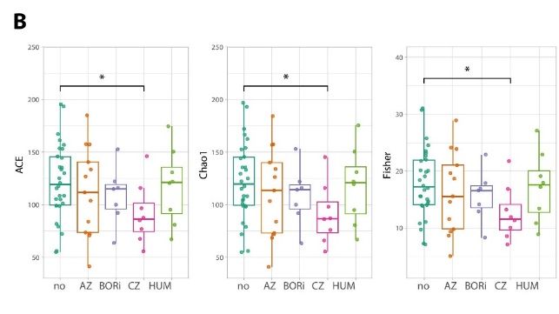
  - Figure 2B. Alpha diversity metrics (ACE, Chao1 and Fisher) were used for comparison of between patient cohorts. AR: allograft rejection.

The results of beta diversity analysis comparing the (dis)similarity of the microbial composition of controls to the 4 rejection sub-groups revealed statistically significant differences between controls and patients with cTCMR (p-value=0.013 based on Bray-Curtis, p-value= 0.012 based on Jaccard). Also patients with aTCMR showed significant differences in beta-diversity compared to controls (p-value=0.049 based on Bray-Curtis, p-value=0.047 based on Jaccard) (fig. 2C).

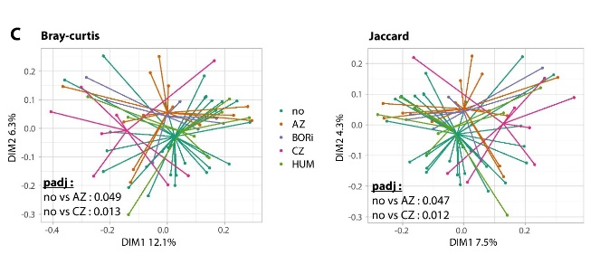
  - Figure 2C: comparison of gut microbiota of AR and contro.l ASV-level gut microbial community variation represented by principal coordinates analysis (Bray–Curtis dissimilarity and Jaccard distance).

The control group was characterised by a substantial higher abundance of the genera Faecalibacterium, Bifidobacterium, Lactobacillus, Tannerellaceae, Oscillospiraceae, Oscillospira, Merdibacter, Slackia, Pseudoflovonifractor, and ASF356, while the genera Latococcus, Anaerotroncus, Eubacterium xylanophilum, Odoribacter, Lachnospiraceae UCG-10 and Alloprevotella were overrepresented in the AR group (fig. 3). The aTCMR group was characterised by a higher abundance of Bacteroides and Eubacterium. Lachnoclostridium, Ruminococcus gnavus group and Anaerostignum were significantly more enriched in the group of patients with cTCMR, while Escherichia-Shigella was overrepresented in the AMR group (fig. 3A).

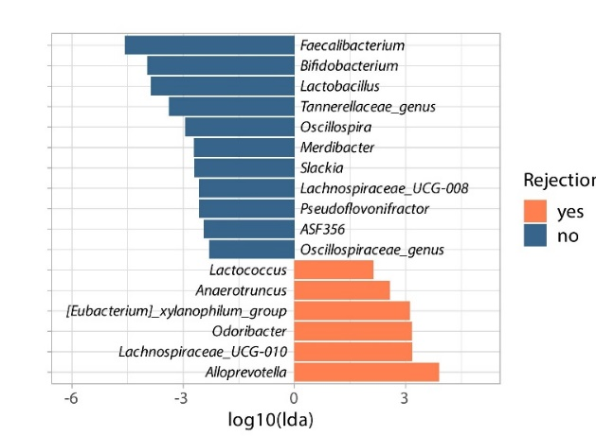
  - Figure 3A distribution of taxa between control and AR. Lefse analysis showing differentially abundant genera between patients with AR and controls.

The bioinformatics software package PICRUSt 2, able to predict metagenome functional content from marker gene (16S rRNA), revealed differentially abundant metabolic pathways between AR and control groups. Remarkable of note, microbiome of controls was characterized by higher expression of cytolethal distending toxin, 2-methylcitrate synthase and dehydratase, heme iron utilization proteins, lincomycin resistance protein, heat shock protein repressor, and cytochrome c oxidase cbb3-type (fig. 4C). Microbiome of AR was characterized by higher abundance of the paired small multidrug resistance pump, 23S rRNA (adenine1618-N6)-methyltransferase, and dTDP-6-deoxy-L-talose 4-dehydrogenase (NAD+).

  - Figure 5B: comparison of enzymatic and metabolic pathways between AR and control. PICRUSt 2.0 analysis of the different enzymatic abundance and metabolic pathways between the group of patients with rejection and controls.

Discussion
We found that gut microbial composition of patients with AR was significantly different from that of controls, characterised by a lower alpha diversity and higher abundance of inflammation-sustaining taxa. In contrast, the control group was characterised by a higher alpha diversity and an eubiotic, immunomodulating microbial fingerprint. Beta diversity analysis revealed statistically relevant differences in the microbial composition between controls and patients with AR with major differences between patients with cTCMR and controls. The predicted functional analysis of microbial communities showed a greater, statistically significant variety of enzymes and metabolic pathways in the control group than in the AR cohort. Among the taxa significantly enriched in the AR cohort, most are notable for their proinflammatory interaction with our immune system. Exemplary is the Escherichia-Shigella group, which is well known for its property to excessively activate gut mucosal immunity by Nod-like receptors protein 3 (NLRP3) inflammasome ⁽³⁾. High abundance of this group has been observed in several inflammation-mediated diseases, including brain amyloidosis ⁽⁴⁾, inflammatory bowel disease ⁽⁵⁾, and non-alcoholic fatty liver disease ⁽⁶⁾. On the other hand, gut microbial fingerprint of controls was characterised by high abundance of Bifidobacterium and Lactobacillus, well known gut commensals, whose beneficial properties led to the integration of some species of these genera into probiotic supplements ^{(7, 8)}. Several strains of Lactobacillus have a remarkable capability to induce CD4+ Foxp3+ regulatory T cells, which express high level of IL-10 and TGF-β and downregulate Th1, Th2, and Th17 cytokines ^{(9, 10, 11)}, conferring immune-regulating properties to this genus.
Conclusions
A distinct microbial fingerprint was detectable in stool samples from patients with AR, which might either facilitate immunological dysbalance towards kidney graft or might be a result of it. In the future, specific subgroups of stool ASV might serve as a non-invasive biomarker for AR.
References
- Naik RH, Shawar SH. Renal Transplantation Rejection. StatPearls. StatPearls Publishing Copyright © 2022, StatPearls Publishing LLC.; 2022
2. Maynard CL, Elson CO, Hatton RD, Weaver CT. Reciprocal interactions of the intestinal microbiota and immune system. Nature. Sep 13 2012;489(7415):231-41. doi:10.1038/nature11551
3. Zhao J, Bai M, Ning X, et al. Expansion of Escherichia-Shigella in Gut Is Associated with the Onset and Response to Immunosuppressive Therapy of IgA Nephropathy. J Am Soc Nephrol. Aug 30 2022;doi:10.1681/asn.2022020189
4. Cattaneo A, Cattane N, Galluzzi S, et al. Association of brain amyloidosis with pro-inflammatory gut bacterial taxa and peripheral inflammation markers in cognitively impaired elderly. Neurobiol Aging. Jan 2017;49:60-68. doi:10.1016/j.neurobiolaging.2016.08.019
5. Abdelbary MMH, Hatting M, Bott A, et al. The oral-gut axis: Salivary and fecal microbiome dysbiosis in patients with inflammatory bowel disease. Front Cell Infect Microbiol. 2022;12:1010853. doi:10.3389/fcimb.2022.1010853
6. Liang T, Li D, Zunong J, et al. Interplay of Lymphocytes with the Intestinal Microbiota in Children with Nonalcoholic Fatty Liver Disease. Nutrients. Nov 3 2022;14(21)doi:10.3390/nu14214641
7. O'Callaghan A, van Sinderen D. Bifidobacteria and Their Role as Members of the Human Gut Microbiota. Front Microbiol. 2016;7:925. doi:10.3389/fmicb.2016.00925
8. Fontana L, Bermudez-Brito M, Plaza-Diaz J, Muñoz-Quezada S, Gil A. Sources, isolation, characterisation and evaluation of probiotics. British Journal of Nutrition. 2013;109(S2):S35-S50. doi:10.1017/S0007114512004011
9. Kwon H-K, Lee C-G, So J-S, et al. Generation of regulatory dendritic cells and CD4<sup>+</sup>Foxp3<sup>+</sup> T cells by probiotics administration suppresses immune disorders. Proceedings of the National Academy of Sciences. 2010;107(5):2159-2164. doi:doi:10.1073/pnas.0904055107
10. Azad MAK, Sarker M, Wan D. Immunomodulatory Effects of Probiotics on Cytokine Profiles. Biomed Res Int. 2018;2018:8063647. doi:10.1155/2018/8063647
11. Aghamohammad S, Sepehr A, Miri ST, Najafi S, Pourshafie MR, Rohani M. Anti-inflammatory and immunomodulatory effects of Lactobacillus spp. as a preservative and therapeutic agent for IBD control. Immunity, Inflammation and Disease. 2022;10(6):e635. doi:https://doi.org/10.1002/iid3.635

Anne Dieterle, MD
Establishment of an international registry for
autosomal dominant tubulointerstitial kidney disease (ADTKD)

Department of Medicine 4, Universitätsklinikum Erlangen
Mentors: Prof. Michael Wiesener, Prof. Mario Schiffer


Anne Dieterle
Introduction
ADTKD is a tubulointerstitial kidney disease which leads to end-stage renal disease (ESRD) in mid adulthood. Germline mutations in at least five different genes cause the disease, which shows an almost complete penetrance. Thus, affected patients often show a positive family history for ESRD. The most frequent subforms are caused by mutations in either UMOD or MUC1, which are currently regarded as “toxic proteinopathies”. Numerous publications have shown that accumulation of the mutated proteins cause cellular damage, possibly as main mechanism of disease. Recently, therapeutical strategies for ADTKD have been reported, which lead to cellular clearance of the mutated protein (Dvela-Levitt et al., Cell 2019). Therefore, clinical studies are currently being prepared and prospected to start within the next 24 months. Since the disease is rare, a global effort will have to take place to include suitable patients. For this purpose, we have agreed to an international collaboration and to register our patients into a joint registry, led by A. Bleyer, Wake Forest School of Medicine, U.S.A. We have extended our consenting and received permission to do so from the local ethics committee.
Report
Over the last 15 years, we have diagnosed and registered 45 families with ADTKD, of which more than 30 families belong to the subforms –UMOD or –MUC1 (the main focus of the planned study). In her research period, Dr. Dieterle has re-contacted most recorded families, re-newed the scientific consenting and updated the pedigrees. Importantly, the younger generation was now directly addressed and information about the planned study shared. Many of the younger family members have not yet had a clinical genetic test. Therefore, Dr. Dieterle has assisted in this procedure for many probands, which is ongoing. Furthermore, a standard nephrological workup (serum creatinine, urinary findings, ultrasound) was performed, or recommended (since many probands live quite distant to our center). Dr. Dieterle has begun to consent and enter affected probands into the international registry (https://redcap.wakehealth.edu/redcap/), as soon as their genetic report was returned. This process is also ongoing. To date, not a single patient declined the research consent and entry into the international registry. Thus, their support and hope for a targeted therapy is extremely high.

Side Project
Dr. Dieterle sees a transplanted female patient with ESRD of unknown origin next to blindness due to retinitis pigmentosa in her outpatient clinic. Since her deceased brother suffered from the same condition we suspected a ciliopathy in terms of Senior-Loken syndrome. Genome sequencing revealed a heterozygous frameshift variant (ACMG class 4), as well as a heterozygous deep intronic variant (ACMG class 3) in SDCCAG8, which is a known Senior-Loken candidate gene. The latter is predicted to lead to the loss of an exonic splice enhancer-site and was not detected in exome sequencing (as expected). Dr. Dieterle has performed a punch biopsy of the skin and isolated primary fibroblasts from this patient. She has extracted mRNA and we are currently awaiting the results of RNAseq, which will possibly explain the effect of the intronic variant.

Christian Schmidt-Lauber, MD
Risk Factors and Modifiers of Progressing Kidney Disease

III. Medical Clinic and Polyclinic Universitätsklinikum Hamburg-Eppendorf
Mentors: Prof. Victor Puelles, Prof. Tobias Huber


Christian Schmidt-Lauber
Although the understanding of rare kidney diseases has made remarkable progress, knowledge about risk factors, modifiers, and consequences is still limited. Current evidence mostly derives from experimental data and clinical observations, but clinical studies on these populations are scarce. Cohort studies have a great potential in closing this gap by investigating clinical risk factors and modifiers for rare kidney diseases. Also, such cohorts allow to investigate new and orphan conditions influencing common kidney diseases.
This project aims to examine risk factors, modifiers, and long-term trajectories of rare kidney diseases as well as to discover novel and orphan conditions influencing common kidney diseases. A key aspect of this undertaken is the investigation of minimal change disease (MCD), focal segmental glomerulosclerosis (FSGS) as well as the kidney sequalae of the coronavirus disaes-19 (COVID-19) and its consequences including rare but important long-term effects.
Investigations are performed on various cohorts, including retrospective patient cohorts such as COVID-19 patients treated at the University Medical Center Hamburg-Eppendorf (UKE), the population-based Hamburg City Health Study (HCHS), nationwide Danish patient registries as well as German health insurance databases. Risk factors, modifiers and trajectories of kidney diseases are realized in exploratory analyses and analyzed in close collaboration with statisticians and data scientists experienced in big data handling.
As of now we have conducted several analyses on rare COVID-19 conditions and consequences as well as data extraction and preparation of data from nationwide Danish health registries.
While endothelial changes in COVID-19 and the interaction of the severe acute respiratory syndrome coronavirus 2 (SARS-CoV-2) with the known blood pressure regulator angiotensin-converting-enzyme 2 (ACE-2) indicated a hypertensive sequela after COVID-19,^{1,2} population-based studies only showed mild blood pressure alterations during the pandemic suggesting that a relevant hypertensive sequela is a rare condition.³ As hypertension is one of the most important risk factors for kidney diseases, we investigated possible post-acute hypertensive effects in a sub-cohort of the HCHS including 443 subjects after mostly mild and moderate COVID-19 compared to a matched population-based cohort deriving from the general HCHS program. Interestingly, we observed a relevant increase in diastolic blood pressure by 4.7 mmHg (p < 0.001) and a trend towards a higher systolic blood pressure (+1.4 mmHg, p = 0.12) in subjects after non-severe COVID-19. This difference led to a significant increase in individuals with de novo or uncontrolled hypertension defined as readings of at least 130/80 mmHg (OR 2.0, 95% confidence interval 1.5-2.7, p < 0.001). These results suggest that hypertension is not a rare but rather frequent consequence of non-severe COVID-19. Further analysis are needed to confirm this sequela and investigate the relevance for cardiovascular consequences of COVID-19.
In a second approach, we examined the incidence and relevance of acute kidney injury (AKI) in subjects with COVID-19 requiring intensive care unit (ICU) treatment and extracorporeal membrane oxygenation (ECMO) – a condition that has become uncommon by now. A retrospective analysis of 91 individuals with severe COVID-19 and veno-venous ECMO therapy treated at the UKE between March 2020 and July 2021 showed that the incidence of AKI was high (84%) with most AKI occuring within the first three days of ICU therapy (54%). 70% of all AKI led to initiation of kidney replacement therapy (KRT), but the need of KRT was not associated with longer hospital stays (38 versus 30 days in individuals with and without KRT, P = 0.23) or an increased 90-day mortality (66% versus 56%, p = 0.652). Although further studies are needed, this single center analysis indicates that short-term outcome in this severely ill population is rather determined by other factors than AKI.
Furthermore, we received a first dataset from the national Danish authorities of individuals with a creatinine measurement between 2000 and 2015. This dataset was checked for plausibility and completeness. It covers about 1.8 million unique subjects, with data on socio-economics, selected prescribed medication, laboratory data, in- and outpatient registered diagnoses, procedures as well as causes of death until 2022. Also, renal pathology data is available for more than 2000 individuals with kidney biopsies. As recent reports indicate a better coverage of all Danish individuals by the registries after 2016⁴ and more information on immunosuppressive medication is needed, an amendment was requested to add selected immunosuppressive drugs as well as individuals with a creatinine test until 2022. In a next step, analyses on the incidence and trajectory of MCD, FSGS as well as other rare kidney diseases are planned on the final dataset.

References
1. Varga Z, Flammer AJ, Steiger P, et al. Endothelial cell infection and endotheliitis in COVID-19. Lancet 2020;395(10234):1417-1418. DOI: 10.1016/S0140-6736(20)30937-5.
2. Yan R, Zhang Y, Li Y, Xia L, Guo Y, Zhou Q. Structural basis for the recognition of SARS-CoV-2 by full-length human ACE2. Science (New York, NY) 2020;367(6485):1444-1448. DOI: 10.1126/science.abb2762.
3. Laffin LJ, Kaufman HW, Chen Z, et al. Rise in Blood Pressure Observed Among US Adults During the COVID-19 Pandemic. Circulation 2022;145(3):235-237. DOI: 10.1161/CIRCULATIONAHA.121.057075.
4. Jensen SK, Heide-Jorgensen U, Vestergaard SV, Sorensen HT, Christiansen CF. Routine Clinical Care Creatinine Data in Denmark - An Epidemiological Resource for Nationwide Population-Based Studies of Kidney Disease. Clin Epidemiol 2022;14:1415-1426. DOI: 10.2147/CLEP.S380840.

Amrei Mandel, MD
DNA damage-induced mTORC1 activation mediates the development of FSGS
Department of Internal Medicine II, Uniklinik Köln
Mentors: Prof. Thomas Benzing, Prof. Christine Kurschat


Amrei Mandel
Introduction
Terminally differentiated, post-mitotic podocytes need a strong stress response to maintain their cellular integrity. The delicate structures of podocyte foot processes form the slit diaphragm, an essential part of the kidney filtration barrier. Podocyte injury can lead to glomerulosclerosis and albuminuria. Consequently, we observed differential expression of various DNA repair genes in glomeruli of patients with focal segmental glomerulosclerosis (FSGS). Mutations in the DNA repair gene ERCC1 cause progeroid syndromes in humans, and the progeroid Ercc1^{-/Δ}-mouse model develops a kidney phenotype. To study the role of DNA damage repair in podocytes, we generated a podocyte-specific Ercc1 knockout mouse (pko), which develops albuminuria and glomerulosclerosis by 11-13 weeks, followed by premature death between 15-20 weeks.
Transcription stress through aging or by deleting Ercc1 specifically in podocytes results in the development of FSGS. DNA damage and aging in podocytes are not well described, yet highly important phenomena in an aging population. My project aims to shed light on the podocytes’ response to transcription stress, focusing on inflammation, mTORC1 activation, and oxidative stress as aging hallmarks. In order to reduce oxidative stress, we conducted a dietary restriction intervention with the Ercc1 pko model and demonstrated beneficial effects of reduced calorie intake on the renal phenotype. In addition to increased DNA damage, these mice show mTORC1 activation in podocytes. Subsequent mTORC1 inhibition by rapamycin treatment leads to reduced glomerulosclerosis in our model. My project studies the link between DNA damage repair and mTORC1 in FSGS by in vitro studies with inhibitors of DNA-PK/ATM kinases, important factors of the DNA damage response and by genetically modifying the activation of mTORC1 in vivo in Ercc1 pko mice.
Methods
To investigate the inflammatory response upon DNA damage in podocytes, we analyzed immune cells in Ercc1 pko mice by flow cytometry at 9 weeks and immunohistochemistry at 12 weeks. Podocytes’ repair capacity, involvement of NER-components, antioxidant defense, and actin cytoskeleton reorganization in response to DNA damage were characterized in vitro by whole-proteome studies, western blot, and immunofluorescence (data not shown).
A calorie restriction intervention was conducted in Ercc1 pko mice: four week-old Ercc1^{fl/fl}; Pod:Cre^{tg/wt} mice (mixed FVB/CD1 background) of both sexes were fed with 3 g standard diet once daily over 4 weeks (calorie restriction; CR). Two control groups were either fed once daily with 4.5 g (single-dose; SD) to control for intermittent fasting, or ad libitum (AL). The effect of the intervention was analyzed by immunofluorescence, immunohistochemistry, measurement of urinary albumin excretion, and serum analysis.
Cultured murine podocytes were damaged by UV-C and Mitomycin C, treated with different inhibitors of DNA repair kinases and the effect on mTORC1 activation was analyzed by western blot for the downstream effector protein pS6-RP. To study effects of the mTORC1 pathway in podocytes in vivo, one floxed Raptor allele was crossed into the Ercc1 pko model and the resulting phenotype was compared to the Ercc1 pko mice.
Results
Deleting Ercc1 specifically in podocytes causes glomerulosclerosis and albuminuria, leading to premature death. DNA damage in podocytes causes interstitial inflammation (Fig. 1). By 9 weeks of age, total leukocyte count increases due to an increase of the Th1 cell population (Fig. 1A). Macrophages were not elevated at this early timepoint but are induced by Th1 cells at later disease stages (12 weeks) in our Ercc1 pko model (Fig. 1 B-F). The post-mitotic podocyte displays sufficient repair mechanisms and reacts to Mitomycin C-induced DNA damage by reorganization of the actin cytoskeleton and an oxidative stress response (data not shown).

  - 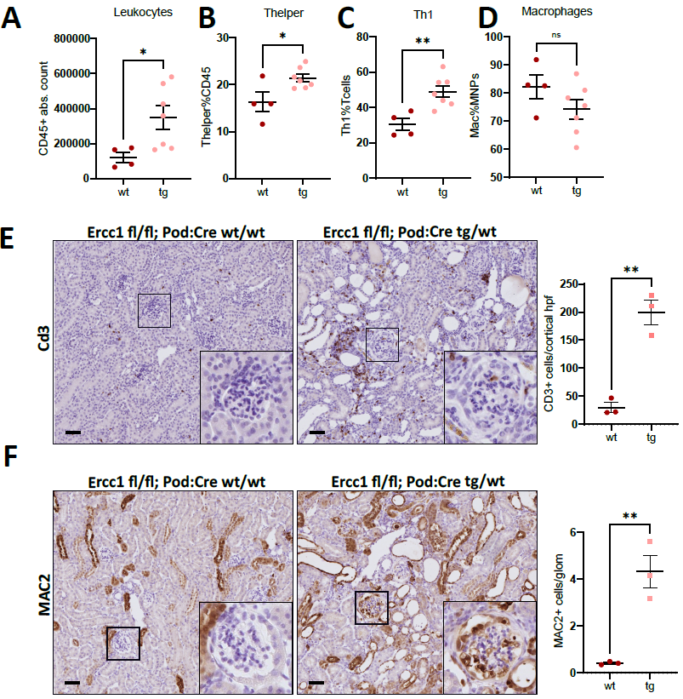
  - Figure 1: A-C Total leukocyte count, T helper and Th1 cells increase significantly in kidneys of 9-week-old Ercc1 pko mice as compared to controls. Single cell suspensions were prepared, labelled, and cells characterized by flow cytometry. D Macrophages did not change significantly in 9-week-old mice. E Immunohistochemistry of kidneys from 12-week-old mice shows interstitial infiltration of Cd3+ T cells. F At 12 weeks macrophages infiltrate glomeruli of Ercc1 pko mice.

Calorie restriction ameliorates the FSGS-like phenotype of Ercc1 pko mice by reducing albuminuria, glomerulosclerosis, and T cell infiltration (Fig. 2). Moreover, calorie restriction diminishes mTORC1 activation in podocytes of Ercc1 pko mice (data not shown).

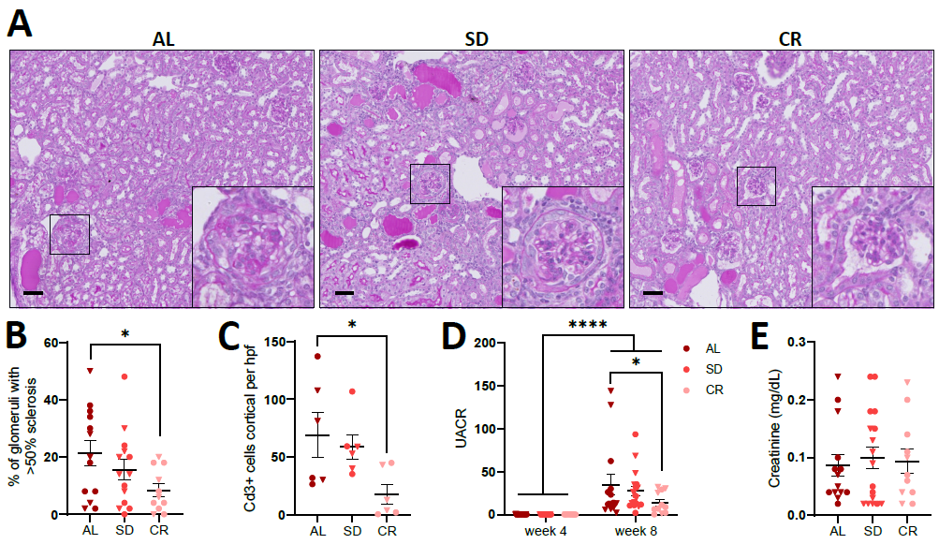
  - Figure 2: After four weeks of treatment, mice with reduced calorie intake (70%) displayed significantly less sclerotic glomeruli (A, B), less interstitial infiltration with Cd3+ T cells into the kidney cortex (C), and a decreased urinary albumin creatinine ratio (D). E The calorie restriction intervention did not have an effect on serum creatinine levels.

In this Ercc1 pko model, we observed increased activation of mTORC1 and were able to ameliorate disease progression by rapamycin treatment. Inhibition of the DNA damage repair kinases DNA-PK or ATM by Nedisertib and KU60019, respectively, in Mitomycin C- or UVC-treated immortalized murine podocytes resulted in abrogation of S6RP phosphorylation (Fig. 3A). This indicates a direct mechanistic link between transcription stress and mTORC1 activation in podocytes. However, genetically reducing mTORC1 activation did not modulate the phenotype (Fig. 3 B-F).

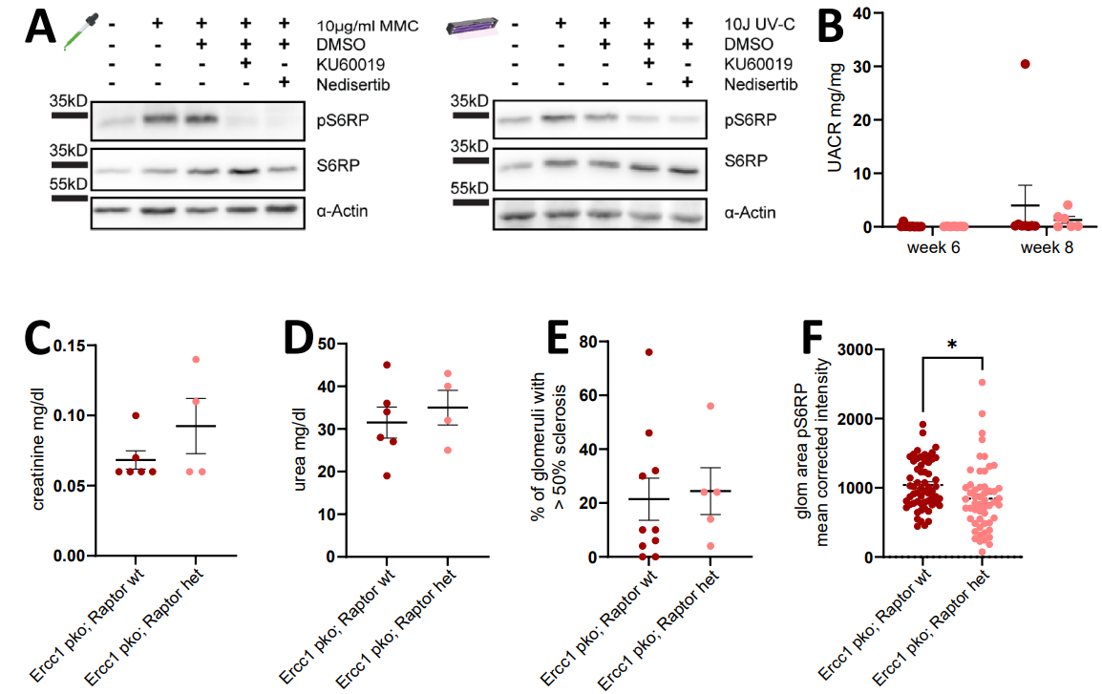
  - Figure 3: (A) Activation of mTORC1 in DNA-damaged podocytes is mediated via DNA-PK and ATM kinases, as phosphorylation of S6RP is diminished upon inhibition with KU60019 (ATM) and Nedisertib (DNA-PK). B-E Podocyte-specific deletion of one Raptor allele in Ercc1 pko mice does neither affect albuminuria (B), serum creatinine (C), serum urea (D), nor glomerulosclerosis (E). F Podocyte-specific deletion of one Raptor allele in Ercc1 pko mice leads to a significant decrease of glomerular pS6RP-intensity measured by immunofluorescence.

Conclusion and outlook
Deficiency of the endonuclease cofactor Ercc1 causes progeroid syndromes in both humans and mice. Deleting Ercc1 specifically in podocytes leads to an FSGS-like phenotype, characterized by severe renal insufficiency and premature death. The post-mitotic podocyte reacts to transcription stress with an inflammatory and oxidative stress response. In vitro, differentiated podocytes are highly resilient to induced damage. However, impairing the DNA repair machinery leads to reduced viability in vitro and to glomerulosclerosis and albuminuria in vivo. Calorie restriction is a well-established method to reduce inflammation, oxidative stress, to inhibit mTORC1 activation, and to slow aging. Interestingly, four weeks of calorie restriction were sufficient to ameliorate disease progression, reflected by less albuminuria and less globally sclerosed glomeruli in Ercc1 pko mice.
In this Ercc1 pko model, we observed increased activation of mTORC1 and were able to ameliorate glomerular sclerosis by rapamycin treatment. In vitro experiments established a link between mTORC1 activation and the DNA damage repair kinases DNA-PK and ATM in podocytes in response to induced DNA damage. To further unravel the role of mTORC1 in DNA damage-induced FSGS, we conducted a genetic intervention by additionally deleting one allele of Raptor, which failed to modulate the Ercc1 pko phenotype.
In conclusion, these findings indicate that the hallmarks of aging – DNA damage, inflammation, mTORC1 activation, and oxidative stress all contribute to the pathomechanisms observed in our Ercc1 pko mouse model.

Felicitas Hengel, MD
Exploring Autoimmunity in Nephrotic Syndrome
III. Medical Clinic and Polyclinic Universitätsklinikum Hamburg-Eppendorf
Mentors: Prof. Tobias B. Huber, Prof. Ulf Panzer



Felicitas Hengel

Introduction
Minimal Change Disease (MCD) is the most common podocytopathy causing nephrotic syndrome (NS) in children and accounts for about 10 – 15 % of NS in adults. It is characterized by minimal changes in light microscopy and podocyte foot process effacement in electron microscopy. No or only minimal podocyte-associated staining for immunoglobulins or complement components is seen in immunofluorescence.

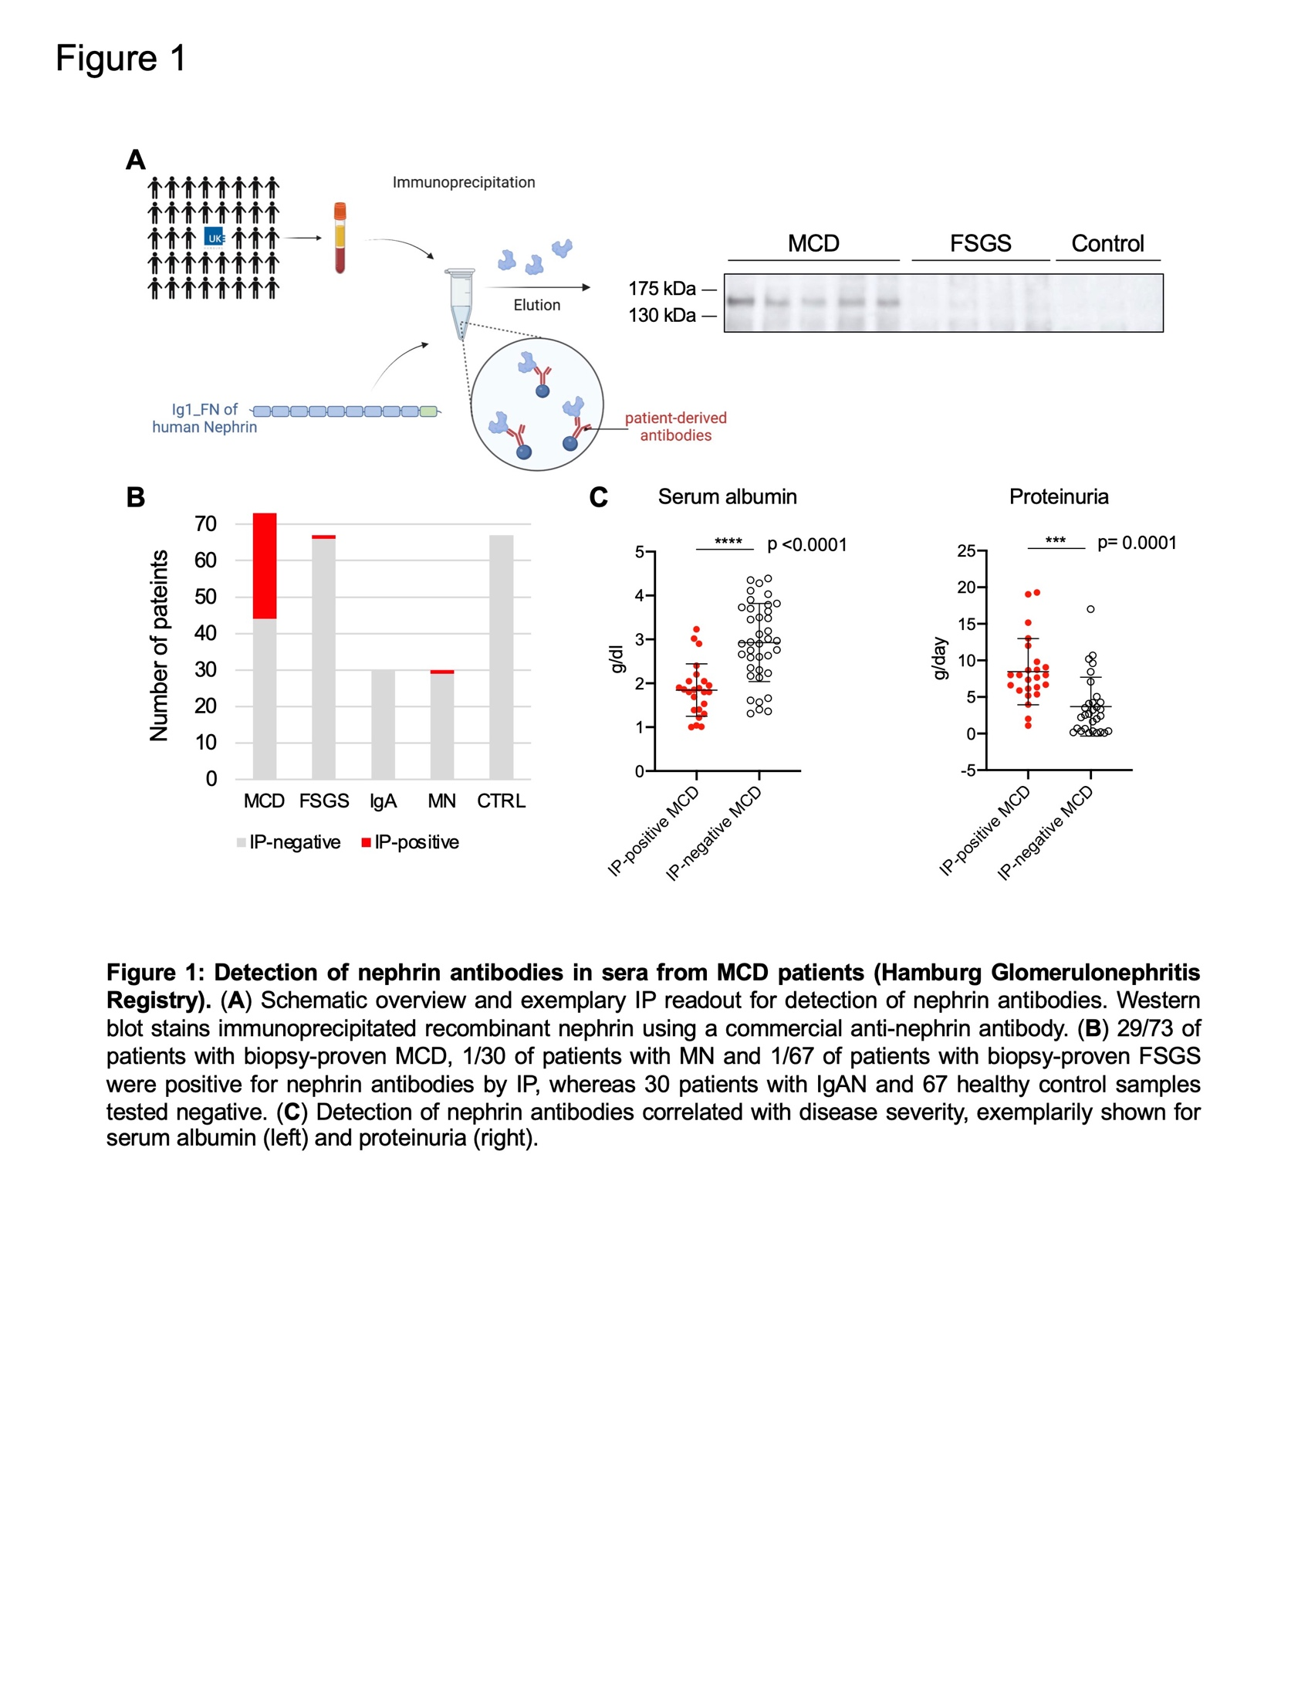
Figure 2: Detection of nephrin antibodies in sera from MCD patients (Hamburg Glomerulonephritis Registry). (A) Schematic overview and exemplary IP readout for detection of nephrin antibodies. Western blot stains immunoprecipitated recombinant nephrin using a commercial anti-nephrin antibody. (B) 29/73 of patients with biopsy-proven MCD, 1/30 of patients with MN and 1/67 of patients with biopsy-proven FSGS were positive for nephrin antibodies by IP, whereas 30 patients with IgAN and 67 healthy control samples tested negative. (C) Detection of nephrin antibodies in the MCD cohort correlated with disease severity, exemplarily shown for serum albumin (left) and proteinuria (right).
Recently, an autoantibody-mediated etiology of MCD was suggested due to the detection of autoantibodies against nephrin in 29% of MCD patients. Nephrin is a central component of the slit diaphragm. Autoantibodies against nephrin were previously identified in patients with congenital NS of the Finnish type with major mutations in the NPHS1 gene and recurrent NS after kidney transplantation. Additionally, recent case reports described anti-nephrin autoantibodies in primary forms of focal segmental glomerulosclerosis (FSGS).
In this project, we aim to assess the presence and pathogenic significance of autoantibodies in MCD and FSGS patients and to further characterize the autoimmune etiology by establishing a mouse model of active immunization.

Workplan
We expressed the extracellular domains of human nephrin in HEK293 cells with subsequent purification by Ni-NTA via a C-terminal 6x his-tag. Purification was confirmed by Western blot (ɑ-his and ɑ-nephrin) and Coomassie staining. We evaluated 435 serum samples for circulating nephrin antibodies by immunoprecipitation (IP) in a blinded study design (Figure 1A). We included 73 patients with MCD, 67 patients with FSGS, 30 patients with membranous nephropathy (MN) and 30 patients with IgA nephropathy (IgAN) of the Hamburger Glomerulonephritis Registry in comparison to 67 healthy control samples.

Preliminary results
Blinded screening of sera from 200 patients with biopsy-proven glomerular diseases by means of IP of recombinant human nephrin led to the detection of nephrin antibodies in 29/73 (39.7%) of patients with MCD, 1/30 of patients with MN (3.3%) and 1/67 (1.5%) of patients with FSGS (Figure 1B). Importantly, we did not detect nephrin antibodies in sera of 30 patients with IgAN as well as in 67 healthy controls. Detection of nephrin antibodies in patients with MCD correlated with disease severity as exemplarily shown for serum albumin and proteinuria (Figure 1C). These preliminary findings will be studied further by analyzing follow-up samples of our patient cohort and corresponding clinical data.

Outlook
As a next step, we aim to narrow down the relevant epitope-containing domain(s) using fragments of the extracellular part of nephrin. Knowing the epitope-containing region might help to determine the prognostic relevance of different epitopes and to develop precisely targeted epitope blocking therapies. Further studies should also include the establishment of a mouse model involving active immunization. Thereby we could closely mimic and characterize the immune response and possible functional effects of such antibodies in this subset of MCD. The precise characterization of nephrin antibodies within our MCD cohort may lead to the clinical application of antibody measurements for diagnostic or prognostic purpose such as to predict disease progression and severity. Additionally, identifying potential further antigenic targets may improve our understanding of the antibodies’ pathological role in disease development and could lead to new diagnostic and prognostic tools for patients with MCD.

Second Funding Period

Scholars and Projects 2023

Lioba Ester, MD
YAP and TAZ in the podocyte – Twins distinguished by transcriptomic analysis

Department of Internal Medicine II, Uniklinik Köln
Mentors: Prof. Thomas Benzing, PD Dr. Martin Kann
External Mentor: Prof. Janina Müller-Deile


Lioba Ester

Introduction
Increased mechanical strain can lead to podocyte injury and foot processes effacement resulting in proteinuria and nephrotic syndrome. Therefore, podocytes must rapidly adapt to and cope with a lifetime of mechanical stress caused by transient glomerular hypertension or hyperfiltration.¹ The exact molecular mechanisms of this extraordinary adaptation remain unclear. YAP and TAZ, the final effectors of Hippo signaling, are mechanotransducers active in podocytes. In most non-proliferative adult tissues, YAP and TAZ are inactive, phosphorylated and retained in the cytoplasm.² In podocytes, however, YAP and TAZ seem to have a different role. Nuclear YAP activity has been shown to be essential in podocytes to promote cell survival and inhibit apoptosis.^{3,4} Recently, we identified NUP205, a nucleoporin, which- when mutated- causes genetic FSGS, as part of YAP/TAZ protein complexes in podocytes ⁵. We showed that nuclear shuttling of YAP and TAZ is dependent on NUP205, suggesting nuclear deficiency of YAP as a potential pathomechanism in NUP205-deficient patients. Interestingly, transient increased nuclear activity of YAP was described during the development of glomerular disease suggesting a transient protective role of YAP in the podocyte ^{4,6,7}. Aim of this project is to unravel the shared and unique roles of YAP and TAZ in podocytes in vivo.

Preliminary Results
To thoroughly characterize the role of YAP and TAZ in podocytes we established genetic mouse lines with a podocyte-specific knockout (pKO) of either YAP or TAZ (Figure 1 a, b). YAP pKO mice presented a severe glomerular phenotype while TAZ pKO remained healthy. Some YAP pKO animals develop proteinuria at week 4 or earlier and some develop proteinuria later (Figure 1c). To understand the underlying disease mechanisms leading to podocyte injury we divided the YAP pKO mice into two groups regarding on whether they developed proteinuria at week 4 (‘early-onset’) or not (‘late-onset’). In line with the urine analysis, BUN levels in the ‘early-onset’ group were significantly increased at 4 weeks of age and stayed elevated also after 12 weeks of age, while the ‘late-onset’ group – with unremarkable BUN levels at 4 weeks of age- showed a significant BUN elevation after 12 weeks (Figure 1d). Further, YAP pKO survival rate was impaired compared to wildtype and TAZ pKO (Figure 1e). Corroborating the observations, the “early-onset” group showed reduced slit diaphragm length at 4 weeks of age as determined using an unsupervised semi-automated approach and super resolution microscopy (Figure 1f). Interestingly, slit diaphragm length was also already reduced in young mice of the “late-onset” group. At the age of 12 weeks the slit diaphragm length of all YAP pKO mice is significantly reduced. Notably, also young TAZ pKO mice seem to show a tendency for a reduced slit diaphragm length without developing proteinuria or increased serum urea (Figure 1f).
Strikingly, no living offspring with less than two of the four YAP/TAZ alleles were born, while the heterozygous-YAP-heterozygous-TAZ pKO mice are born in mendelian ratios and do not present an overt kidney phenotype (Figure 1g). This interesting finding led us to hypothesize that, in case of lack of YAP or TAZ, the respective other protein might take over a compensatory role in the podocyte requiring two intact alleles and that combined YAP/TAZ activity above a certain threshold is indispensable for podocyte homeostasis.

Outlook
To further identify similarities, differences, and potential compensatory mechanisms among these two very similar proteins a single nuclei RNA sequencing (snRNA Seq) analysis of isolated glomeruli of our YAP or TAZ pKO mice will be performed. Diseased YAP pKO mice at different ages and stages of the disease will be compared to wildtype and TAZ pKO mice. The analysis will likely provide an explanation on the high variability of disease onset and development. Further, we might elucidate compensatory effects that protect the TAZ pKO mice from developing disease and potential explanations why the combined podocyte knockout of YAP and TAZ is not viable.

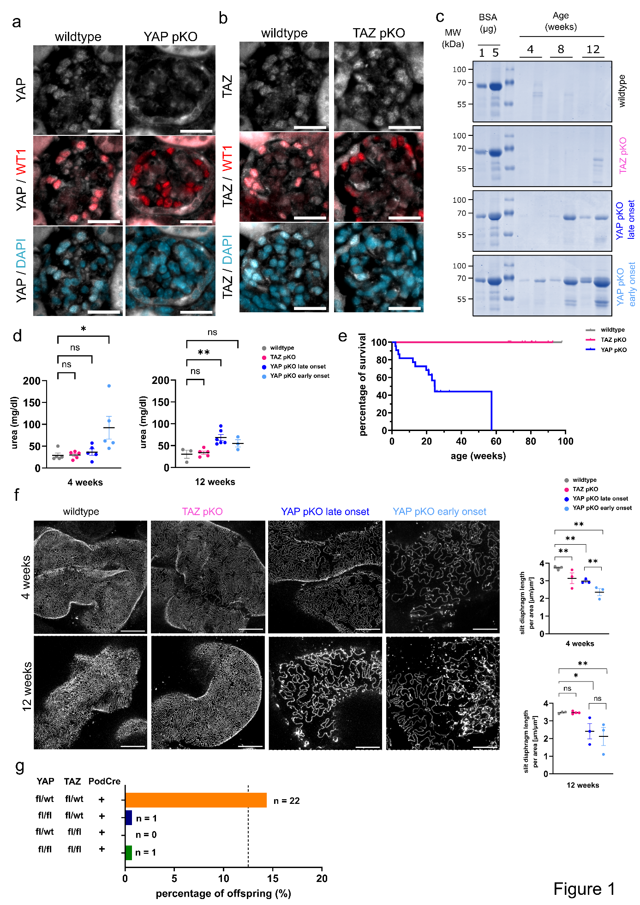
  - Figure 1: a,b) Immunostaining of glomeruli of wildtype, YAP pKO and TAZ pKO mice for YAP(A, white), TAZ (B, white), WT1 (red) and DAPI (nuclear stain, blue), scale bar 20 µm. c) Representative colloidal coomassie staining of urine samples from wildtype, TAZ pKO, YAP pKO late onset and YAP pKO early onset mice at 4, 8 and 12 weeks of age. Bovine serum albumin (BSA; 1µg and 5µg) was loaded as positive control. n = 2 mice. d) Urea levels in the serum samples from wildtype, TAZ pKO, YAP pKO late onset or YAP pKO early onset of 4 or 12 week old mice. n = 3-6 mice. e) Kaplan-Meier-Curve showing the percentage of survival of YAP pKO, TAZ pKO and wildtype animals. n = 19-22 mice. f) STED imaging displaying representative Nephrin staining depicting the slit diaphragm of 4 and 12 weeks old wildtype, podocyte specific TAZ knockout (TAZ pKO), podocyte specific YAP knockout with late phenotype onset (YAP pKO late onset), or early onset (YAP pKO early onset), and the quantification of the slit diaphragm length. n = average of 5 glomeruli/3-4 mice. g) Ratios of genotypes from viable offsprings of the mating for the double knockout. The dotted line indicates the expected mendelian ratio of 12,5 %. Only PodCre-positive genotypes are depicted. * p<0,05, ** p<0,01, by Student’s t-Test.

References
1. Benzing T, Salant D. Insights into Glomerular Filtration and Albuminuria. N Engl J Med. Apr 15 2021;384(15):1437-1446. doi:10.1056/NEJMra1808786
2. Moya IM, Halder G. Hippo-YAP/TAZ signalling in organ regeneration and regenerative medicine. Nat Rev Mol Cell Biol. Apr 2019;20(4):211-226. doi:10.1038/s41580-018-0086-y
3. Campbell KN, Wong JS, Gupta R, et al. Yes-associated protein (YAP) promotes cell survival by inhibiting proapoptotic dendrin signaling. J Biol Chem. Jun 14 2013;288(24):17057-17062. doi:10.1074/jbc.C113.457390
4. Zhuang Q, Li F, Liu J, et al. Nuclear exclusion of YAP exacerbates podocyte apoptosis and disease progression in Adriamycin-induced focal segmental glomerulosclerosis. Lab Invest. Feb 2021;101(2):258-270. doi:10.1038/s41374-020-00503-3
5. Ester L, Cabrita I, Ventzke M, et al. The FSGS disease gene product and nuclear pore protein NUP205 regulates nuclear localization and activity of the transcriptional regulators YAP and TAZ in podocytes. bioRxiv. 2023:2023.2003.2007.531564. doi:10.1101/2023.03.07.531564
6. Rinschen MM, Grahammer F, Hoppe AK, et al. YAP-mediated mechanotransduction determines the podocyte's response to damage. Sci Signal. Apr 11 2017;10(474)doi:10.1126/scisignal.aaf8165
7. Chung JJ, Goldstein L, Chen YJ, et al. Single-Cell Transcriptome Profiling of the Kidney Glomerulus Identifies Key Cell Types and Reactions to Injury. J Am Soc Nephrol. Oct 2020;31(10):2341-2354. doi:10.1681/asn.2020020220

Daniel Hahn, MD
CSE1L, a novel candidate gene for lower urinary tract obstructions (LUTO)

Department of Paediatrics and Adolescent Medicine, Universitätsklinikum Erlangen
Mentors: Prof. Heiko Reutter, Prof. Mario Schiffer
External Mentor: Prof. Benjamin Odermatt, Uniklinik Bonn


Daniel Hahn

Introduction
Congenital LUTO represent a heterogeneous group, characterized by urinary retention. Most represent an anatomical blockage of the urethra, some represent voiding dysfunctions. The most common forms are posterior urethral valves (PUVs), a male limited lesion (Capone et al., 2022). LUTO are disproportionately frequently associated with anorectal malformations (ARM). The aim of this project is a systematic investigation of the human LUTO and ARM candidate gene CSE1L (* 601342) in the development of the urinary tract in zebrafish larvae (zfl). A knock-down using morpholino RNA has already been described in Zebrafish showing a CFTR dependent intestinal dilatation (Bagnat et al., 2010).
In order to support a specific involvement of CSE1L in human congenital anomalies of the kidneys and urinary tract (CAKUT), especially LUTO, a transient knockdown (KD) of CSE1L in zebrafish larvae using translation and splice blocking morpholinos was performed. Further a knockout (KO) was established by CRISPR/Cas9 with single guide RNAs (sgRNA) targeting different genomic positions in the zebrafish ortholog CSE1L. The KO was verified by Sanger sequencing and in situ hybridization. For visualization of specific morphologic changes of the zebrafish urinary tract two transgenic zebrafish reporter lines were used (Tg(wt1b:eGFP), Tg(HGj4A;UAS:GFP)). The transgenic zebrafish line Tg(wt1b:eGFP) shows eGFP-coupled wt1b expression in the proximal pronephric duct. Accordingly, the transgenic zebrafish line Tg(HGj4A;UAS:GFP) shows eGFP expression in the distal pronephic duct, cloacal opening and gut. A Sulforhodamine 101 excretion assay was performed to evaluate differences in the gastrointestinal passage.

Methods
Zebrafishes are kept according to national law and to recommendations by Westerfield (2000) in the zebrafish facility of Prof. Schiffer in the Translational Research Center (TRC) at the University Hospital Erlangen. Zebrafish larvae (zfl) of wild-type AB/TL and the transgenic reporter lines comprising Tg(wt1b:eGFP) and Tg(HGj4A;UAS:GFP), are obtained by natural spawning and raised at 28°C ERM on a 14 h light and 10 h dark cycle. All experiments are performed on zfl ≤ 5 dpf. To suppress pigmentation 1-phenyl-2-thiourea (final concentration 0.003 %) is added to the ERM culture medium from 1 dpf onward.
A splice-blocking morpholino of exon 2 and a translation-blocking morpholino already described by Bagnat et al. were injected in zebrafish embryos before 4 cell stage. Successful knock-down was confirmed by MALDI-TOF mass spectroscopy.
For CRISPR/Cas9 synthetic single guide RNA (sgRNA) were designed using the crisprscan online tool (Moreno-Mateos et al., 2015) following their ranking algorithm. The mixture of sgRNA and tracrRNA were then injected as crRNA with Cas9 protein intracellularly in zebrafish embryos before 4 cell stage. After visual evaluation mutagenesis was verified by Western Blot or Sanger sequencing. ICE synthego online tool is used to analyse sequences for insertions and/or deletions and for rate of mutagenesis (https://ice.synthego. com/#/).
Brightfield and fluorescence in vivo imaging are performed from one to five dpf using ZEISS Axio V16 Multi-Zoom microscope and analyzed with ZEN 2.3 Software. Phenotypic differences in the developing pronephros in Tg(wt1b:EGFP) and Tg(HGj4A;UAS:GFP) zfl were analysed with the respective imaging software.
Kaplan-Meier survival curves are used to analyse survival within the first 5 dpf. Statistical analysis is performed using SPSS.

Preliminary results
While we were not able to identify pathologies in the developing urinary tract or the cloacal region in cse1l KD and KO zfl using microscopic phenotypization and Sulforhodamine 101 excretion assay, and further could not reproduce the previously described phenotype of intestinal inflation, CRISPR/Cas9 treated cse1l KO zfl (n = 329) compared to control CRISPR/Cas9 treated zfl (n = 273) and uninjected zfl (n = 636) showed a significant decreased rate of pneumatized swim bladders (p < 0.01) as shown in Figure 1. These results were also applicable for translation blocking morpholinos in screening observations (Figure 2).
Fluorescence staining showed a reduced signal uptake for CRISPR/Cas9 cse1l KO zfl but not in control or untreated zfl (Figure 3).

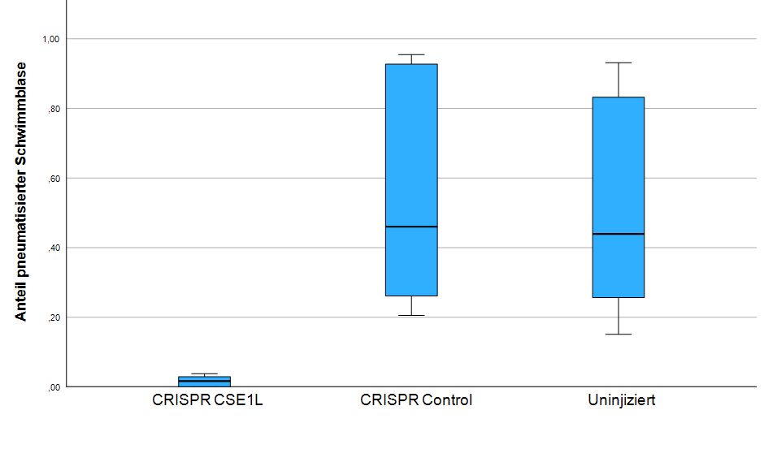
Figure 1. Boxplot chart of the ratio of pneumatized swim bladders in 4.5 dpf zebrafish larvae.

Discussion
Developing from the embryonal tissue of the foregut the swim bladder is anatomically believed to compare to mammalian lung tissue. To further evaluate the essential role of cse1l in development, observation of larvae beyond 5 dpf is being discussed. These further observations could bring additional information for the critical malfunction in development that leads to letality of homozygous cse1l knock-out mice embryos. Also, a mRNA rescue experiment using wildtype as well as variant mRNA in knockout Zebrafish larvae could be used to locate the critical part of the protein which is necessary for its function during development.

Annexes
Bagnat, M., Navis, A., Herbstreith, S., Brand-Arzamendi, K., Curado, S., Gabriel, S., Mostov, K., Huisken, J., & Stainier, D. Y. (2010). Cse1l is a negative regulator of CFTR-dependent fluid secretion. Curr Biol, 20(20), 1840-1845. https://doi.org/10.1016/j.cub.2010.09.012
Capone, V., Persico, N., Berrettini, A., Decramer, S., De Marco, E. A., De Palma, D., Familiari, A., Feitz, W., Herthelius, M., Kazlauskas, V., Liebau, M., Manzoni, G., Maternik, M., Mosiello, G., Schanstra, J. P., Vande Walle, J., Wuhl, E., Ylinen, E., Zurowska, A., . . . Montini, G. (2022). Definition, diagnosis and management of fetal lower urinary tract obstruction: consensus of the ERKNet CAKUT-Obstructive Uropathy Work Group. Nat Rev Urol, 19(5), 295-303. https://doi.org/10.1038/s41585-022-00563-8.
Moreno-Mateos, M. A., Vejnar, C. E., Beaudoin, J. D., Fernandez, J. P., Mis, E. K., Khokha, M. K., & Giraldez, A. J. (2015). CRISPRscan: designing highly efficient sgRNAs for CRISPR-Cas9 targeting in vivo. Nat Methods, 12(10), 982-988. https://doi.org/10.1038/nmeth.3543.
Westerfield, M. (2000). The Zebrafish Book. A Guide for the Laboratory Use of Zebrafish (Danio rerio) (4th Edition ed.). University of Oregon Press, Eugene.
Cecilia Lanny Winata, Svetlana Korzh, Igor Kondrychyn, Weiling Zheng, Vladimir Korzh, Zhiyuan Gong, Development of zebrafish swimbladder: The requirement of Hedgehog signaling in specification and organization of the three tissue layers, Developmental Biology, Volume 331, Issue 2, 2009, Pages 222-236, ISSN 0012-1606, https://doi.org/10.1016/j. ydbio.2009.04.035.

1000 µm
1000 µm
1000 µm

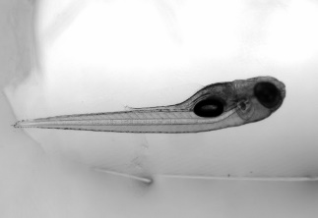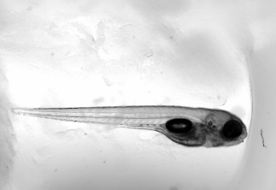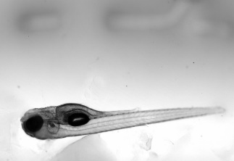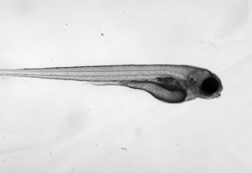
  - Figure 2. Microscopy images of 4.5 dpf zebrafish larvae in white light (upper row), GFP fluorescence (middle row) and sulforhodamine 101 fluorescence (lower row), comparing untreated zfl (left column), control morpholino (left center column), splice-blocking morpholino (right center column) and translation-blocking morpholino (right column).
1000 µm
1000 µm
TBMO 3,5 ng
SBMO 3,5 ng
COMO 3,5 ng
untreated

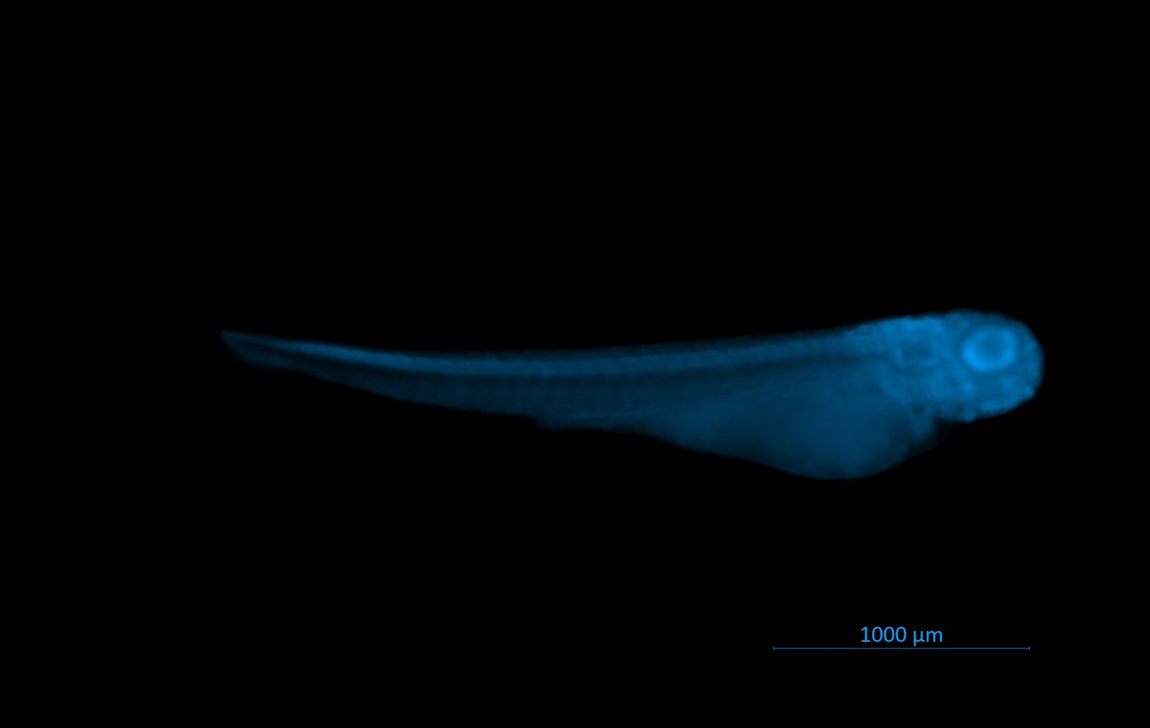
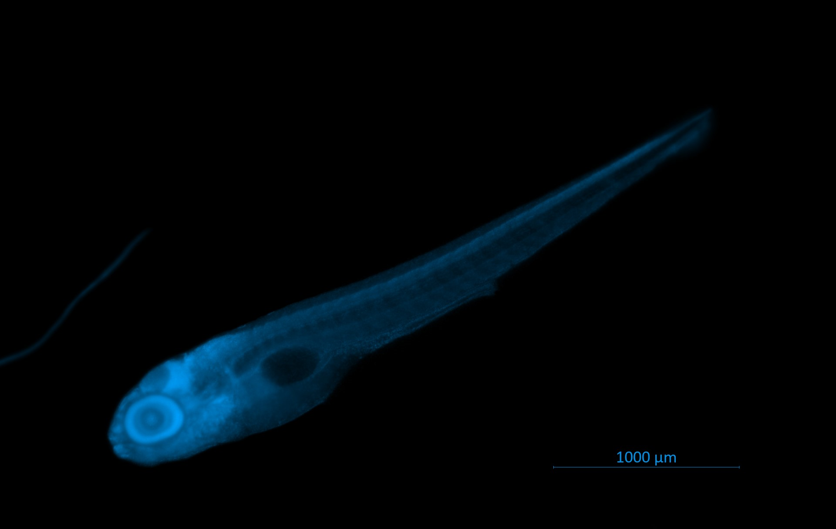
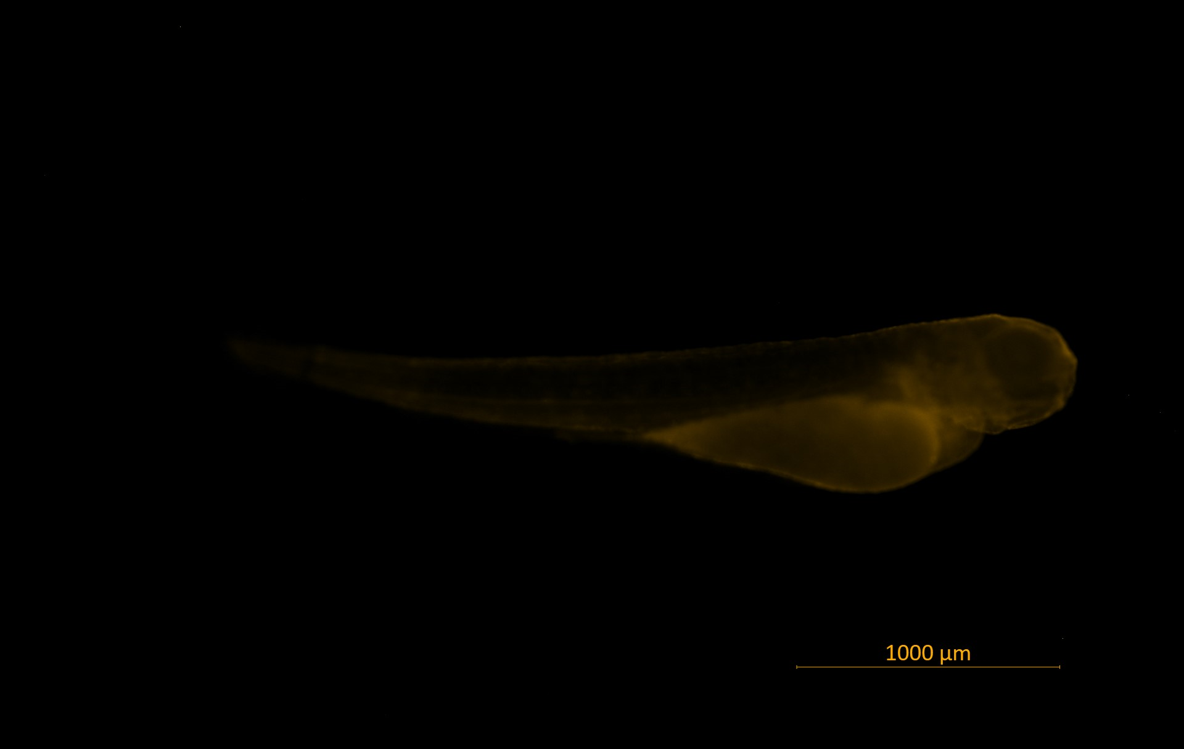
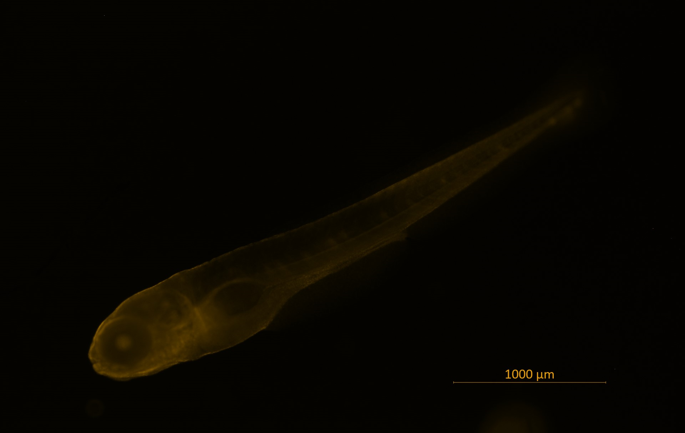
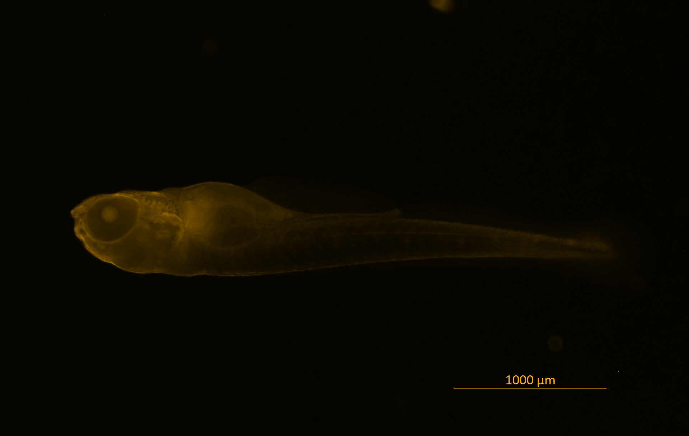
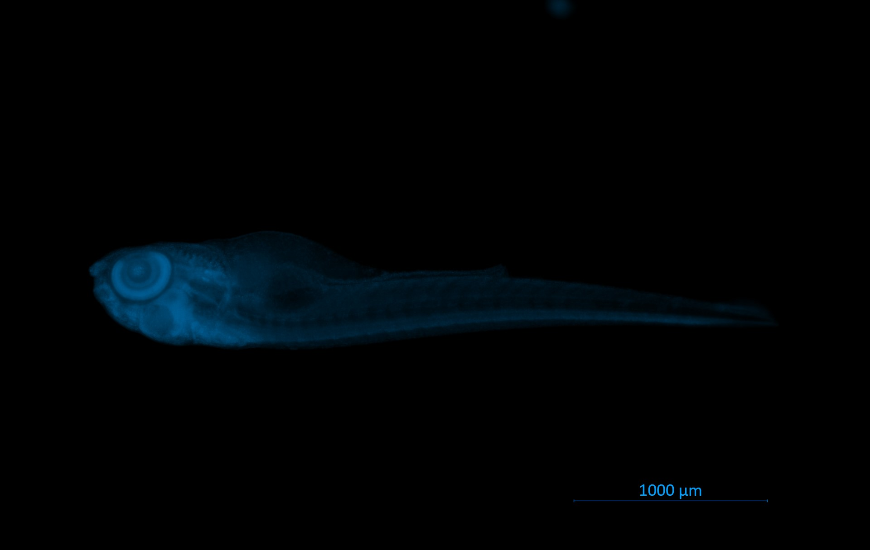
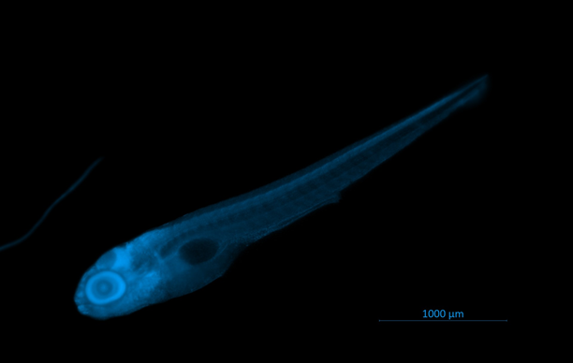
  - Figure 3. Microscopy images of 4.5 dpf fluorescence stained zebrafish larvae. DAPI (upper row), Anti-cse1l (lower row), comparing untreated zfl (left column), CRISPR/Cas9 control (center column) and CRISPR/Cas9 cse1l KO (right column).
untreated
CRISPR SCR Control
CRISPR CSE1L
DAPI
Anti-CSE1L

Karen Reichert, MD
Proteinuria and renal perfusion in renal transplant recipients

Department of Medicine 4, Universitätsklinikum Erlangen
Mentors: Prof. Mario Schiffer, Dr. Dennis Kannenkeril
External Mentor: Prof. Tobias Huber


Karen Reichert
Primary focal segmental glomerulosclerosis (FSGS) is a rare histopathologic “pattern of injury“, causing end stage kidney disease in most patients. Patients frequently present with nephrotic syndrome, including proteinuria, edema, hypoalbuminemia and hyperlipidemia. After kidney transplantation, there is a 50 percent risk of recurrence and this is associated with a high risk of allograft loss.^{1,4} Although there is limited data on therapeutic efficacy, early diagnosis and treatment might improve outcomes. Evidence suggests, that podocyte injury is reversible before renal scarring occurs.⁵ Due to lack of controlled trials, the management of recurrent FSGS is inconsistent and highly empirical. At present, monitoring proteinuria is the most common methodology to detect recurrent FSGS in the allograft besides invasive biopsy. However, the source of proteinuria can be of the native kidneys or the allograft.^{2,3} In disease progression of FSGS, distinctive hemodynamic alterations with characteristic decrease in renal plasma flow, peritubular capillary flow, and elevated renal arteriolar resistances have been observed.^{6,7}
In the first phase of our study, we aim to analyse the association between proteinuria and kidney perfusion in recipients from our living donor kidney transplantation program. It is not feasible to limit the study population to FSGS patients in the first phase as this would result in a long recruitment period due the rarity of the disease. After completing the first phase and demonstrating a significant association between perfusion of the transplanted kidney and proteinuria, patients with FSGS will be recruited to confirm the findings of the first phase (Fig.1).
Analyses of the native kidney and allograft is performed using the innovative Arterial Spin Labelling (ASL)-MRI-technology without the need of contrast dye (Fig. 2). This is particularly important for vulnerable patients with chronic kidney disease because it avoids the risk of contrast dye induced acute kidney injury and reducing the risk of nephrogenic systemic fibrosis. Measurement of total, cortical and medullary renal perfusion and intrarenal vascular resistance using ASL-MRI allows us to determine perfusion of different renal compartments.⁸⁻¹⁰
Our aim is to include 25 patients from our living donor kidney transplantation programme. This single-centre clinical trial at the Clinical Research Center (CRC) of the Department of Nephrology and Hypertension in Erlangen will plan four visits for its patients. Appropriate candidates will be screened according to the inclusion and exclusion criteria on the first visit. The second visit should take place 4-8 weeks before transplantation and will include a physical examination, blood and urine sampling and an ASL-MRI of the native kidneys. The third visit is scheduled 2 months after kidney transplantation and will include a physical examination, blood and urine collection and a repeated ASL-MRI of the native kidneys and renal transplant. The final visit will occur 12 months after kidney transplantation.
This study is consisting of two phases, allowing us to demonstrate an association between proteinuria and perfusion of native kidneys and renal allograft and secondly detect early hemodynamic changes in the allograft of FSGS patients.

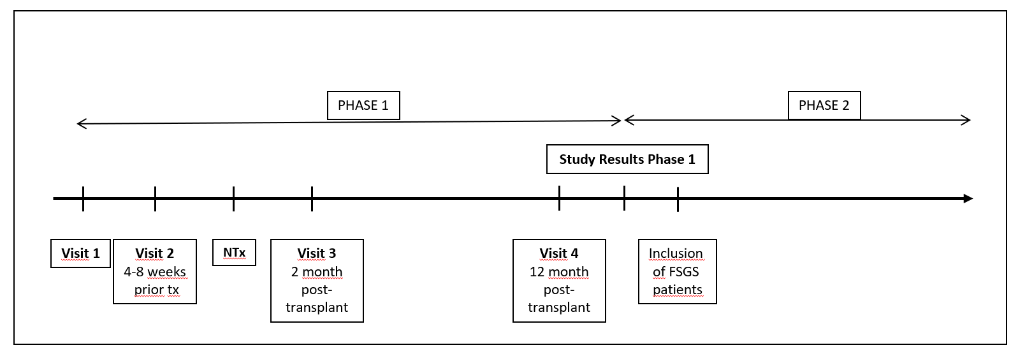
Figure 1: Study design
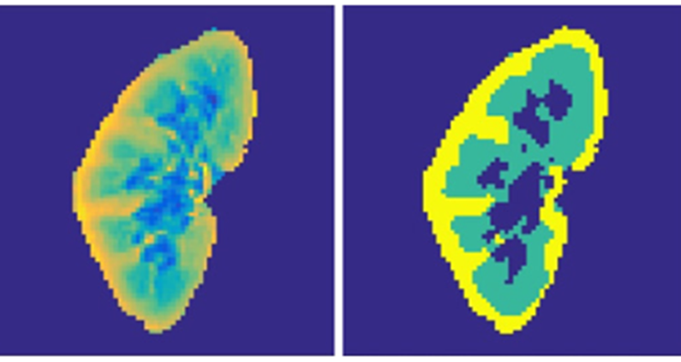
Figure 2: Kannenkeril D, Schmieder RE et al., Detection of Changes in Renal Blood Flow Using Arterial Spin Labeling MRI, Am J Nephrol 2021

References:
- Uffing A, Pérez-Sáez MJ, Mazzali M, Manfro RC, Bauer AC, de Sottomaior Drumond F, O'Shaughnessy MM, Cheng XS, Chin KK, Ventura CG, Agena F, David-Neto E, Mansur JB, Kirsztajn GM, Tedesco-Silva H Jr, Neto GMV, Arias-Cabrales C, Buxeda A, Bugnazet M, Jouve T, Malvezzi P, Akalin E, Alani O, Agrawal N, La Manna G, Comai G, Bini C, Muhsin SA, Riella MC, Hokazono SR, Farouk SS, Haverly M, Mothi SS, Berger SP, Cravedi P, Riella LV. Recurrence of FSGS after Kidney Transplantation in Adults. Clin J Am Soc Nephrol. 2020 Feb 7;15(2):247-256. doi: 10.2215/CJN.08970719. Epub 2020 Jan 23. PMID: 31974287; PMCID: PMC7015092.
- Calabuig AS, Guirado L, Ramos D. Prognostic significance and diagnosis of proteinuria in renal transplantation. Transplant Rev (Orlando). 2012 Jan;26(1):30-5. doi: 10.1016/j.trre.2011.07.008. PMID: 22137730.
- D´Cunha Prakas Thomas, Ravi Parasuraman, K.K. Venkat, Rapid Resolution of Proteinuria of Native Kidney Origin Following Live Donor Renal Transplantation, American Journal of Transplantation, Volume 5, Issue 2, 2005, Pages 351-355, ISSN 1600-6135, https://doi.org/10.1111/j.1600-6143.2004.00665.x.
- Chang J.-W., Pardo V., Sageshima J., et al. Podocyte foot process effacement in postreperfusion allograft biopsies correlates with early recurrence of proteinuria in focal segmental glomerulosclerosis. Transplantation. 2012;93(12):1238–1244. doi: 10.1097/tp.0b013e318250234a
- Gallon L., Leventhal J., Skaro A., Kanwar Y., Alvarado A. Resolution of recurrent focal segmental glomerulosclerosis after retransplantation.The New England Journal of Medicine.2012;366(17):1648–1649. doi: 10.1056/nejmc1202500.
- Narisa Futrakul, Prasong Siriviriyakul, Tawatchai Deekajorndej & Prasit Futrakul (2004) Hemodynamic Maladjustment and Disease Progression in Nephrosis with FSGS, Renal Failure, 26:3, 231-236, DOI: 10.1081/JDI-120039520
- Futrakul P, Futrakul N: Renal hypoperfusion and segmental glomerulosclcrotic lesion. Pe- diatr Nephrol 1994:8:260-26!.
- Schmieder et al., Reproducibility of Kidney Perfusion Measurements with Arterial Spin Labeling at 1.5 Tesla MRI Combined With Semiautomatic Segmentation for Differential Cortical and Medullary Assessment, Medicine (Baltimore). 2016
- Kannenkeril et al., Detection of Changes in Renal Blood Flow Using Arterial Spin Labeling MRI, Am J Nephrol. 2021
- Schmieder et al., Measurement of kidney perfusion by magnetic resonance imaging: comparison of MRI with arterial spin labeling to para-aminohippuric acid plasma clearance in male subjects with
- metabolic syndrome, Nephrol Dial Transplant. 2010

Leonie Dreher, MD
The effect of anaphylatoxin receptors in RPGN

III. Medical Clinic and Polyclinic Universitätsklinikum Hamburg-Eppendorf
Mentors: Prof. Ulrich Wenzel, Dr. Nicola Martin Tomas
External Mentor: Prof. Mario Schiffer


Leonie Dreher
The complement system is an ancient part of innate immunity and is central to the detection and destruction of invading microbes. Its activation leads to the generation of proinflammatory cleavage fragments like the anaphylatoxins C3a and C5a. These anaphylatoxins promote inflammation and have important roles in regulating the innate and adaptive immune system. Their effects are carried out through interactions with specific anaphylatoxin receptors such as C3aR and C5aR1 which are mainly located on immune cells (1,2).
Regulatory T cells (Tregs), which are a significant subgroup of T cells, play a crucial role in maintaining immunological tolerance. The mentioned anaphylatoxins C3a and C5a are known regulators of Treg activity. The regulatory function is mediated through the anaphylatoxin receptors C3aR and C5aR1 via inhibiting the function of circulating CD4⁺ Foxp3⁺ Tregs (3,4). In contrast, the absence of C3aR and C5aR1 activation leads to the spontaneous differentiation of CD4⁺ T cells into Foxp3⁺ Tregs.
In the pathogenesis of glomerulonephritis a protective role of Tregs has been described (5). While TH1 and TH17 cells play an important pathogenic role, Tregs are potentially protective (6,7). Previous studies could show a renal infiltration of Tregs in a nephrotoxic nephritis mouse (NTN) model suggesting a direct anti-inflammatory role of Tregs in the organ itself (8). Furthermore, a pronounced glomerulonephritis activity in Foxp3⁺ Treg depleted NTN mice could be detected (8).
Previously we investigated the role of the anaphylatoxin receptors C3aR, C5aR1 and C5aR2 in high blood pressure (9,10). Results showed an increased expression of the anaphylatoxin receptors in hypertensive nephropathy in humans (single cell RNAseq, European Renal cDNA Bank-Kröner-Fresenius biopsy bank, immunohistochemistry). Analysis of the expression patterns of C3aR, C5aR1, and C5aR2 revealed predominant expression on immune cells such as dendritic cells, monocytes, and macrophages (9,10).
Treatment of rapid progressive glomerulonephritis (RPGN) mostly consists of non-specific immunosuppression with potentially severe side effects. Recently, avacopan, a C5aR1-inhibitor, has been approved for the treatment of ANCA-associated vasculitis (AAV), a rare inflammatory disease (11). In this project, we aim to further investigate the role of anaphylatoxin receptors and their (combined) effect on Tregs in a model of severe inflammation and to evaluate their potential as a treatment option in RPGN in order to obtain a more specific treatment approach. First, we want to examine the localization and expression of C3aR and C5aR1 in kidney biopsies of patients with biopsy proven AAV. First data from a CD45⁺ single cell RNAseq data set (obtained from Prof. C. Krebs, University Hospital Hamburg-Eppendorf), the European Renal cDNA Bank-Kröner-Fresenius biopsy bank and immunohistochemistry showed main expression in myeloid cells with an increased number in AAV patients (figure 1). To further address the effect of the anaphylatoxin receptors we used a C3aRxC5aR1 double knockout and induced glomerulonephritis using the NTN model. Preliminary results showed significantly higher levels of cholesterol, more albuminuria and crescent formation in wildtype mice treated with NTN compared to the control group whereas no significant differences were observed between the knockout and the control group group indicating a beneficial effect of the knockout (figure 1). Additionally, flow cytometry analysis revealed a reduced infiltration of CD4⁺ cells with decreased proinflammatory Th17 cells and increased Tregs in C3aRxC5aR1 double knockout animals compared to control mice.
In summary, blockade of C3aR plus C5aR1 could exert a protective effect in RPGN. In the future, the role of the anaphylatoxin receptors will be further validated using different knockout models and pharmacological blockage.
References:
1. Lalli PN, Strainic MG, Yang M, Lin F, Medof ME, Heeger PS. Locally produced C5a binds to T cell–expressed C5aR to enhance effector T-cell expansion by limiting antigen-induced apoptosis. Blood. 1. September 2008;112(5):1759–66.
2. Liszewski MK, Kolev M, Le Friec G, Leung M, Bertram PG, Fara AF, u. a. Intracellular Complement Activation Sustains T Cell Homeostasis and Mediates Effector Differentiation. Immunity. Dezember 2013;39(6):1143–57.
3. Kwan W hong, Van Der Touw W, Paz-Artal E, Li MO, Heeger PS. Signaling through C5a receptor and C3a receptor diminishes function of murine natural regulatory T cells. Journal of Experimental Medicine. 11. Februar 2013;210(2):257–68.
4. Strainic MG, Shevach EM, An F, Lin F, Medof ME. Absence of signaling into CD4+ cells via C3aR and C5aR enables autoinductive TGF-β1 signaling and induction of Foxp3+ regulatory T cells. Nat Immunol. Februar 2013;14(2):162–71.
5. Herrnstadt GR, Steinmetz OM. The role of Treg subtypes in glomerulonephritis. Cell Tissue Res. August 2021;385(2):293–304.
6. Krebs CF, Paust HJ, Krohn S, Koyro T, Brix SR, Riedel JH, u. a. Autoimmune Renal Disease Is Exacerbated by S1P-Receptor-1-Dependent Intestinal Th17 Cell Migration to the Kidney. Immunity. November 2016;45(5):1078–92.
7. Steinmetz OM, Summers SA, Gan PY, Semple T, Holdsworth SR, Kitching AR. The Th17-Defining Transcription Factor RORγt Promotes Glomerulonephritis. Journal of the American Society of Nephrology. März 2011;22(3):472–83.
8. Paust HJ, Riedel JH, Krebs CF, Turner JE, Brix SR, Krohn S, u. a. CXCR3+ Regulatory T Cells Control TH1 Responses in Crescentic GN. JASN. Juli 2016;27(7):1933–42.
9. Bode M, Herrnstadt GR, Dreher L, Ehnert N, Kirkerup P, Lindenmeyer MT, u. a. Deficiency of Complement C3a and C5a receptors Does Not Prevent Angiotensin II–Induced Hypertension and Hypertensive End-Organ Damage. Hypertension. Januar 2024;81(1):138–50.
10. Dreher L, Bode M, Ehnert N, Meyer-Schwesinger C, Wiech T, Köhl J, u. a. Role of the anaphylatoxin receptor C5aR2 in angiotensin II induced hypertension and hypertensive end organ damage. Am J Hypertension. 2024;
11. Jayne DRW, Merkel PA, Schall TJ, Bekker P. Avacopan for the Treatment of ANCA-Associated Vasculitis. N Engl J Med. 18. Februar 2021;384(7):599–609.

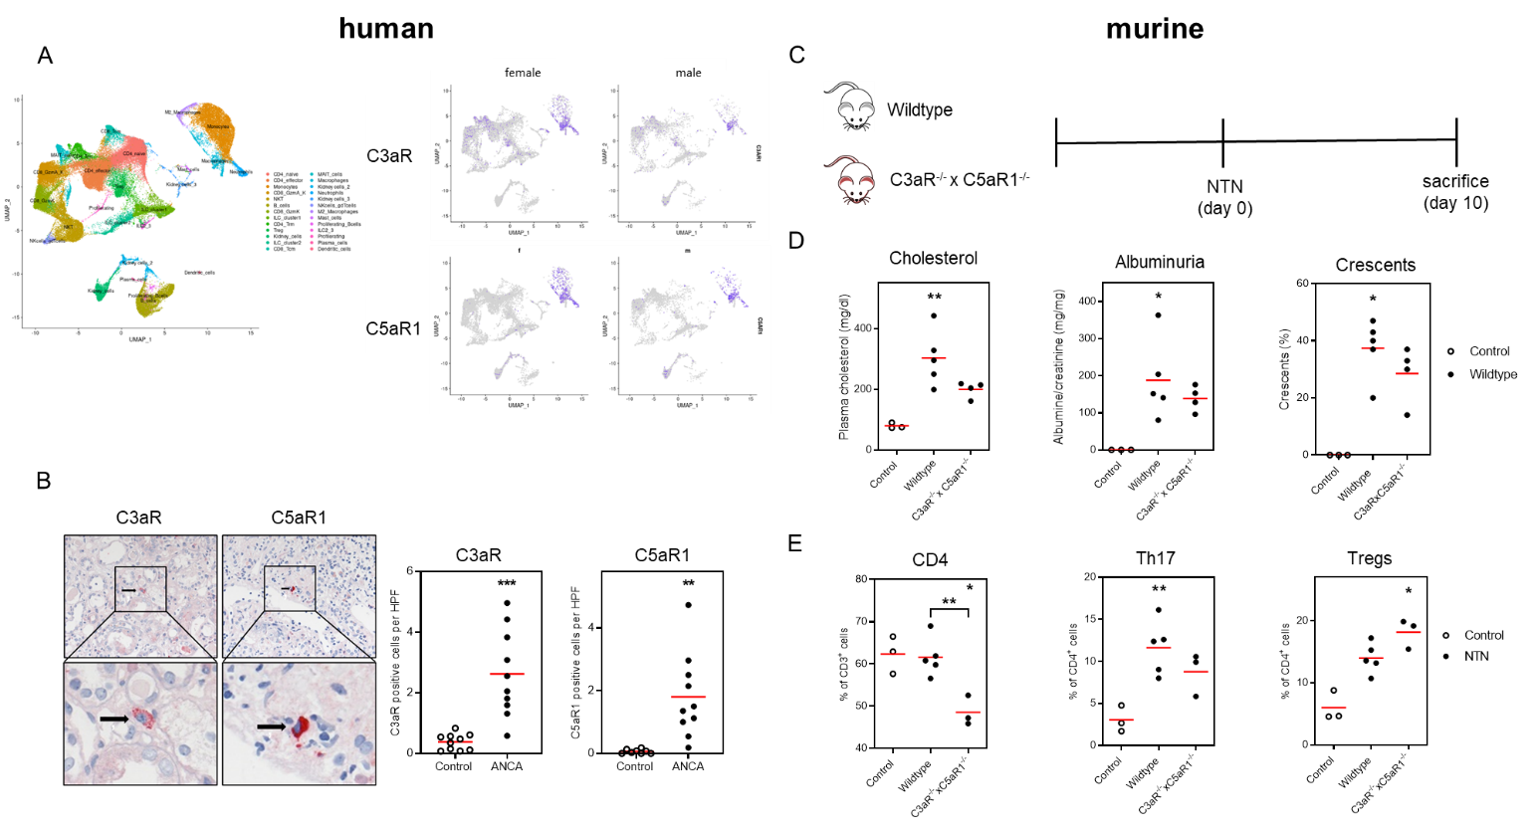
  - Figure 1: Human and murine data for C3aR and C5aR1 in rapid progressive glomerulonephritis. (A) Single Cell RNA Sequencing data from a CD45⁺ data set from patients (female, male) with ANCA-associated vasculitis (AAV) showing main expression of C3aR and C5aR1 in myeloid cells. (B) Immunohistochemistry from AAV patients with higher number of C3aR and C5aR1 positive cells in AAV compared to control. **p<0,001; ***p<0,0001 vs. control (unpaired t-test). (C) Use of the NTN model in C3aRxC5aR1 knockout (KO) mice. (D) Increased cholesterol levels, albuminuria and crescents in wildtype (WT) but not KO mice. (E) Flow cytometry analysis showing decreased renal infiltration of CD4⁺ in KO mice with less Th17 cell and more Treg infiltration. *p<0,05; **p<0,001 vs control (One-way ANOVA).

Hannah Schwarz, MD
Identification of binding partners and regulatory mechanisms in ADTKD-MUC1

Department of Medicine 4, Universitätsklinikum Erlangen
Mentors: Dr. Karl Knaup, Prof. Michael Wiesener
External Mentor: Prof. Thomas Benzing


Hannah Schwarz
Understanding the pathogenesis of monogenic and rare diseases fuels hopes to unravel mechanisms of broader importance. This may be particularly true for the Autosomal Dominant Tubulointerstitial Kidney Diseases (ADTKD), where interstitial fibrosis and tubular atrophy (IF/TA) is an early hallmark of the disease1,2. Since IF/TA is the common final path of virtually all kidney diseases, independent of their primary causes, the molecular mechanisms of ADTKD may be transferable for chronic kidney diseases (CKD) in general. In line with this, individual patients with diseases such as ADTKD, hypertensive nephropathy and nephronophthisis (NPHP) can be impossible to recognize on clinical or histological grounds3.
ADTKD are rare, monogenic diseases which lead to end-stage kidney disease in mid-adulthood. The disease mechanisms are incompletely understood. However, for the most frequent subforms of ADTKD (-MUC1 and -UMOD) recent data has suggested that cellular accumulation of the respective mutated proteins in renal tubular cells causes unfolded protein response (UPR) and cellular apoptosis4,5. In ADTKD-MUC1 the mutated mucin 1 protein (characteristic frameshift protein, MUC1-fs) can be detected as cytoplasmic accumulation in distal tubular segments of affected kidneys6, which already led to the assumption that this protein accumulation would be pathogenic.

Figure 1: A. Schematic illustration of the mucin 1 wildtype protein (upper panel) with its distinct domains. The characteristic mutated protein is illustrated in the middle panel. Lower panel shows the tagged expression plasmid available for overexpression experiments. B. Immunofluorescence and confocal microscopy for TMED9 and Calnexin (ER marker) of patient derived immortalised renal tubular cells (iTC) with ADTKD-MUC1.

Although the current literature places both ADTKD subforms (UMOD and MUC1) into the UPR pathway, we do see striking differences which in our opinion suggest further mechanisms for ADTKD-MUC1. To date, more than 100 different mutations have been reported causing ADTKD-UMOD. Many of these have been studied functionally with confirmation of protein accumulation and cellular UPR4. On the other hand, in several dozens of non-related families with ADTKD-MUC1 only one type of mutation with a specific effect has been published. In all cases the mutation leads to a specific frameshift protein (+1, MUC1-fs) which retains the repeat structure but contains a completely novel amino acid composition and leads to a premature translational termination after the variable number of tandem repeats (VNTR, see Figure 1A). No other type of mutation has so far been reported. We therefore believe, that the MUC1-fs protein exerts specific effects, which are not restricted to UPR. This/ese mechanism/s have not been unraveled by localizing MUC1-fs to the early secretory pathway or pharmacological downregulation5. Thus, it would be important to better understand the intracellular action and identify binding partners of MUC1-fs, which will be one focus of this workpackage.
Co-immunoprecipitation assays will be performed for overexpressed MUC1-fs (Fig. 1A) in human primary tubular cells (huPTC) from healthy donors, which have been immortalized (iTC). Distal clones of iTC will be used, which express native mucin 1. Furthermore, native human MUC1-fs will be immunoprecipitated in patient-derived iTC expressing endogenous MUC1-fs (Fig. 1B). Antibodies against mucin 1 (2x), MUC1-fs (2x) and the FLAG tag (1x) of the MUC1 expression plasmids are available. The co-immunoprecipitated proteins will be identified by Mass spectrometry (MALDI-TOF).
The second avenue of the project will address cellular expression and regulation of the cargo receptor “transmembrane emp24 domain 9” protein (TMED9) of “coat protein complexes” (COPI/II) vesicular transport between endoplasmatic reticulum and Golgi apparatus. Dvela-Levitt et al.5 have shown that the small molecule BRD4780 binds TMED9 and leads to its down-regulation. In parallel, MUC1-fs is believed to be degraded by re-routing it to the lysosome. Thus, TMED9 appears to be crucial in cellular MUC1-fs storage (regulation?) and therefore will be studied in detail in renal tubular cells. Initial studies confirmed the specificity of commercial anti-TMED9 antibodies as well as its downregulation by BRD4780 (Fig. 2). The project will broadly characterize the expression and regulation of TMED9 in renal tubular cells.

  - Figure 2:A. Co-immunofluorescence for TMED9 and Calnexin (ER marker) of patient derived immortalised renal tubular cells (iTC) with ADTKD-MUC1. B. Immunoblot of TMED9 from patient derived cells with a time course of BRD4780 exposure.

Literature
1. Ekici AB, Hackenbeck T, Moriniere V, et al. Renal fibrosis is the common feature of autosomal dominant tubulointerstitial kidney diseases caused by mutations in mucin 1 or uromodulin. Kidney Int 2014;86(3):589-99. (In eng). DOI: 10.1038/ki.2014.72.
2. Eckardt KU, Alper SL, Antignac C, et al. Autosomal dominant tubulointerstitial kidney disease: diagnosis, classification, and management-A KDIGO consensus report. Kidney Int 2015;88(4):676-683. (In English). DOI: 10.1038/ki.2015.28.
3. Schwarz H, Popp B, Airik R, et al. Biallelic ANKS6 mutations cause late-onset ciliopathy with chronic kidney disease through YAP dysregulation. Human molecular genetics 2022;31(9):1357-1369. DOI: 10.1093/hmg/ddab322.
4. Devuyst O, Olinger E, Weber S, et al. Autosomal dominant tubulointerstitial kidney disease. Nat Rev Dis Primers 2019;5(1):60. DOI: 10.1038/s41572-019-0109-9.
5. Dvela-Levitt M, Kost-Alimova M, Emani M, et al. Small Molecule Targets TMED9 and Promotes Lysosomal Degradation to Reverse Proteinopathy. Cell 2019;178(3):521-535 e23. (In eng). DOI: 10.1016/j.cell.2019.07.002.
6. Knaup KX, Hackenbeck T, Popp B, et al. Biallelic Expression of Mucin-1 in Autosomal Dominant Tubulointerstitial Kidney Disease: Implications for Nongenetic Disease Recognition. J Am Soc Nephrol 2018;29(9):2298-2309. (In eng). DOI: 10.1681/ASN.2018030245.

Henriette Mandelbaum, MD
Non-invasive evaluation of graft condition in adult patients with kidney transplant using Multispectral Optoacoustic Tomography and Ultrasound Localization Microscopy

Department of Paediatrics and Adolescent Medicine, Universitätsklinikum Erlangen
Mentors: Dr. Ferdinand Knieling, Prof. Mario Schiffer
External Mentor: Prof. Britta George


Henriette Mandelbaum

Introduction
Vascular impairment, especially within the glomerular apparatus, is decisive in rare kidney disease. Non-invasive diagnostic tools for kidney evaluation remain sparse and invasive biopsies are often necessary. Ultrasound Localization microscopy (ULM) has been introduced as a novel non-invasive imaging modality to assess microvascular architecture and perfusion dynamics in unprecedented spatiotemporal resolution. Through localization and tracking of intravasal contrast agents (microbubbles, MB) reconstruction of vasculature up to the scale of a single glomerulus becomes feasible [1-3]. Multispectral Optoacoustic Tomography (MSOT) is a new imaging modality, using the photoacoustic effect of various chromophores and enables molecular tissue profiling. Our project focuses on the clinical translation of ULM and MSOT into the human kidney transplant to pave the way for a new era of non-invasive precision imaging in kidney disease.
Methods
Adult patients with kidney transplants were examined prior to kidney biopsy. ULM imaging was done with a clinical ultrasound scanner (GE) and intravenous application of MBs (SonoVue, Bracco). ULM maps were generated with established algorithms [1-3] using MATLAB (version 9.13.0). We have also explored ULM imaging in cooperation with an industry partner (Vinno Technology) and their on-device algorithm. MSOT acquisitions were taken with MSOT Acuity (iThera Medical GmbH). Moreover, parameters for renal function were measured in both blood and urine probes and immunologic profiling via FACS analysis of T - and B - cell populations was carried out.
Results
We’ve successfully completed the recruiting phase of all 10 patients within our pilot study. All of them received ULM and MSOT imaging as well as laboratory testing as mentioned above. 9/10 patients received a kidney biopsy. Main results can be reported for ULM imaging. Localization and tracking of contrast agents in the renal vasculature enabled detailed reconstruction of microvascular kidney architecture and perfusion (Figure 1). Velocities could be measured as perfusion parameters and led to detection of fast- and slow-moving microbubbles (Figure 2). Fast moving MBs were mainly found in bigger vessels, whereas slow tracks were primarily found in the kidney cortex. Filtering of slow tracks for their typical route through a glomerulus by calculating their distance metric enabled non-invasive transabdominal resolution and quantification of renal glomeruli in all 10 patients (Figure 3). We have also generated high-dimensional ULM maps with an on-device algorithm and hardware from Vinno Technology (Figure 4).
Conclusion and Outlook
We hereby present one of the first datasets with high-dimensional ULM data and clinical findings in kidney transplants. The aim of the following months will be the correlation of mentioned ULM parameters such as velocity, directivity and glomerulus count with clinical parameters, immunological characterization and histological findings in the respective patients and their kidney transplants. Molecular tissue profiling with MSOT will also be correlated with ULM results.
References
[1] L. Denis et al., "Sensing ultrasound localization microscopy for the visualization of glomeruli in living rats and humans," EBioMedicine, vol. 91, p. 104578, May 2023, doi: 10.1016/j.ebiom.2023.104578.
[2] S. Bodard et al., "Visualization of Renal Glomeruli in Human Native Kidneys With Sensing Ultrasound Localization Microscopy," Invest Radiol, Jan 13 2024, doi: 10.1097/RLI.0000000000001061.
[3] S. Bodard et al., "Ultrasound localization microscopy of the human kidney allograft on a clinical ultrasound scanner," Kidney Int, vol. 103, no. 5, pp. 930-935, May 2023, doi: 10.1016/j.kint.2023.01.027.
.
Figure1 Microvascular reconstruction of human kidney transplants via ULM A Density Map B Directivity Map C Velocity Map of a human kidney transplant.
Figure2 Detection of fast and slow tracks in human kidney transplants Combined map of fast (green) and slow (purple) MB tracks. Slow tracks are mainly represented in the kidney cortex.
Figure 3 Non-invasive visualization of human renal glomeruli in kidney transplants Combined map of fast tracks (lightblue) and glomeruli (red) in kidney transplants.

Figure 4 On-Device URM Reconstruction with Hardware System Vinno Technology A Whole organ reconstruction B kidney cortex reconstruction.

Scholars and Projects 2024

Nicolas Kaiser, MD
Renal tubular collagen IV α345 expression
Implications for Alport syndrome

Department of Nephrology, University Hospital, Erlangen, Germany
Mentors: Prof. Michael Wiesener, PD Karl Knaup, Prof. Bernhard Schermer

Nicolas Kaiser

Project description

People with Alport Syndrome (AS) have a significant risk of kidney failure due to mutations in COL4A3/4/5 genes. Recent genetic studies suggest AS is more prevalent than previously recognized, leading to atypical clinical presentations resembling other kidney diseases. While previous studies primarily focused on glomerular expression, collagen IV α345 molecule shows equally strong expression in the distal renal tubule, where its disruption may drive kidney disease progression.
Cultivation of human urinary primary tubular cells (huPTCs) from urine is established in our laboratory, these cells have shown to produce the collagen IV α345 molecule. ELX-02 is a gentamycin derivate known for its translational readthrough effect and has recently been studied in genetic diseases caused by premature stop codons. We have obtained huPTCs from AS patients with COL4A5 variants leading to premature translational termination and are planning to assess the impact of ELX-02 on collagen IV α345 molecule expression in these cells. Kidneys obtained from Col4a3 knockout mice will be employed for immunohistochemical studies of tubular collagen IV α345 expression and tubulointerstitial inflammation, as well as electron-microscopic examination of variability in tubular basement membrane thickness. These experiments can help clarify the pathophysiological contribution of tubular collagen IV α345 expression in Alport syndrome.

Maya Machalitza, MD
Clinical implementation of an antigen-identification approach in patients with membranous nephropathy and unknown antigen

III. Medizinische Klinik und Poliklinik, Universitätsklinikum Hamburg-Eppendorf
Mentors: Prof. Janina Müller-Deile/Prof. Elion Hoxha/Prof. Thorsten Wiech


Maya Machalitza, MD

Project description

The identification of the pathogenic role of PLA2R1-antibodies in 75% of patients with membranous nephropathy (MN) has improved diagnosis and treatment decisions. In 10-15% of patients with MN the target antigen remains unknown. The aim of this project is the clinical implementation of a diagnostic approach, by which in every patient with MN the (hitherto unknown) target antigen is identified and the underlying pathomechanism of disease clarified, to enable the development of pathogenesis-based diagnosis and therapies. In a first step, a serologic multi-antigen screening was performed in PLA2R1-antibody negative patients to identify circulating antibodies directed against conformation-dependent epitopes of different potential MN-antigens. With this approach, an antigen-specific diagnosis can be made in 4-7% of PLA2R1-antibody negative patients. In a following step, methods for the production of human glomerular extract (HGE) were established validated. These HGE preparations were used to identify antibodies against glomerular proteins that could act as yet unknown MN-antigens. 15% of sera from patients with MN caused by an unknown antigen showed a reactivity toward the different preparations of HGE and in 40% of cases the immune-response was IgG4-specific. Screening of follow up time points and correlation with clinical characteristics and disease course is currently being performed.

Tobias Staudner, MD
Investigation of polycystin-1L1/polycystin-2 heteromers to clarify their ion channel function and possible role in ADPKD associated heterotaxy

Department of Medicine 4, Universitätsklinikum Erlangen
Mentors: Prof. Mario Schiffer, Prof. Christoph Korbmacher


Tobias Staudner

Project description
Abnormal arrangement of thoraco-abdominal organs across the left-right axis (heterotaxy) is a rare symptom associated with autosomal-dominant polycystic kidney disease (ADPKD). The majority of ADPKD patients suffer from gene mutations in PKD1 and PKD2 encoding polycystin-1 (PC1) and polycystin-2 (PC2), respectively. While mutations in PC1 or PC2 lead to renal cystogenesis, heterotaxy has been reported only for PC2 mutations. The rarity of heterotaxy in ADPKD and its exclusive association with PC2 mutations may be explained by the fact that in the embryonic node PC2 probably associates with polycystin-1L1 (PC1L1) rather than with PC1 in renal tubules.
Using gain-of-function mutants we recently established that PC2 can function as a homotetrameric or as a PC1/PC2 heterotetrameric ion channel with a 1:3 stoichiometry. Here we aim to verify the existence of PC1L1/PC2 ion channels using the two-electrode voltage clamp technique (Aim 1). Subsequently, we will analyse the ion channel function of rare PC2 mutants associated with heterotaxy (E444G, E102ins) and ADPKD (C632R, R742X) in both PC1/PC2 and PC1L1/PC2 ion channels (Aim 2). In addition, the effects of these mutations on heart laterality will be assessed in zebrafish as an in-vivo proof of principle (Aim 3).
In summary, this study aims to reveal PC1L1/PC2 ion channel function with implications for our pathophysiological understanding of heterotaxy. Furthermore, we hope to clarify whether PKD2-associated laterality defects are ADPKD related or a separate disease entity. Finally, our findings may uncover novel pathways involved in ADPKD pathophysiology and offer new perspectives on its rare extrarenal manifestations.

